Victorian Budget 15 I 16
For Families

Rural and Regional
Budget Information Paper

The Secretary
Department of Treasury and Finance
1 Treasury Place
Melbourne, Victoria, 3002 Australia
Tel: +61 3 9651 5111
Fax: +61 3 9651 2062
Website: budget.vic.gov.au

Authorised by the Victorian Government
1 Treasury Place, Melbourne, 3002
Printed by On Demand,
Port Melbourne
Printed on recycled paper

This publication makes reference to the 2015-16 Budget paper set which includes:
Budget Paper No. 1 - Treasurer Speech
Budget Paper No. 2 - Strategy and Outlook
Budget Paper No. 3 - Service Delivery
Budget Paper No. 4 - State Capital Program
Budget Paper No. 5 - Statement of Finances
(incorporating Quarterly Financial Report No. 3)

© State of Victoria
(Department of Treasury and Finance) 2015

You are free to re-use this work under a Creative Commons Attribution 4.0 licence, provided you credit the State of Victoria (Department of Treasury and Finance) as author, indicate if changes were made and comply with the other licence terms. The licence does not apply to any images, photographs or branding, including Government logos.

Copyright queries may be directed to IPpolicy@dtf.vic.gov.au

ISBN 978-1-922222-56-5
Published May 2015

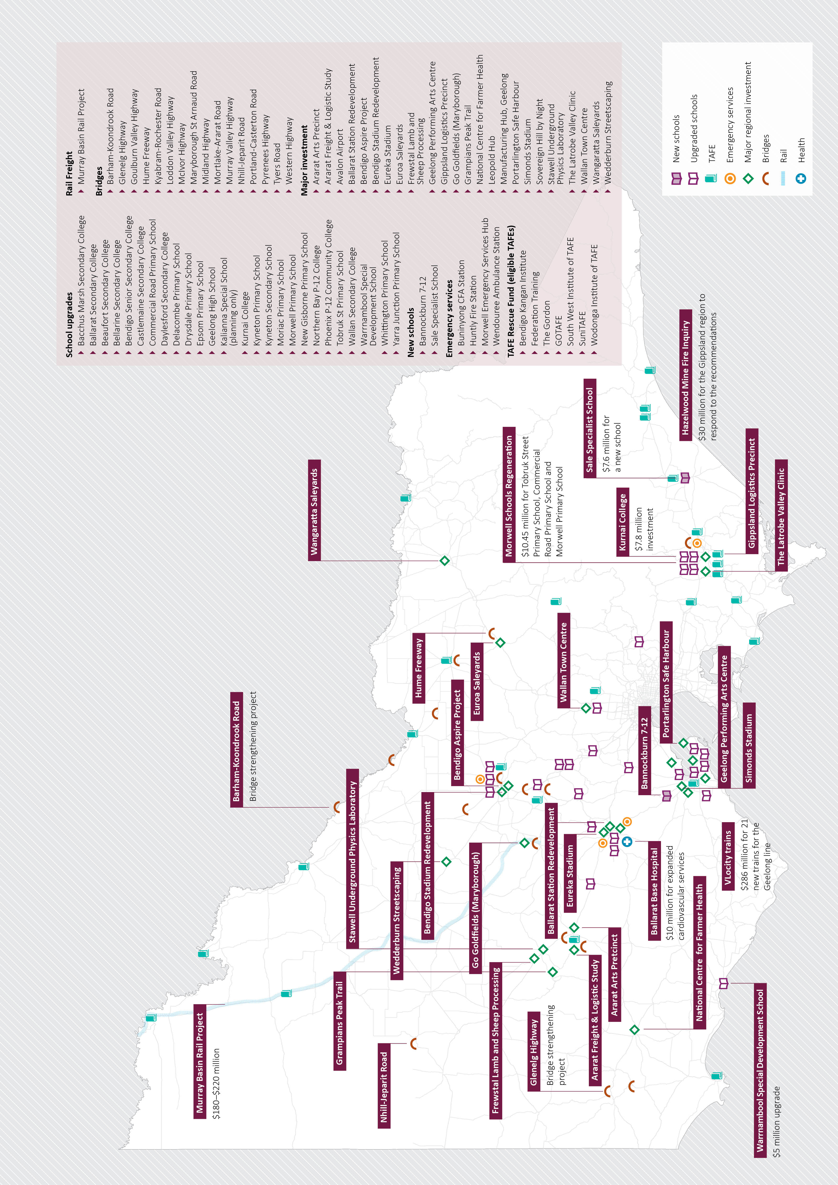

Rural and regional Victoria

Victoria’s rural communities and regional cities are essential to the State’s prosperity and liveability. They are home to about one quarter of Victoria’s population.

Rural and regional Victoria generates around a quarter of the state’s economic output. Key industries include health care and social assistance, retail trade, agriculture, forestry and fishing, manufacturing and construction. The Andrews Labor Government’s investments will make regional Victoria more economically competitive and create new jobs.

Regional Victoria can also seize new opportunities, such as new energy technology, food and fibre processing and tourism.

For rural and regional Victoria to grow, the Labor Government will ensure that:

- There is business confidence to invest in new jobs
- Young people and workers can get the skills they need
- Regional businesses have support to expand and innovate
- Transport infrastructure connects regions to market places

Jobs

The Andrews Labor Government is investing in significant job creation and economic development in regional Victoria.

The Regional Jobs and Infrastructure Fund will provide $500 million over four years to support economic growth in rural and regional Victoria. This will include:

A $200 million Regional Jobs Fund to help regional businesses grow their workforce, expand markets and create jobs of the future.

Initiatives to be funded include:

- Food Source Victoria
- Victorian Defence Procurement Office
- Frewstal Lamb and Sheep Processing
- Wine Victoria strategies
- Latrobe Valley clinic
- Stawell Underground Physics Laboratory
- Geelong Regional Innovation and Investment Fund
- Victorian Automobile Chamber of Commerce LPG industry study
- Horticultural Research Foundation
- A manufacturing hub in Geelong

A $250 million Regional Infrastructure Development Fund to invest in projects that support and grow industry in regional Victoria.

Initiatives to be funded include:

- Ballarat Station Redevelopment
- Harcourt Mountain Bike Trail
- Euroa Saleyards
- Wangaratta Saleyards
- Geelong Performing Arts Centre
- Gippsland Logistics Precinct
- Sovereign Hill by Night
- Grampians Peak Trail
- Eureka Stadium and other Ballarat sporting infrastructure
- Bendigo Aspire Project
- Ararat Arts Precinct Development
- Wallan Town Centre
- Wedderburn Streetscaping
- Leopold Hub
The Back to Work Act 2015 has already established a $100 million fund for payroll tax relief to companies who hire unemployed young people, the long term unemployed and retrenched workers.

The Premier’s Jobs and Investment Fund will provide $508 million over five years. This will draw on the expertise and insight of economic and industry leaders in providing independent, expert and strategic advice directly to Government on a range of issues to drive growth and jobs in Victoria.

The Future Industries Fund, which includes the New Energy Jobs Fund, will also be established to provide $200 million over four years. Two of the six high growth sectors to be targeted from the Future Industries Fund - new energy technology, and food and fibre processing - have a natural home in rural and regional Victoria.

Agriculture
Agriculture is the heart of our regions, with food and fibre contributing over
$11 billion to our economy. The Andrews Labor Government is investing significantly in Victoria’s agriculture industry to secure the livelihoods of farming families and get young people back on the land. The Budget includes:

$30 million already fast tracked to complete Stage 1 of the $180-220 million
Murray Basin Rail Project.

$5.2 million to establish a dedicated unit to make sure that agricultural exports are at the forefront of Victoria’s export strategy.

$9.4 million to enhance Victoria’s biosecurity, so that our farms are safer and more productive, and our produce can be sold all over the world.

$1 million to support the management of foxes and the risks they pose to primary production and biodiversity.

It also includes funding to establish a wine industry Ministerial Advisory Council, to ensure that this vital industry continues to grow.

The Labor Government is also investing in the skills and wellbeing of the people who work on the land. The Budget includes:

- $0.8 million to provide scholarships for young farmers to improve their understanding of their vocation and enhance the productivity of their businesses.
- Funding for a ministerial advisory council on young farmers.
- $1.5 million for the Rural Financial Counselling Service, to support farmers and their families when they fall on hard times.
- $4 million to rebuild and save the National Centre for Farmer Health.
- $45 million to protect our rivers and waterways, improve the health of agricultural land and help farmers manage water use more efficiently.

Transport
The Andrews Labor Government is getting on with the projects rural and regional Victoria needs. This includes:

$90 million for initiatives that will make a big difference, including intelligent transport system technology and upgrades to congested choke points in suburban and regional areas.

$86.7 million to resurface unsafe, deteriorating road surfaces around the state, so families in regional Victoria can get around safely.

To ensure that rural and regional areas are closely linked with key business centres and are able to compete economically, the Labor Government has committed:

$286 million for 21 new VLocity train carriages on the Geelong train line.

$76 million over three years to strengthen bridges on key freight routes across the state to reduce travel time for heavy vehicles, increasing productivity and helping to reduce supply chain costs.

$50.5 million to improve safety at 52 regional level crossings, with $2 million fast tracked so that work can start as soon as possible.

$30 million already fast tracked to complete Stage 1 of the Murray Basin Rail Project. This project, costing $180-$220 million in total, will upgrade rail freight in northern Victoria so larger trains can carry more product.

$6.7 million to relieve congestion and improve safety on regional and outer suburban roads and allow freight to be moved more efficiently across the state.

$2 million for the Bendigo Metro Rail - a dedicated commuter rail service stopping at Epsom, Eaglehawk, Kangaroo Flat and Bendigo.

Education

Upgraded schools
Children across the state need to learn in classrooms that are modern and comfortable, but too many school buildings in Victoria have passed their use-by date.

The following schools in rural and regional Victoria will be renovated, refurbished or rebuilt:

- Bacchus Marsh Secondary College
- Ballarat Secondary College
- Beaufort Secondary College
- Bellarine Secondary College
- Bendigo Senior Secondary College
- Castlemaine Secondary College
- Daylesford Secondary College
- Delacombe Primary School
- Drysdale Primary School
- Epsom Primary School
- Geelong High School
- Kalianna Special School (planning only)
- Kurnai College, Morwell
- Kyneton Primary School
- Kyneton Secondary School
- Moriac Primary School
- Morwell Schools Regeneration Project (Stage 1) - Tobruk Street Primary School, Commercial Road Primary School and Morwell Primary School
- New Gisborne Primary School
- Northern Bay P-12 College, Corio
- Phoenix P-12 Community College, Sebastopol
- Saint Ignatius College, Geelong
- St Patrick’s Primary School Stawell
- Warrnambool Special Developmental School
- Whittington Primary School

New schools
The Labor Government will fund two new regional schools:

- Sale Specialist School
- Bannockburn 7-12

Tech Schools
The Andrews Labor Government is committing $12 million to undertake planning for the establishment of 10 new Tech Schools across the state. This will allow secondary students to get a head start on a hands-on vocation alongside a comprehensive secondary curriculum.

Planning will commence for Tech Schools in:
- Gippsland
- Bendigo
- Ballarat
- Geelong

TAFE
TAFE cuts hurt regions the hardest. The Andrews Labor Government will bring our TAFE system back from the brink, so all kids will have the chance to get a job, start a career and have a decent life.

$300 million will complete the $320 million TAFE Rescue Fund to reopen closed buildings, upgrade workshops and classrooms and get institutes across the state back in the black.

All Victorian TAFEs are eligible for support under the TAFE Rescue Fund, including:

- Bendigo Kangan Institute (in Bendigo and northern suburbs of Melbourne)
- Federation Training
- South West TAFE
- SuniTAFE
- The Gordon Institute
- GOTAFE
- Wodonga TAFE

Health
The 2015-16 Victorian Budget delivers an additional $2.1 billion for hospitals to treat more patients and build a reliable healthcare system for all Victorians.

Key initiatives to support the health of rural and regional communities include:

$40 million to upgrade ambulance stations, vehicles and equipment across the state. This will include a new ambulance station at Wendouree in Ballarat.

$10 million to expand cardiovascular services at the Ballarat Base Hospital, so locals don’t have to travel to Melbourne for urgent heart assessment and treatment.

$4 million over four years to save and rebuild the National Centre for Farmer Health.

$1 million for planning at Goulburn Valley Health.

Ice Action Plan
The Andrews Labor Government has committed $45.5 million for the Ice Action Plan to tackle the profound and disproportionate impact that ice use is having on rural and regional communities. The Ice Action Plan includes:

$18 million to expand and modernise rehabilitation services, particularly in regional and rural Victoria, so people can get the help they need sooner.

$15 million to provide Victoria Police with new booze and drug buses to improve road safety.

$4.6 million to help families identify and support those affected by ice.

$4.5 million to help track down and close clandestine drug labs, reducing supply on the streets.

Police and emergency services

Police
All Victorians are entitled to feel safe and supported in their homes and local communities.

The Budget invests $7.8 million over four years for 15 new sworn police officers in the Bellarine Peninsula and Geelong area.

The Budget also invests $35.4 million to upgrade the outdated analogue communications network used across regional Victoria with a secure, encrypted system, so police can do their job safely and eavesdroppers can’t pick up details of police operations.

Fire protection
The Budget includes funding to commence the recruitment of 450 additional career firefighters. The Andrews Labor Government is also giving our firefighters the resources they need to do their job and keep families safe, including:

$50 million for planned burning on public land to minimise the risk of bushfires to communities.

$44 million to purchase new Country Fire Authority vehicles, to build and upgrade fire stations and install toilet and washroom facilities.

$9.6 million for provision of emergency medical response training and equipment at 33 integrated CFA stations.

$3 million to establish a new Morwell emergency services hub.

The Hazelwood coal mine fire
Communities near coal mines must be confident of their health and safety.

$30 million will be provided to implement all recommendations of the Hazelwood Coal Mine Fire Inquiry.

- Key initiatives include:
- Reform of the regulation of Victoria’s coal mines
- A new CFA district (District 27)
- A long term health study on the impact of emissions exposure from the coal mine fire
- The development of a State Smoke Plan to manage public health if such an event ever happens again

Communities
Safe, strong and thriving communities are the bedrock of regional Victoria, and
the Andrews Labor Government will help cities and towns preserve their liveability. The Budget includes:

$50 million for the Stronger Regional Communities plan, helping towns attract more families and young people to live and work in regional Victoria.

$20 million to bring the arts to our regions, build partnerships with local councils, support regional galleries and performing arts centres and shine a spotlight on creative industries across Victoria.

$80 million to bring more major events to our state and attract more interstate and international visitors to regional Victoria and Melbourne.

$70 million to build a new grandstand at Geelong’s Simonds Stadium, improving facilities and increasing the ground’s capacity to 36,000 - a new life for Australia’s proudest regional stadium.

$11 million to upgrade dilapidated buildings, toilets, paths and roads and build new facilities in national and state parks across Victoria.

$13.5 million to complete the Portarlington Safe Harbour project, giving the pier a new life as a hub for boating, recreation and the local aquaculture industry.

$20 million for Target One Million to support recreational fishing.

