Victoria’s Economic Bulletin

Volume 2: August 2018

The Secretary   
Department of Treasury and Finance  
1 Treasury Place  
Melbourne, Victoria, 3002  
Telephone: +61 3 9651 5111  
Fax: +61 3 9651 2062  
Website: dtf.vic.gov.au

Authorised by the Victorian Government   
1 Treasury Place,  
Melbourne, 3002

Printed by Waratah Group Port Melbourne

© State of Victoria (Department of   
Treasury and Finance) 2018

You are free to re-use this work under a Creative Commons Attribution 4.0 licence, provided you credit the State of Victoria (Department of Treasury and Finance) as author, indicate if changes were made and comply with the other licence terms. The licence does not apply to any branding, including Government logos.

Copyright queries may be directed to [IPpolicy@dtf.vic.gov.au.](mailto:IPpolicy@dtf.vic.gov.au)

Published August 2018

ISSN 2208-8539 (pdf/online)  
ISSN 2209-4245 (print)

Table of contents

Secretary’s foreword 1

Follow the leader: Exploring leading indicators of the Victorian property market 2

Overview 2

1. Hedonic price index 3

2. Leading indicator analysis 7

3. Summary of leading indicator results 18

4. Conclusion 18

How can effective job density help our understanding of economic concentration? 21

1. Relevant literature 22

2. Trends in the geographic distribution of activity in Melbourne 23

3. Measuring concentration – effective job density (EJD) 27

4. Conclusion 32

The role of household debt in national consumption 35

1. Data 38

2. Forecasting household consumption 40

3. The role of debt dynamics for consumer sensitivity 44

4. Conclusion 49

Uncertainty and the value of real options in infrastructure decision-making 51

Overview 52

1. Uncertainty in infrastructure decision-making 52

2. Limitations of traditional economic appraisal approaches to dealing with uncertainty 54

3. Real options analysis in infrastructure 55

4. The value of flexibility in decision-making 57

5. Applying real options analysis techniques to infrastructure investment decision-making 61

6. Conclusions 65

Secretary’s foreword

### By David Martine

The Department of Treasury and Finance (DTF) provides robust and impartial advice to the Victorian Government about the State’s economic, commercial, financial, budget and resource management. Our analysis supports decisions on the most effective ways government funding can be used to make Victoria a better place to live, now and into the future.

Victoria’s economy is broadly equivalent to the size of a small Organisation for Economic Cooperation and Development (OECD) nation. Indeed, measured in terms of real gross domestic product (GDP) in 2017, it would be ranked 26th among the 35 OECD member nations, about the size of Hungary and larger than the economies of Iceland, Finland, Luxembourg and New Zealand.[1] There are, however, relatively few economic research publications that focus on economic trends in Victoria. This research volume, *Victoria’s Economic Bulletin*, is designed to provide one such contribution.

DTF has been investing in the Department’s analytical and research capability. This volume provides a snapshot of some of the staff research being undertaken. By publishing it we hope to contribute to the broader public policy debate on important economic questions. We also hope to highlight important trends driving change in the Victorian economy.

The articles in this volume are summaries of research in progress. They are produced by authors to increase awareness about important economic and social trends.[2]

The first examines potential leading indicators in the Victorian property market for the purposes of analysing market trends and turning points. The second article discusses effective job density to understand economic concentration and access to jobs in Melbourne. The third article discusses the role of household debt in national consumption. The fourth considers the potential benefits of applying real options analysis techniques to infrastructure investment appraisal and decision-making.

I hope the articles provide some insight into the research being undertaken and, perhaps more importantly, start a wider conversation on research into the Victorian economy.

**David Martine**Secretary

Follow the leader: Exploring leading indicators of the Victorian property market[3]

### By Madeleine Tan and Maryam Nasiri

ABSTRACT

This paper examines potential leading indicators in the Victorian property market for the purposes of analysing market trends and turning points. The research will rely on several economic and econometric methods. In the first portion of the paper, hedonic property price indices are constructed and the methodology is described. The second stream looks to determine whether there are certain groups that might lead the wider property market, based on different stratification approaches by either value or location. There is evidence that the inner and metropolitan (metro) regions, the cluster of regions in the central business district (CBD) and the south-east of Melbourne, and high-value properties (top 25 percentile) lead the overall (headline) property price cycle in Victoria. The relationship between Melbourne and Sydney’s property market was found to reflect interdependence, rather than a causal leading-lagging relationship with the direction of causality going both ways. Overall, the leading indicators provide some evidence in favour of future property price growth easing in Victoria in the future

# Overview

Understanding movements in house prices is fundamental for economic and financial development. The boom and bust cycles in the housing market have consequences for the rest of the economy, including real activity, employment, wages and inflation. The events following the collapse of the subprime mortgage market in the United States (US) is an example of the importance of the housing market for the broader economy. It has been found that the economic impact of changes in house prices is often larger than the impact of changes in equity prices and the consequences for the real economy are more pronounced (Case, Quigley, and Shiller, 2005; Jorda, Schularick, and Taylor, 2015).

Housing constitutes the largest share of all household assets in Australia. Movement in housing prices can affect households’ wealth, borrowing and spending decisions. There have been notable developments in the Australian and Victorian housing markets in recent years. Financial liberalisation and lower interest rates, as well as population growth, and strong economic conditions, have contributed to sustained growth in prices with relatively few price corrections since the 1990s. At the same time, household incomes and mortgage debt have also grown steadily.

The most recent upswing in the property market has been sustained for 19 quarters, making it one of the longest cycles on record. In this paper, we explore potential leading indicators for headline property prices in Victoria. Utilising transaction level data of settled sales, we estimate a hedonic measure of housing prices, stratified by location, value and informational content for predicting headline property price growth.

We explore how different stratification approaches provide insight into the Victorian housing market and examine dwelling prices in Melbourne and Sydney to identify possible linkages between the two markets. Specifically, we determine whether this correlation is explained by economic fundamentals particular to each state, or whether there are global, national or other factors that explain the comovement in price and market conditions observed in these two cities.

The remainder of this paper is organised as follows: Section 1 provides an overview of different housing price measurements, explains the construction of our hedonic price index and describes the data used in the analysis; Section 2 explores the relationships based on different stratification methods described earlier; and Section 3 summarises the results from the leading indicator analysis of the Victorian property market before concluding in Section 4.

* + 1. Hedonic price index
       1. Literature review

Property price indices act as a barometer for economic conditions and are important for formulating fiscal and monetary policy. There are two ways the literature attempts to model house prices. The first considers property as an asset, while the second looks to fundamentals, such as demographic and income variables, to help explain property prices. Case (1992) and Case and Shiller (1989) use the first approach to determine the predictability of house prices, while studies such as Bourassa and Hendershott (1995) have taken the second approach to study real housing prices in Australian capital cities.

* + - 1. Housing price measurements across time

Related literature attempts to develop methods to measure housing prices across time. The early empirical literature focused on metrics such as median and mix-adjusted measures, but these methods can have limitations in how they account for quality and compositional change in properties being sold (see Hill, 2011; Hill, Melser, and Syed, 2009).

A key disadvantage of using a median housing price index is related to the changing composition of properties sold. For example, if the share of larger properties increases in the sample, even with no underlying change in price, a rise in median price will be observed. To overcome these limitations, several regression-based approaches such as the hedonic, repeat-sales or a hybrid of these measures have been proposed as alternative measures. In some circumstances, these can better control for changes in composition and quality of the properties being sold.

The drawback of the repeat-sales approach is that it is constructed only using data for properties that have sold multiple times. In other words, this method discards a large proportion of the dataset, that comes from dwellings that are only sold once in the considered time span.

Given the heterogeneity of the housing market, the hedonic price approach, which considers the quality and attributes of dwellings, is favourable as it can control for differences in time and location. The hedonic approach can be applied in several ways, but the two main approaches that are often used in practice are time-dummy and imputation methods.

* + - 1. Comparison of different housing price indices

Hedonic price indices have been developed in many countries to measure movements of property prices across time. Although the main property price indices in the US are based on the repeat-sales approach, the use of hedonic price indices has dominated in the United Kingdom and other European countries, including Ireland, France, Switzerland, Finland, Norway, Sweden and Germany (Hill, 2011).[4]

Several studies implement and evaluate the hedonic price approach for the Australian property market. Hill and Melser (2007) use the hedonic imputation method to develop a methodology for hedonic price indices using panel data sets. In another study, Hill et al. (2009) use median prices, repeat- sale and hedonic price approaches to measure booms and busts in the Sydney housing market. They concluded that although the hedonic approach is vulnerable to sample selection bias, it is still a favourable approach to address the quality adjustment problem.[5]

In Victoria, the most commonly reported measures of property prices are the Real Estate Institute of Victoria (REIV) median price, the Australian Bureau of Statistics (ABS) house price index and the CoreLogic home value index. REIV’s median prices are a timely measure, however as discussed previously, median prices are subject to compositional change in the type of homes sold. The ABS measure uses stratification, which controls for changes in the composition of properties sold, but the data is only available with a delay of about one quarter. CoreLogic provides a measure of price using hedonic and repeat-sales techniques.

Although this index is more timely, interpreting the series is complicated due to the complexity involved with producing non-revisionary and high-frequency indices that are smoothed against the effect of outliers. In this paper, we estimate a relatively simple and transparent measure of property prices using the hedonic approach with transaction-level settled sales data provided by CoreLogic, called the DTF hedonic price index.

* + - 1. Data and methodology

The constructed hedonic price index controls for location, property type and attributes of dwellings sold each month, such as the number of bedrooms or lot size. A key advantage of this approach is that indices can be constructed for any type of disaggregated group, by value or region, in a straightforward manner and with relatively little modification. This facilitates direct comparisons of price trends over time for different regions, types, and values of properties. Consequently, it allows us to explore whether different groups of homes, stratified along these three dimensions, are locally more informative for future housing price trends.

Importantly, we have a long time span of data. The settled sales dataset used to construct the index spans 44 years from 1975 Q1 to 2018 Q1. This long time series helps us to identify the change in the composition of dwellings sold over time, and also stratify the data with a sufficiently large number of observations for robust results. The constructed index can be seen as a ‘composition-adjusted’ measure as it takes into account the individual characteristics of the properties sold, such as the number of bedrooms, location or land size.

BOX 1: METHODOLOGY FOR HEDONIC PRICE INDEX CONSTRUCTION

The methodology builds on earlier work by Hansen (2009) and Genesove and Hansen (2014). If we denote *N* as the total number of transactions, *K* as the number of hedonic characteristics, *H* as the number of postcodes and *T* the number of quarters in the sample, the following hedonic price regression is run to construct the hedonic price index.

$$\log\left(P_{it}\right)= \sum_{k=1}^{K}{β_{j}X_{\left\{k,it\right\}}}+\sum_{t=1}^{T}{δ_{t}D_{t}}+\sum_{h=1}^{H}{γ_{h}Postcode_{h}}+ ε_{it} (1)$$

Where:

* *Pit* is the sale price of property *i* sold in period *t*
* *Xk,it* ={# bedrooms, # bathrooms, # car spaces, land size, floor area, ... , age of structure} [6]
* *Dt* is a *T*-vector of quarterly time dummies equal to 1 in the period in which the property is sold and zero, otherwise

*t*

* *Postcode* is an *H*-vector of postcode dummies, which provides a simple control for the location in which homes are sold. [7]

*h*

Following this, the estimates of *δt* are used to construct the hedonic price index.

Our dataset contains 2 617 733 transactions across 79 local government areas (LGAs) in Victoria. Houses make up a larger proportion of property types that are transacted relative to units. 81 per cent of the dataset is made up of transactions of houses, while only 19 per cent of the dataset relates to units. The descriptive statistics for some property characteristics that were used in the hedonic price index are provided in Table 1.

Table 1: Descriptive statistics of property characteristics

|  |  |  |  |  |
| --- | --- | --- | --- | --- |
| PROPERTY CHARACTERISTICS | PROPERTY TYPE | | | |
| **HOUSE** | | **UNIT** | |
|  | **MEAN** | **MEDIAN** | **MEAN** | **MEDIAN** |
| Land size[8] (sqm) | 657.6 | 639 | 412.5 | 251 |
| Floor area (sqm) | 184.8 | 152 | 115.8 | 98 |
| Number of bedrooms | 3.3 | 3 | 2.3 | 2 |
| Number of bathrooms | 1.7 | 2 | 1.3 | 1 |
| Number of car spaces | 1.9 | 1 | 1.3 | 1 |

We create our hedonic price index measure based on the model above. Figure 1 compares the newly constructed measure against CoreLogic’s Home Value Index (HVI) and the ABS’s House Price Index (HPI) measure for Victoria. [9]

The three measures of price growth suggest broadly similar cycles in property price growth over time. We observe that the constructed hedonic price index is less volatile relative to the other measures, however the peaks and troughs in the cycle are broadly in line with each other.

Figure 1: Hedonic dwelling price index comparison – two-quarter average through-the-year growth

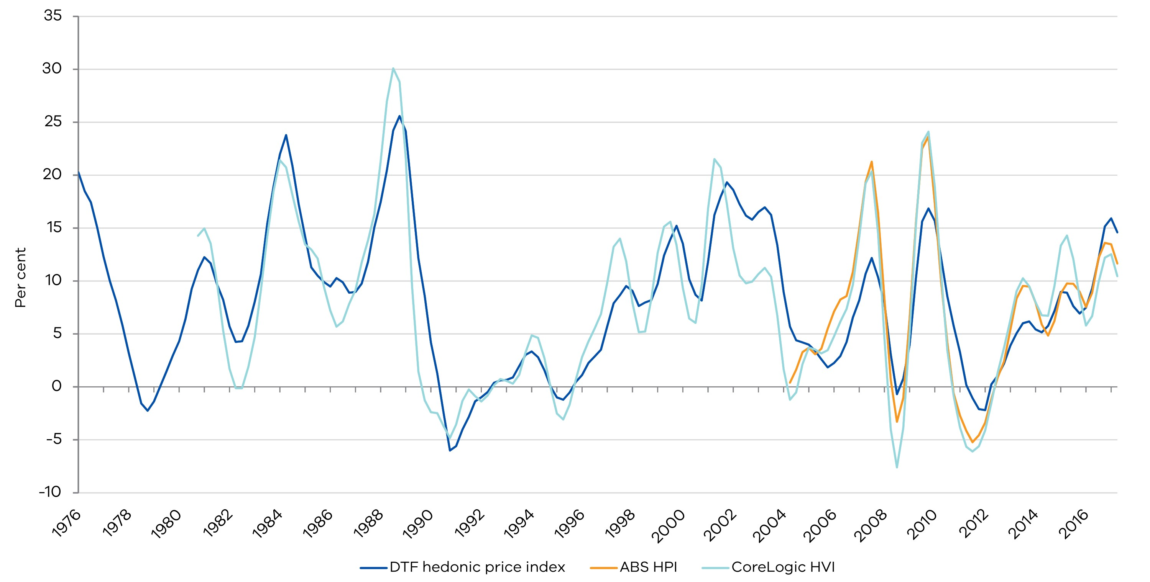

In Figure 2, we provide a comparison of the indices constructed for all of Victoria (headline), Greater Melbourne and regional Victoria, based on the new DTF hedonic price measure. This figure shows that the Greater Melbourne hedonic price index makes up a significant portion of the overall headline property price index. Moreover, there is a noticeable delay in price changes in regional Victoria relative to the headline and Greater Melbourne price movements.

Figure 2: Victorian hedonic dwelling price index comparison by region – two-quarter average through the-year growth

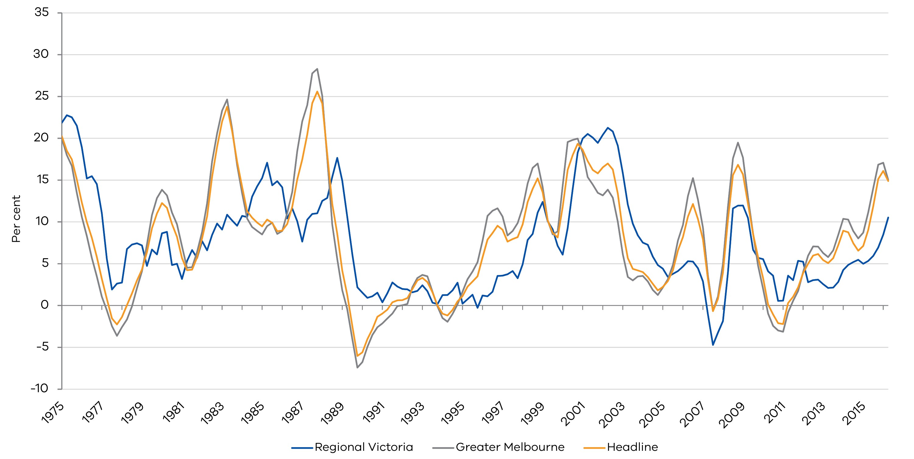

* + 1. Leading indicator analysis
       1. Stratification by region

In this section, we try to identify leading indicators of the Victorian property price cycle by using several econometric techniques, which include correlation analysis, bivariate Granger causality tests, Johansen co-integration tests and regression analysis. Three different spatial relationships are explored as possible leading indicators, such as proximity to the CBD, disaggregated leading regions in Greater Melbourne at the Statistical Area 4 (SA4) level, and the inter-regional relationship between the Melbourne and Sydney markets.[10]

* + - * 1. Regions in Greater Melbourne

To allow for some heterogeneity in property markets, the analysis can be split into three different regions of Greater Melbourne, inner, metro and outer, as defined in Figure 3.[11] Descriptive statistics reveal there are more transactions in the metro and outer regions relative to the inner Melbourne region; the inner area makes up only 5 per cent of the data, while the metro and outer regions make up 39 per cent and 31 per cent, respectively, of the whole settled sales dataset.

Figure 4 shows the transaction volumes for units and houses by regions.

Figure 3: Regions of Greater Melbourne

|  |  |
| --- | --- |
| Decorative | **Inner Melbourne includes:** Melbourne, Port Phillip, Stonnington, and Yarra  **Metro Melbourne includes:** Banyule, Bayside, Boroondara, Brimbank, Darebin, Glen Eira, Hobsons Bay, Kingston, Manningham, Maribyrnong, Monash, Moonee Valley, Moreland and Whitehorse  **Outer Melbourne includes:** Cardinia, Casey, Frankston, Greater Dandenong, Hume, Knox, Maroondah, Melton, Mornington Peninsula, Nillumbik, Whittlesea, Wyndham and Yarra Ranges |

Figure 4: Transaction volumes by regions

Transaction Volume (House) Transaction Unit (Unit)

##### Decorative Decorative

Figure 5 shows the two-quarter through-the-year growth rate of the constructed hedonic price index for Victoria, and the sub-regions of inner, metro and outer areas of Greater Melbourne. A visual inspection of the hedonic price indices for the inner, metro and outer region of Greater Melbourne suggests inner and metro price growth are highly correlated contemporaneously and lead the outer and headline property price cycles.

Figure 6 compares these hedonic price growth rates against their equivalent median price growth. A key difference between the two measures is that median prices reflect the actual contract price, while the hedonic price index aims to compare price growth of similar properties (for example, two-bedroom houses in the same location with the same lot size). Therefore, if median price growth has decreased, it may not necessarily mean that prices are falling. Rather, it could potentially signal that less expensive properties are being transacted, as discussed in the literature review. As such, divergence between median price growth and hedonic price growth signifies compositional change.

Figure 5: Hedonic dwelling price index two-quarter average through-the-year growth

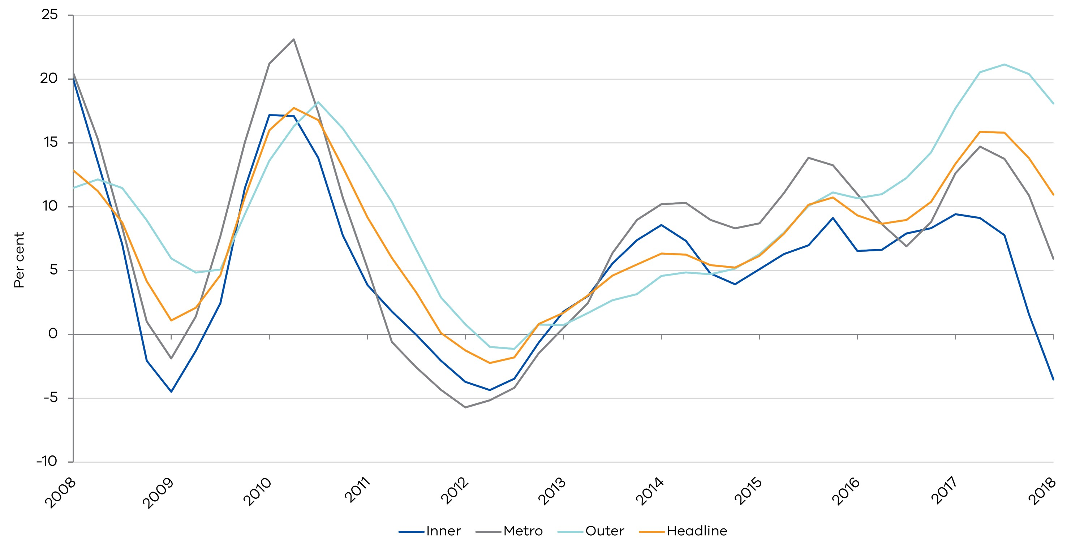

Figure 6 shows that the inner Melbourne hedonic price and median price growth are quite different. However, in the metro and outer regions where compositional change has been less of an issue, price growth in the two measures are more aligned. State Revenue Office (SRO) unit record data for land transfer duty also corroborates this compositional change pattern for the three regions.

Figure 6: DTF hedonic price index through-the-year growth for regions of Melbourne and share of transactions by property type; quarterly

Inner Melbourne

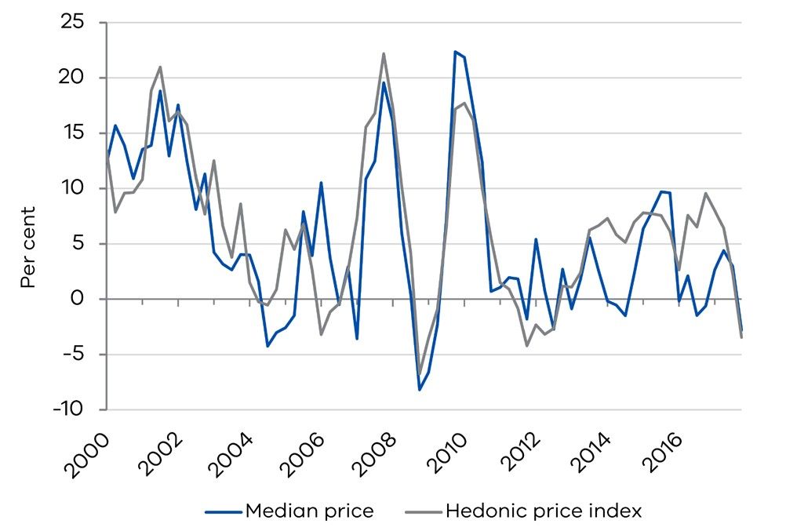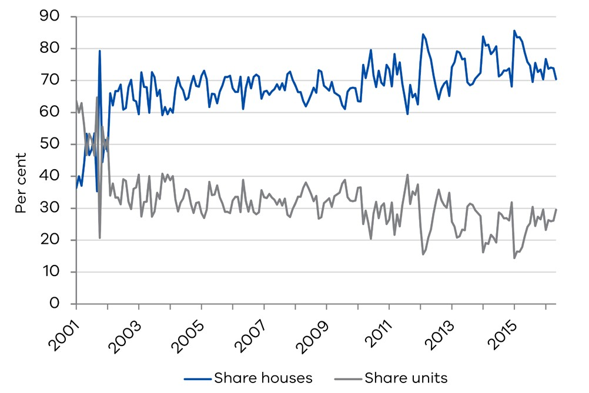

Metro Melbourne

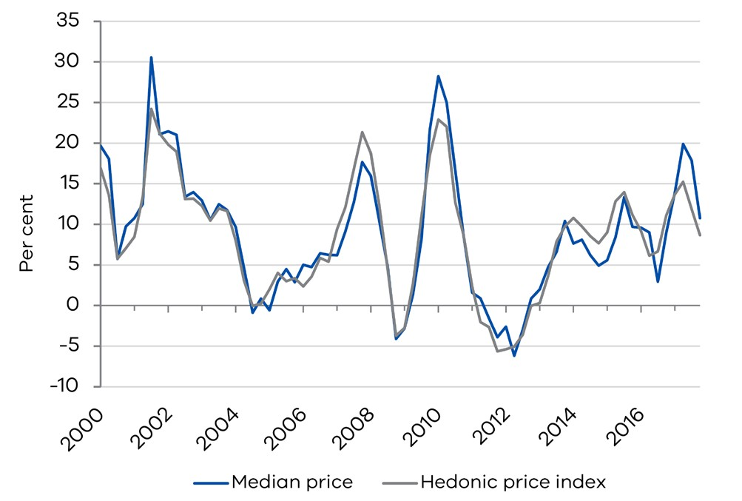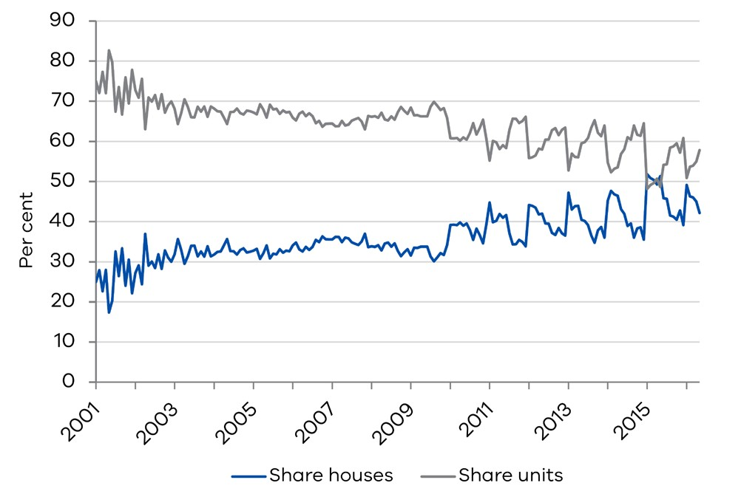

Outer Melbourne

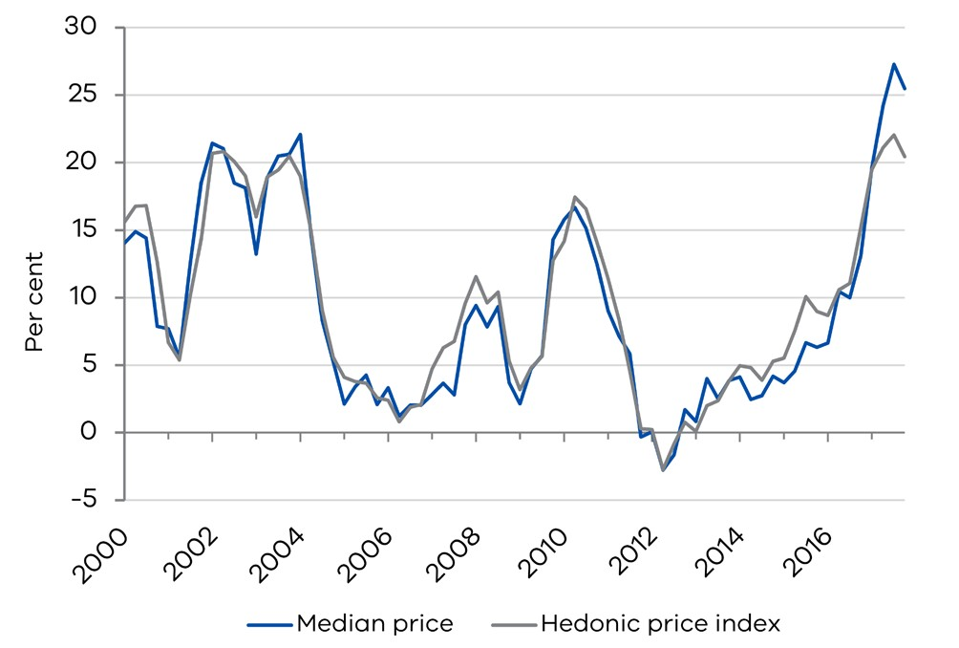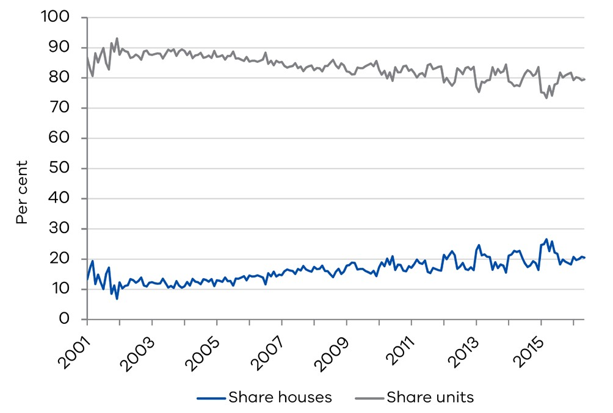

From Figure 6 and Table 2, we note the outer and headline indices appear to be very closely correlated contemporaneously. The correlation coefficients of the indices found in Table 2 confirm this leading-lagging relationship between the different regions.

The correlation coefficients between the lags of both the inner and metro indices, and the outer and headline indices at time *t*, are higher than the correlation coefficients between the lags of outer, and the inner and metro indices at time *t*. This result suggests the inner and metro indices lead the outer and headline property price cycle.

Table 2: Correlation of growth rates in inner, metro and outer regions

|  |  |  |  |
| --- | --- | --- | --- |
| INNER AT TIME: | METRO AT TIME *t* | OUTER AT TIME *t* | HEADLINE AT TIME *t* |
| t | 0.87 | 0.53 | 0.71 |
| t-1 | 0.87 | 0.66 | 0.79 |
| t-2 | 0.75 | 0.71 | 0.77 |
| t-3 | 0.56 | 0.67 | 0.67 |
| t-4 | 0.35 | 0.57 | 0.52 |
| **METRO AT TIME:** | **INNER AT TIME *t*** | **OUTER AT TIME *t*** | **HEADLINE AT TIME *t*** |
| t | 0.87 | 0.77 | 0.91 |
| t-1 | 0.74 | 0.86 | 0.93 |
| t-2 | 0.53 | 0.86 | 0.86 |
| t-3 | 0.31 | 0.77 | 0.72 |
| t-4 | 0.12 | 0.63 | 0.54 |
| **OUTER AT TIME:** | **INNER AT TIME *t*** | **METRO AT TIME *t*** | **HEADLINE AT TIME *t*** |
| t | 0.54 | 0.77 | 0.95 |
| t-1 | 0.37 | 0.61 | 0.86 |
| t-2 | 0.19 | 0.42 | 0.70 |
| t-3 | 0.03 | 0.24 | 0.52 |
| t-4 | -0.09 | 0.09 | 0.35 |

In the next step, we investigate whether past lags in price growth based on the constructed indices can be useful for predicting future price growth for the inner, metro and outer areas. For this purpose, we run a Granger causality test (see Box 2).

BOX 2: GRANGER CAUSALITY TEST

The bivariate Granger causality test is run for pairs of x and y set up as: $y_{t}=α_{0}+ α_{1}y_{t-1}+…+α_{l}y_{t-l}+β_{1}x_{t-1}+…+ β_{l}x_{t-l}+ε_{t}{ and x}_{t}=α_{0}+ α_{1}x_{t-1}+…+α_{l}x_{t-l}+β_{1}y_{t-1}+…+ β_{l}y_{t-l}+u_{t. }$

The bivariate Granger causality test is run for pairs of *x* and *y* set up as:Under the null hypothesis   
(*H* : *β =* … *= β =* 0*)*, lags of the x (y) series do not Granger cause the y (x) series. The null hypothesis is rejected if any *β ≠ 0* suggesting that the x (y) series does Granger cause the y (x) series.

*l*

This test is run as a Wald (F-statistic) test where the larger the Wald statistic, the more the lags of the right- hand-side variable are able to explain the contemporaneous left-hand-side variable. In other words, the larger the Wald statistic, the higher the information content of the right-hand-side variable in predicting the left-hand-side variable.

The results provided in Table 3 show inner Melbourne price movements lead metro and outer price growth, but there is no evidence that changes in either metro or outer prices are useful for predicting price growth in the inner region. For the metro region, we find strong evidence that metro prices lead outer Melbourne prices, but only weak evidence (significant at the 10 per cent level of significance) that outer prices can be used to predict metro prices.

Taken together, these results suggest a pattern where changes in property market conditions are first captured in the inner areas of Melbourne, before spreading to the metro and outer regions.

Table 3: Granger causality test for headline, inner, metro and outer region hedonic price growth

|  |  |  |  |  |
| --- | --- | --- | --- | --- |
| TEST CATEGORY | NULL HYPOTHESIS | F-STATISTIC | PROB. | REJECT THE NULL HYPOTHESIS? |
| Within Greater Melbourne | Metro area does not Granger Cause Inner | 0.154 | 0.857 | No |
| Inner area does not Granger Cause Metro | 11.781*** | 0.000 | Yes |
| Outer area does not Granger Cause Inner | 0.091 | 0.913 | No |
| Inner area does not Granger Cause Outer | 11.582*** | 0.000 | Yes |
| Outer area does not Granger Cause Metro | 2.378* | 0.096 | Yes |
| Metro area does not Granger Cause Outer | 29.258*** | 0.000 | Yes |
| Headline does not Granger Cause Inner | 0.477 | 0.752 | No |
| Headline does not Granger Cause Metro | 0.940 | 0.443 | No |
| Headline does not Granger Cause Outer | 13.840*** | 0.000 | Yes |
| Inner area does not Granger Cause Headline | 5.355*** | 0.001 | Yes |
|  | Metro area does not Granger Cause Headline | 10.186*** | 0.000 | Yes |
|  | Outer area does not Granger Cause Headline | 3.471*** | 0.010 | Yes |

***, ** and * indicate that the results are signifiican at 1 per cent, 5 per cent and 10 per cent, respectively.

* + - * 1. Bellwether regions of Greater Melbourne

The inner, metro and outer regions were selected assuming the CBD as the centre. A more granular analysis of the data, for example SA4 levels could provide even more information about which areas of Melbourne are most informative for near-term changes in property prices. To consider spatial relationships of this nature, hedonic price indices from CoreLogic’s settled sales data can be constructed for SA4s in Greater Melbourne. Again, using bivariate Granger causality tests with four lags as determined by the SIC, leading local markets can be identified.[12]

To identify leading property market regions in Greater Melbourne, this test is set up by pairing each headline hedonic price index with each SA4 hedonic price index generated in Greater Melbourne. Table 4 shows the Wald test statistic associated with each of the SA4s in Greater Melbourne.[13] Based on these test statistics, clusters of SA4s were identified as ‘bellwether’ or leading local areas.

Bell 1 is a cluster of local areas that lead the headline price index the most, followed by Bell 2, and then Bell 3, which has minimal to no leading ability. From Figure 7, it appears the Bell 3 cluster may even lag the headline price cycle (which is useful information in itself). This figure illustrates visually that the peaks of Bell 1 do indeed lead the headline price growth cycle, as well as Bell 2 and Bell 3’s price growth cycles. The map on the right shows the ‘bellwether’ regions in relation to the rest of Victoria.

Table 4: Granger causality test for bellwether regions in Greater Melbourne

|  |  |  |  |
| --- | --- | --- | --- |
| WALD TEST STATISTIC | | EXAMPLE SUBURB IN THE SA4 | |
| SA208 | 9.84705 | Malvern area | Bell 1 |
| SA207 | 13.3365 | Kew area | Bell 1 |
| SA211 | 1.67044 | Doncaster East area | Bell 2 |
| SA212 | 2.67908 | Burwood area | Bell 2 |
| SA209 | 1.62844 | Coburg area | Bell 2 |
| SA213 | 0.82591 | Footscray area | Bell 3 |
| SA210 | 0.61634 | Essendon area | Bell 3 |

Figure 7: Hedonic price index for bellwether regions in Greater Melbourne, two-quarter average through-the-year; quarterly

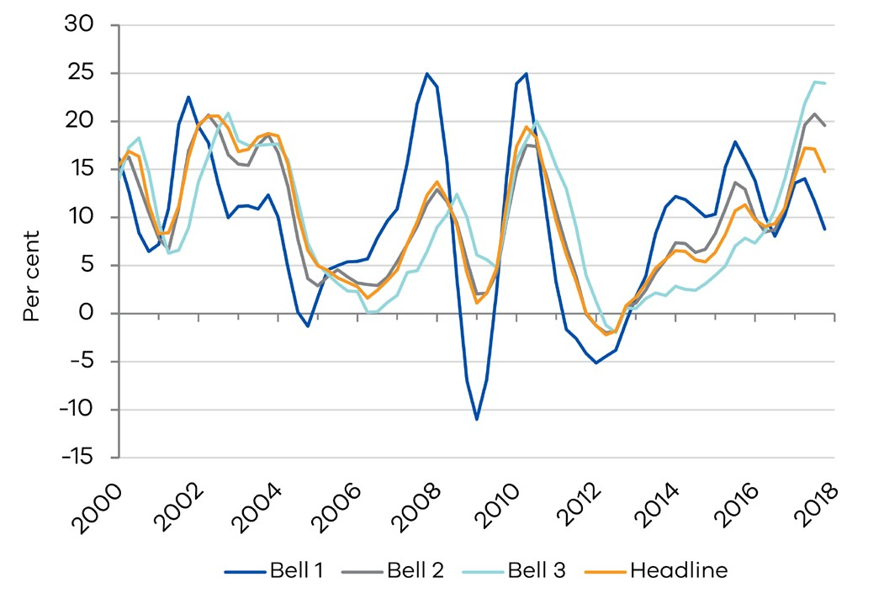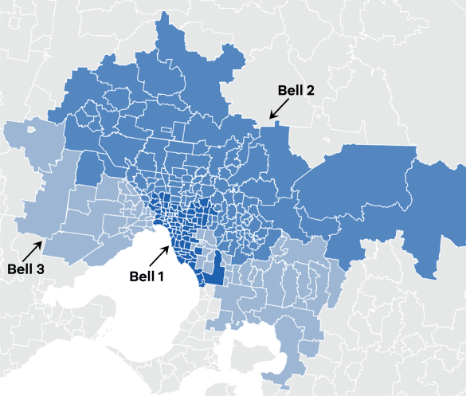

* + - * 1. Inter-regional markets: Does the Sydney property market influence Melbourne’s?

In this section, we investigate whether the Melbourne property market is influenced by changes in the Sydney property market, and to what extent the Sydney property market may lead Melbourne’s. Figure 8 shows property price cycles in the two cities are highly synchronised, especially when compared to other states. Auction clearance rates have followed similar trajectories when measured on a weekly basis, although the Sydney clearance rate is generally more volatile (see Figure 9).[14]

Figure 8: CoreLogic HVI comparison

Melbourne and Sydney CoreLogic HVI for dwellings  
 two-quarter average through-the-year growth quarterly CoreLogic HVI index comparison in capital cities

##### Decorative Decorative

Figure 9: Auction clearance rates for Melbourne and Sydney, 4-week average; weekly

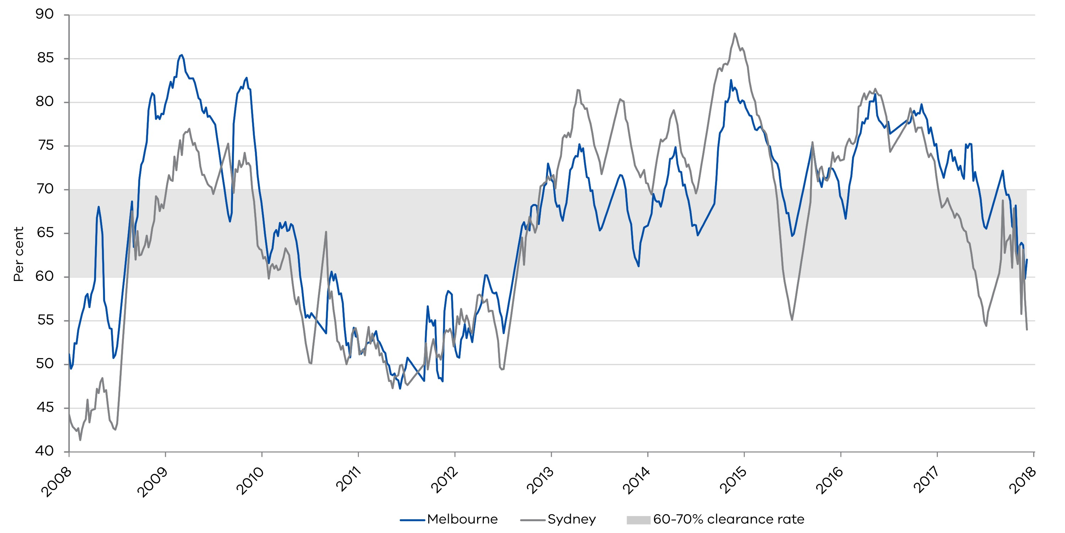

Using the CoreLogic HVI for Melbourne and Sydney, a Granger causality test was run with three lags, which was found to be the optimal number of lags based on the SIC and AIC.[15] The results suggest the relationship between Melbourne and Sydney is bi-directional. In other words, Sydney’s property prices appears to influence Melbourne’s property prices and vice versa. Both the Johansen maximum eigenvalue and trace tests provide evidence of a long-run relationship.

* + - * 1. Understanding the co-movement across cities

One might suspect that the Melbourne and Sydney property markets experience common national shocks or spillover effects. Evidence of co-integration between the two markets suggests that they share a long-term trend, which reflects common sources of shocks to both markets. Some examples of these shocks could be national factors such as a common interest rate, a common federal taxation environment and/ or some degree of substitution between two markets by the marginal investor or buyer. The International Monetary Fund’s (IMF) most recent Global Financial Stability Report highlighted that the Melbourne and Sydney housing markets were similar to other capital cities in that they were found to be largely driven by global forces (IMF April 2018).

The charts in Figure 10 show the similarities and differences in the two states. Population growth in Victoria has been consistently higher relative to NSW since the early 2000s, however, the growth rates have moved in tandem. Similarly, their respective state final demand and housing affordability measures have moved closely together.

Figure 10: Comparison of indicators for NSW and VIC

Population through-the-year growth; quarterly State final demand through-the-year growth; quarterly

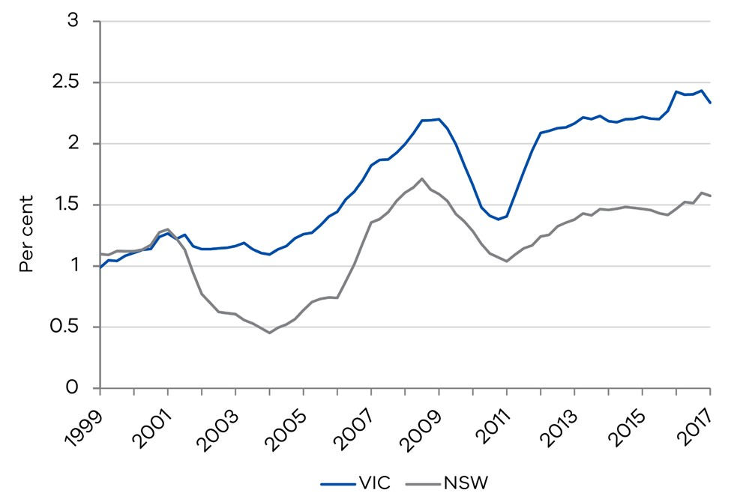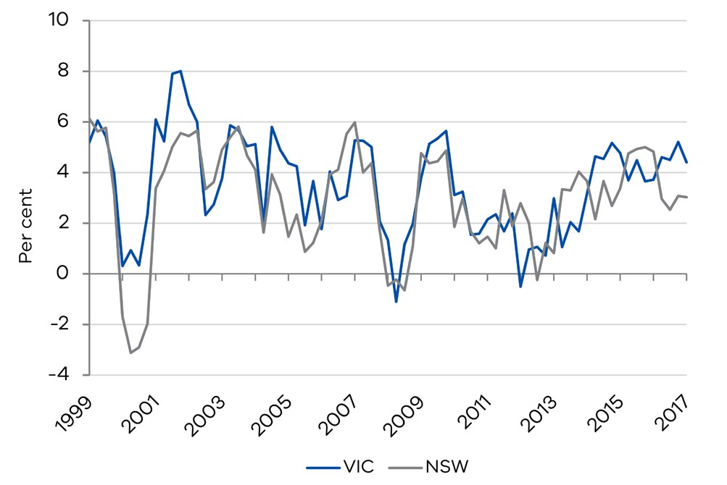

Source: ABS Source: ABS

Housing affordability index (REIA) through-the-year   
 growth; quarterly Mortgage rate

##### DecorativeDecorative

Source: Real Estate Institute of Australia (REIA) Source: RBA

The following regression was run to determine whether their property markets are driven by state fundamentals, spill-overs or national variables, such as the mortgage rate. The results are reported in Table 5. Wald statistics are reported for joint F-tests on all the lags of the variable included in the estimated equation; where only one lag is present, t-statistics are presented instead.

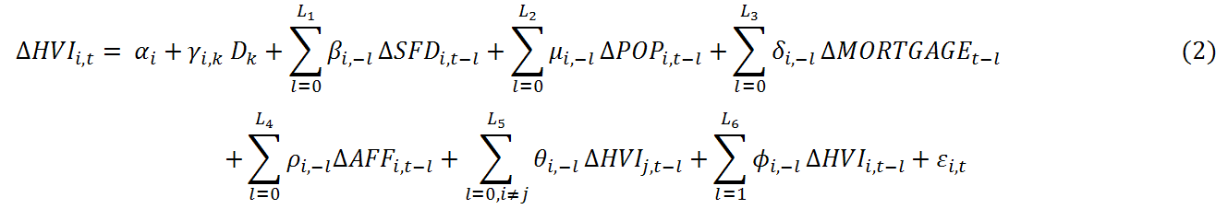

where,

* $∆HVI_{i,t}$ refers to the CoreLogic home value index growth for dwellings; *i = MEL or SYD*
* $∆SFD_{i,t}$ refers to the respective state final demand growth, $POP_{i,t}$, the population growth and $∆AFF_{i,t}$, changes in the affordability index from REIA; *i = MEL or SYD*
* $∆MORTGAGE_{t}$ is the mortgage rate change, which is a national variable common to both the Sydney and Melbourne property markets
* $D_{k}$ refers to the quarterly dummies included to control for seasonality; as the data is quarterly and a constant has been included, $k=1,2,3$

Table 5: Regression results for the role of economic variables on Melbourne and Sydney property markets

|  |  |  |  |  |
| --- | --- | --- | --- | --- |
| SAMPLE PERIOD: 1993 Q1 – 2017 Q4 | | | | |
| **DEPENDENT VARIABLE:** | HVIMEL | | HVISYD | |
| **WALD-STATISTIC FOR:** | **MODEL 1** | **MODEL 2** | **MODEL 1** | **MODEL 2** |
| $$POP^{MEL}$$ |  | 7.19** |  |  |
| $$POP^{SYD}$$ |  |  |  | 1.39 |
| ${MORTGAGE}_{t-1}$*(t-stat)* |  | -3.94** |  |  |
| $${HVI}^{MEL}$$ | 745.98** | 309.41** |  | 19.41** |
| $${HVI}^{SYD}$$ |  | 13.95** | 625.38** | 342.07** |
| ${AFF}_{t-1}^{MEL}$*(t-stat)* |  | -2.54** |  |  |
| $${AFF}^{SYD}$$ |  |  |  | 7.83** |
| R-squared | 0.97 | 0.98 | 0.98 | 0.98 |
| Adjusted R-squared | 0.96 | 0.98 | 0.98 | 0.98 |
| Durbin-Watson stat | 1.92 | 1.98 | 2.02 | 2.03 |
| SSR | 0.02 | 0.01 | 0.02 | 0.01 |

Notes:

1. A constant, quarterly dummies and trend (for Melbourne only) were included in the estimated regressions.

2. Wald statistics are reported for joint F-tests on all the lags of the variable included in the estimated equation; where only one lag is present, t-statistics are presented instead.

3. ** indicates that the results are significant at 5 per cent.

A structural break was identified in 1993 Q1 through a Quandt-Andrews test. Although data is available prior to this quarter, the monetary policy and macroeconomic environment in Australia was significantly different prior to inflation targeting (1993 Q1 onwards), suggesting it is possible different structures existed in the two markets prior to this date.

The historical mortgage rate chart in Figure 10 shows that prior to 1993, mortgage rates were significantly higher, in double digits, which is remarkably different from the levels experienced since then. The analysis is based on the latter period to account for these differences.

Based on the Wald tests, the results reported in Table 5 suggest that both Melbourne and Sydney’s property markets are affected by lags of changes in their own property prices. Hwang and Quigley (2006) find a similar result for the US metropolitan areas. They attribute the strong positive relationship between the contemporaneous price growth and the first lag of the price growth to slow adjustments to market conditions. This result is also consistent with Case (1992) and Case and Shiller (1989) finding evidence of predictability in house prices in a number of US cities; specifically, quarters with strong (weak) growth were followed by quarters with weak (strong) growth. Results from our analysis find that lags are significantly correlated to the contemporaneous changes in the respective housing prices for both Sydney and Melbourne.

Both markets are also affected by their respective lagged changes in housing affordability and population growth rate, although the influence of the latter on Sydney’s property price growth is weak. In addition to these factors, Melbourne’s property price growth was found to be sensitive to the national mortgage rate and to also contain a trend.

These results are consistent with the study of Australian capital city property markets by Bodman and Crosby (2004). Their analysis relies on predicting the property prices of the capital cities and comparing it against actual levels to determine whether a market is overvalued or not. In their estimations, they find Melbourne property prices were broadly in line with predicted prices based on demographic factors. In contrast, they found Sydney’s property prices were not aligned with predicted prices from any model using economic or demographic drivers. As lags of price changes in the Melbourne market affect Sydney's and vice versa, this provides some evidence of linkages between the two markets. This is consistent with the previous Granger causality and co-integration test results.

* + - 1. Stratification by property value in Greater Melbourne: the top 25 versus bottom 25 per cent

The previous section explored potential leading indicators based on different spatial stratifications. In this section, stratification based on property values are explored instead to determine if perhaps high-value or low-value properties lead or lag the wider Victorian property price cycle.

High-value transaction price changes could lead property price cycles in the rest of the market for two reasons. Firstly, high-value property transactions stand to benefit more from auctions (Wang 1998). In an environment that is lacking in signals, the information from these auction sales are easily accessed and help to inform property price expectations of potential buyers in the rest of the market. Secondly, macroeconomic shocks could affect the property market through asymmetric changes in the income distribution. Shocks to income would impact the higher value properties more than they might lower value properties. [16]As the economic conditions flow through the economy, this will eventually impact on the price of lower value properties as well.

This hypothesis is tested using property price transactions that are stratified according to median postcode prices for Victoria. The top 25 and bottom 25 percentile of the distribution of median postcode prices over the five-year period from 2000 to 2005 are identified and categorised into the ‘high-value’ group and ‘low-value’ group, respectively.[17]

Figure 11 provides support for the hypothesis that high-value properties can lead low-value properties. To check that this stratification remains broadly stable through time, out of the 697 postcodes in 2000-2005, the median price of only 12 postcodes swapped from one value group to the other over 20 years. This represents a very small proportion of all postcodes (approximately 1.7 per cent).[18]

Figure 11: Stratified hedonic price index 2-quarter through-the-year growth; quarterly

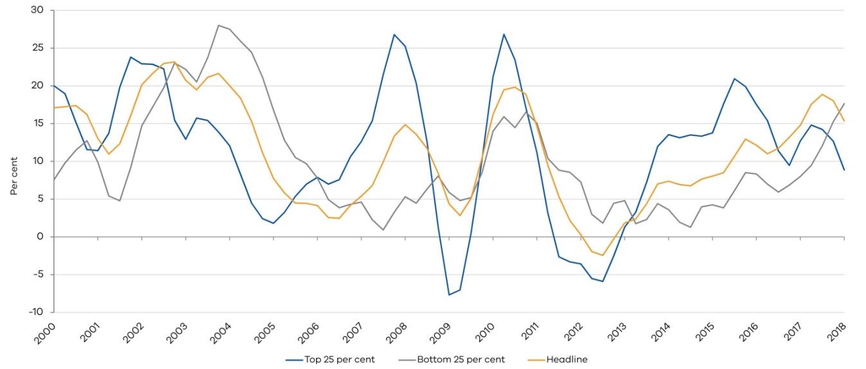

Hedonic price indices are then constructed for each of these groups, and Granger causality tests determine if indeed the high-value index leads either or both the low-value and headline (non-stratified) index. The Granger causality test was run with two lags as determined by the SIC and AIC.

The results of these pairwise Granger causality tests are presented in Table 6 and show that the high-value (Top 25 per cent) group does indeed lead both the low-value (bottom 25 per cent) group price cycle and the headline price cycle. There is a bi-directional relationship between the low-value group price cycle and the headline price cycle, which means that although they are interdependent, neither leads the other.

Table 6: Granger causality test for stratified median prices

|  |  |  |
| --- | --- | --- |
| NULL HYPOTHESIS | OBS | F-STATISTICS |
| HIGH does not Granger Cause HEADLINE | 164 | 12.846** |
| HEADLINE does not Granger Cause HIGH | 164 | 0.387 |
| LOW does not Granger Cause HEADLINE | 164 | 13.445** |
| HEADLINE does not Granger Cause LOW | 164 | 12.023** |
| LOW does not Granger Cause HIGH | 164 | 0.324 |
| HIGH does not Granger Cause LOW | 164 | 5.767** |

** indicate that the results are significant at 5 per cent.

* + 1. Summary of leading indicator results

Leading indicator analysis suggests that the inner Melbourne region, Bell 1 region and high value properties lead the aggregate property price cycle. All of these cycles had shown some signs of property price growth easing.

Updating the index to the latest quarter of data (2018 Q1) has confirmed the leading ability of these indicators. As seen from Figure 12, property price growth in the metro and outer regions have indeed trailed the price growth decrease in the inner Melbourne region (top left). Price growth in both Bell 2 and Bell 3 have also continued to deteriorate following the trajectory of the Bell 1 region (top right), previously (middle panel). Similarly, the headline price growth has also started to see a more pronounced decrease in the most recent quarter however, the price cycle of low value properties in Victoria has yet to peak (bottom left).

Figure 12: Updated hedonic price index two-quarter average through-the-year growth to 2018 Q1

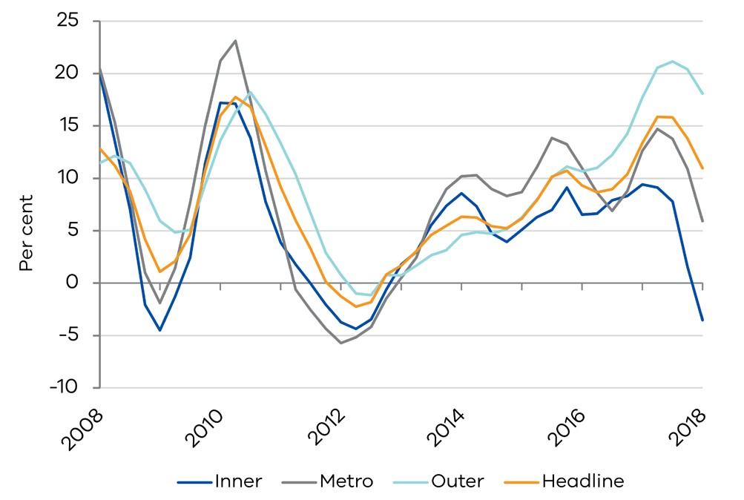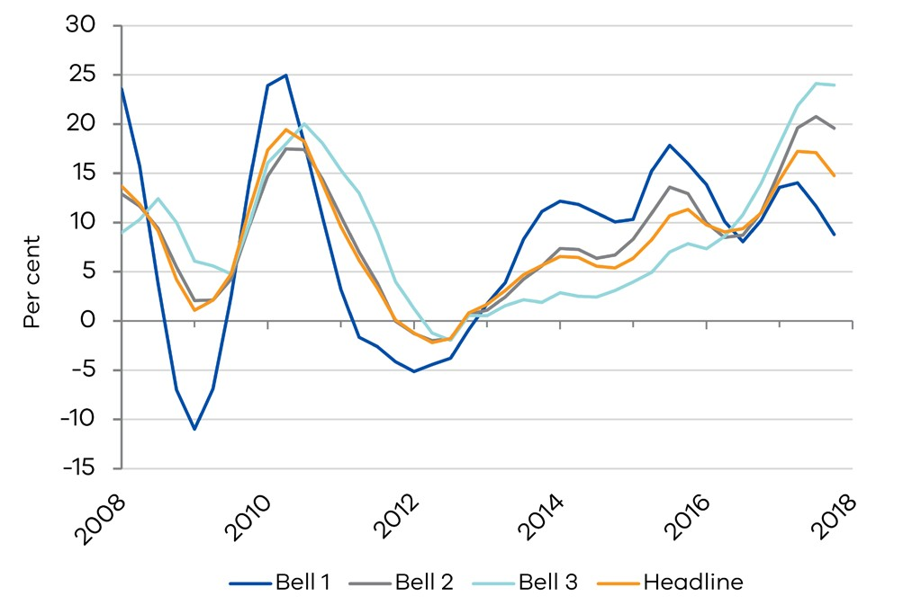

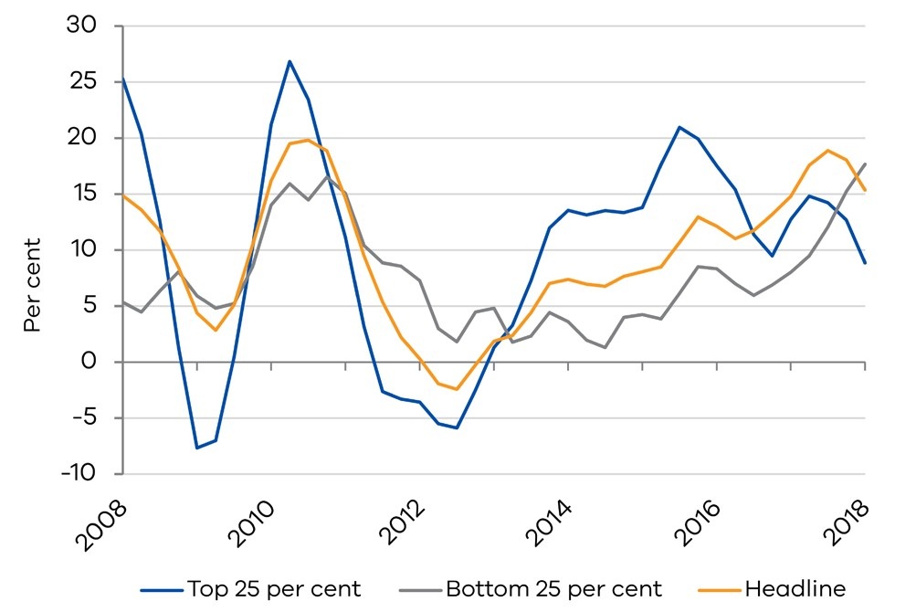

* + 1. Conclusion

The analyses undertaken in this paper have provided evidence in favour of leading indicators using different stratifications, based on location and value providing robust information for the trajectory of overall headline property prices in Victoria.

The analysis based on the inner, metro and outer areas of Greater Melbourne show that both inner and metro areas have historically led the outer and headline property price cycles. In recent quarters, we have seen inner property prices decline, while price growth in the metro areas has started to slow as well.

Although the outer areas of Melbourne and the aggregate Victorian property price index have continued to see historically high growth rates, it is possible some easing might soon be observed.

Significantly slower growth in Sydney’s property market in early 2018 has led to calls that the Melbourne property market might follow suit. The relationship between Sydney and Melbourne’s property markets was therefore explored in the analysis. Interdependence rather than a causal leading- lagging relationship was found as both markets are driven by common shocks likely from national factors such as interest rates, a common federal taxation system and/or some degree of substitutability between the two markets by the marginal investor. To some extent, common shocks arise from the global financial and economic environment as well.

Although some economic fundamentals, such as state final demand and population growth, have diverged a little in recent quarters between Sydney and Melbourne, historically, they have closely tracked each other, especially in comparison to other states. An analysis of drivers of property prices suggests it is largely due to the momentum in their respective markets and interdependence between the two that explain changes in property prices. To a limited extent, housing affordability changes and state population growth were also correlated with property price growth.

The identified bellwether regions that lead the wider Victorian property market also suggest that some future easing in property price growth can be expected. Another leading indicator was found in the stratified median price analysis where properties in the top 25 percentile of median prices considered ‘high-value’ properties were seen to lead the market; this group was found to lead both the overall headline market and the bottom 25 percentile of median prices or ‘low-value’ properties. Property price growth in the ‘high-value’ group has stabilised in recent periods, but is still relatively elevated when compared to historical growth.

The most recent quarter of data confirmed the leading ability of these identified indicators. Some softening in property price growth across Victoria is expected in the next few quarters based on the leading indicators.

References

Alonso, W. (1964). 'Location and Land Use: Toward a General Theory of Land Rent', Harvard University Press, Cambridge.

Bodman, P. & Crosby, M. (2004). 'Can Macroeconomic Factors Explain High House Prices in Australia?', *Australian Property Journal*, August 2004, pp. 175–179.

Bourassa, S.C. & Hendershott, P.H. (1995). 'Australian Capital City Real House Prices, 1979-1993', *Australian Economic Review,* vol. 111, no. 3, pp. 16–26.

Case, K.E. (1992). 'The Real Estate Cycle and the Massachussetts Boom of 1984-87', *Urban Studies*, vol. 29, no. 2, pp. 171–183.

Case, K.E. & Shiller, R.J. (1989). 'The Efficiency of the Market for Single-Family Homes', *American Economic Review*, vol. 79, no. 1, pp. 125–137.

Case, K.E. & Quigley, M. and Shiller, R.J. (2005). 'Comparing Wealth Effects: The Stock Market Versus the Housing Market', *Advances in Macroeconomics*, vol. 5, pp. 235–1235.

Genesove, D. & Hansen, J. (2014). 'Predicting Dwelling Prices with Consideration of the Sales Mechanism,' RBA Research Discussion Papers, RDP 2014-09, Reserve Bank of Australia.

Hansen, J. (2009). 'Australian House Prices: A Comparison of Hedonic and Repeat-Sales Measures', *Economic Record,* vol. 85, pp. 132–145.

Hill, R & Melser, D. (2007). 'Comparing House Prices Across Regions and Time: An Hedonic Approach', School of Economics Discussion Paper: 2007/33, University of New South Wales, Australia.

Hill, R. J., Melser, D. & Syed, I. (2009). 'Measuring a Boom and Bust: The Sydney Housing Market 2001-2006,' *Journal of Housing Economics*, vol.18, no. 3, pp. 193–205.

Hill, Robert. (2011). 'Hedonic Price Indices for Housing'. OECD Statistics Working Papers, 2011/01, OECD Publishing, available at dx.doi.org/10.1787/5kghzxpt6g6f-en.

Hwang, M. & Quigley, J.M. (2006). 'Economic Fundamentals in Local Housing Markets: Evidence from U.S. Metropolitan Regions', *Journal of Regional Science*, vol. 46, no. 3, pp. 425–453.

IMF (2018). 'Chapter 3: House Price Synchronization: What Role for Financial Factors?', Global Financial Stability Report April 2018', [www.imf.org/en/Publications/GFSR/Issues/2018/04/02/Global-](http://www.imf.org/en/Publications/GFSR/Issues/2018/04/02/Global-) Financial-Stability-Report-April-2018.

Jordà, Ò., Schularick, M. & Taylor, AM. (2015). 'Leveraged bubbles',

*Journal of Monetary Economics*, vol. 76, pp. S1-S20.

Knoll, K., Schularick, M. & Steger, T. (2014). 'No Price Like Home: Global House Prices', 1870-2012, CESifo Working Paper, No. 5006.

Mills E. S. (1967). 'An Aggregative Model of Resource Allocation in a Metropolitan Area', *The American Economic Review*, Papers and Proceedings, vol. 57, no. 2, pp. 197–210.

Muth R.F. (1969). Cities and Housing: The Spatial Pattern of Urban Residential Land Use, Third Series: Studies in Business and Society, University of Chicago Press, Chicago.

Prasad, N. & Richards, A. (2006). 'Measuring House Price Growth – Using Stratification to Improve Median-Based Measures,' Reserve Bank of Australia Research Discussion Paper, RDP 2006-04, Reserve Bank of Australia.

Rambaldi, A. N. & Rao, D. S. P. (2011). 'Hedonic Predicted House Price Indices Using Time-Varying Hedonic Models with Spatial Autocorrelation,' School of Economics Discussion Paper No. 432, University of Queensland, Australia.

Rambaldi, A. N., McAllister, R. R. J., Collins, K., & Fletcher, C. S. (2011). 'An Unobserved Components Approach to Separating Land from Structure in Property Prices: A Case Study for the City of Brisbane,' School of Economics Discussion Paper No. 428, University of Queensland, Australia.

Wang, R. (1998). 'Auctions versus Posted-Price Selling: The Case of Correlated Private Valuations', *The Canadian Journal of Economics*, vol. 31, no. 2, pp. 395–410.

Wheaton W.C. (1974). 'A Comparative Static Analysis of Urban Spatial Structure', *Journal of Economic Theory*, vol. 9, no. 2, pp. 223–237.

How can effective job density help our understanding of economic concentration?[19]

### By Carlos Jimenez and Praveen Jacob

ABSTRACT

This paper highlights that different insights can be drawn from using effective job density (EJD) in the context of Melbourne’s economic geography. This measure takes into account the travel time required in the understanding of economic concentration and access to jobs. Although both population and employment data indicate economic activity is concentrated around Melbourne’s central business district (CBD),

analysis conducted with EJD highlights growth in access to employment has also occurred outside of the CBD between 2006 to 2016. The analysis suggests consideration of the role that travel plays in economic geography can allow governments to make more nuanced decisions when thinking about the economy of place.

Overview

Travel is important for every individual. Faster travel provides better access to medical facilities, places of work and recreational activities, and allows more time spent on leisure or work. Given its importance to individuals, it should also be considered in the analysis of a location’s economy, providing a better picture of access to economic activity. We contend that standard analysis of economic geography can be augmented through the consideration of EJD, which not only takes into account a single variable, such as employment or population, but also analyses the role of geography through travel times. For example, the geographic distribution of employment opportunities may be vastly different to that of population. Without additional information on how quickly this employment can be accessed, we would not know to what extent this is a problem.

In this paper we use an informative measure of the concentration of employment that incorporates the role of travel in access to employment (EJD) to determine whether considering travel times is important in analysing the geographic distribution of population and employment in Melbourne. We show how and where people live and work has changed over the past decade, examining the role of travel in whether economic activity has become more or less concentrated and how accessible this activity is to those living in Melbourne.

Our analysis focuses on the concentration of employment, access to this employment and how this has changed between 2006 and 2016. Specifically, we analyse standard variables such as employment and population, suggesting that Melbourne’s employment and population are concentrated in its CBD. We then explore whether this high concentration of economic activity is linked to the presence of skilled workers close to the CBD. The analysis indicates that over the period analysed, regions closer to the CBD have tended to experience an increase in the level of high- skilled employment. Analysis also indicates that the further a location is from the CBD, the greater the decline in high- skilled labour opportunities.

Although we establish that Melbourne’s economic activity is concentrated, the analysis does not shed light on the level of access to employment by those living in Melbourne. In order to explore the idea of access, we examine EJD to show new insights with existing data. We demonstrate that although employment is concentrated in the centre of Melbourne, there has been high growth in access to this employment in areas outside of the CBD. This indicates the need to consider not only where economic activity is occurring, but how this activity is accessed. The paper concludes with an overview of how EJD can provide additional insights to the analysis of standard variables and points to further applications of EJD to potential policy problems.

The first section presents the related literature and Section 2 describes some trends in the geographic distribution of activity in Melbourne. Following this, Section 3 describes the measure of effective job density and how incorporating travel time allows for a different interpretation of the results based on standard measures of population and employment alone, before concluding in Section 4.

* + 1. Relevant literature

Cities globally are experiencing increasing growth and concentration in population and employment (Fujita and Thisse, 2013). This growth is driven by a number of factors. For example, Krugman (1991) and Hanson (2005) discuss firms’ location choices due to different incentives and constraints, Glaeser, Gyourko and Sake (2006) examine the effect of housing supply on the spatial distribution of an economy and Florida (2002) discusses how the distribution of skills affects economic geography.

In addition to describing the changing distribution of population and employment, we also examine the geographic distribution of workers classified as ‘high-skill’ over time. High-skilled workers are attracted to cities due to quality-of- life factors that economists call ‘consumer agglomeration economies’. Densely concentrated cities attract high-skilled workers as they provide greater access to more and higher quality goods, services and amenities, such as large sporting and cultural events (Shapiro, 2006).

A number of papers have found empirical evidence that high-skilled workers are attracted to larger cities, referred to as ‘sorting’ in the literature (see e.g. Combes et. al, 2012; Combes, Duranton and Gobillon, 2008). This has been found to act as a productivity driver. Close proximity enables sharing of knowledge, information, and most importantly, ideas promoting innovation and invention, which improves productivity (Glaeser and Resseger, 2009; Carlino and Hunt, 2009). Higher-skilled workers may also be important for the economic success of cities, as they have a greater ability to adapt to changing conditions, such as changing technology (Glaeser et. al, 2004; Lin, 2011).

The main contribution of this paper however, is to describe how a measure that incorporates travel times like EJD can add to the analysis of economic geography and access to employment. As highlighted, international evidence has shown that population and employment, particularly for high-skilled workers, are growing and becoming more concentrated in many cities. However, these studies typically do not take into account travel times. Considering these variables in light of travel times has only occurred recently, initially prompted by Graham (2007). Examples of the measurement of economic density using travel times for Melbourne can be found in Rawnsley and Szafraneic (2010), Spiller (2012) and Rawnsley, Finney and Szafraneic (2011). These papers focus on quantifying the link between economic concentration and the productivity of workers. They each find this relationship to be positive. However, they do not focus on describing how measures like EJD can tell a different story around economic geography and how it has changed over time, which is the focus of this paper.

Through our analysis of population, employment and EJD, we examine the changing concentration of economic activity in Melbourne, which is associated with benefits and costs (discussed below). Australian and international research has shown that the concentration of economic activity is associated with improved productivity and wages (Glaeser and Gottlieb (2009), Glaeser et al (2004) and Rauch (1993)). A meta-analysis by Melo, Graham and Noland (2009) reviews the international empirical evidence of this link between concentration and productivity. Other benefits of economic concentration include increased competition, labour market participation, infrastructure efficiency and improved job matching (Helsley and Strange (1990) and Lakshmanan (2007)).

However, the pressures put on the transport system, services, community amenities, housing affordability and the environment will keep growing as more activity occurs in a smaller area. These costs rise as a city’s size increases, driven by both demand and supply side factors. This is extensively explored in existing literature, for example in Henderson (1975) and Tolley (1974).

Glaeser (1998) and Gordon and Richardson (1997) suggest that as economic concentration increases, there is a trade- off between the benefits of concentration and its costs. The benefits from concentration are reliant on accessibility to jobs and as a result, transport plays a key role for cities in realising these benefits.

We use EJD to study how variables such as employment (and skill level) have changed over time, showing that considering employment along with travel times provides a richer understanding of economic geography in Melbourne. To do that however, we first need to establish and explore what the current distribution of employment and population of Melbourne can tell us.

* + 1. Trends in the geographic distribution of activity in Melbourne

To provide some context to the experience of Melbourne over the past decade, we explore trends in the distribution of population and employment. Note that the geographic unit of measurement we use in our analysis is Local Government Areas (LGAs) within metropolitan Melbourne and Victoria.

The City of Melbourne LGA is the focus of our analysis and is where Melbourne’s CBD is located.[20]

* + - 1. Population and Employment

Figure 1 shows the share of Victoria’s total employment located in the City of Melbourne LGA in 2006, 2011 and 2016. It suggests that employment has become slightly more concentrated in the City of Melbourne over the past decade. The share of the State’s total employment in the City of Melbourne LGA increased from 15 per cent in 2006 to 17 per cent in 2016. The greater metropolitan area’s share of total employment remained relatively constant, whereas regional areas have seen a marginal decline in their employment share over the period, from 24 per cent in 2006 to 22 per cent in 2016.

Figure 1. Share of Victoria’s total employment, 2006 to 2016

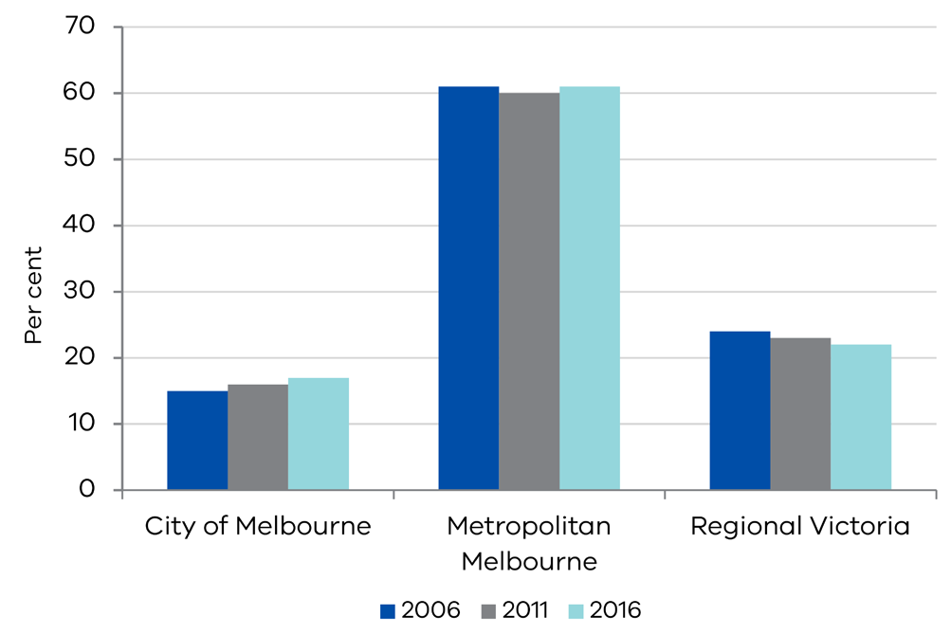

Source: ABS Census 2006 and 2016

Turning to employment between 2006 and 2016, Figure 2 suggests the increase in the number of people employed in the City of Melbourne was greater than in the rest of Melbourne, again indicating an increasing concentration of employment in the CBD for the City of Melbourne. The map in Figure 2 shows the change in the total employment in each LGA in metropolitan Melbourne from 2006 to 2016.

Figure 2. Employment change by LGA in Melbourne, 2006 to 2016

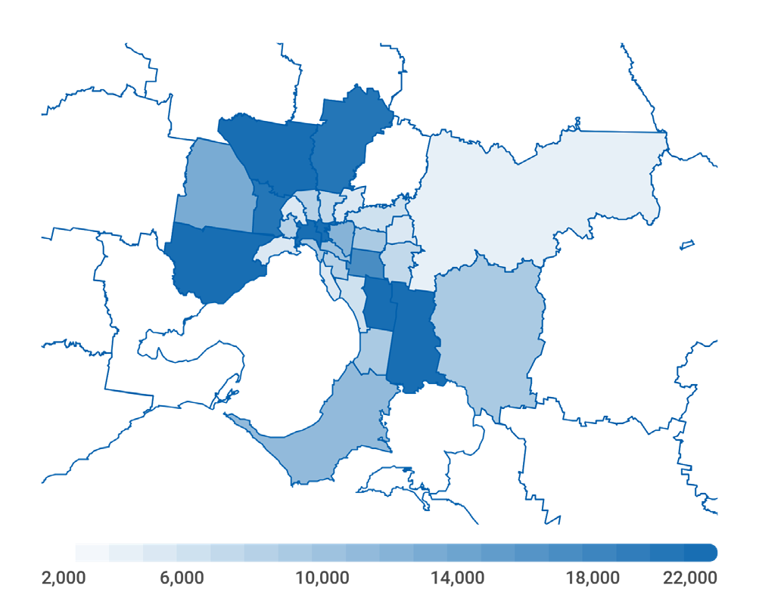

Source: ABS Census 2006 and 2016

Comparing the changes in employment by LGA shown in Figure 2 to Australian Bureau of Statistics (ABS) population data, between 2006 and 2016, suggests the areas that saw large increases in population also experienced large increases in employment. Metropolitan Melbourne’s population increased by nearly 950 000 persons, or 26 per cent, from 2006 to 2016. A noticeable feature of the population data is that the greatest increases in population have occurred in Melbourne’s outer suburbs, more so than for employment. The City of Melbourne had the 2nd highest percentage growth in population from 2006 to 2016, with an increase of 85 per cent. High population growth in metropolitan Melbourne also occurred in LGAs further from the City of Melbourne, such as Wyndham, Melton and Cardinia, where population grew by 98, 76 and 69 per cent respectively over 2006 to 2016.[21]

* + - 1. Composition of skills

The growth of concentrated and large cities has been linked to the presence of skilled workers. Higher skilled workers choose to locate in more densely populated areas, which increases the productivity of those areas. We analyse changes in the location of employment in Melbourne, by skill levels, to see whether this matches what the literature suggests: that increased concentration of economic activity in cities is linked to more high-skilled employment in the inner city.

We define high-skilled occupations as those that have an Australian and New Zealand Standard Classification of Occupations (ANZSCO) skill rating of 1 or 2. These are occupations that require at least a bachelor’s degree education or at least three years’ equivalent experience. Other occupations are defined as those with ANZSCO skill ratings of 3, 4 or 5.

Growth in high-skilled employment, from 2006 to 2016, was higher than for other skill levels. High-skilled employment growth was highest in the City of Melbourne at 5 per cent on average a year, exceeding metropolitan Melbourne (3 per cent), regional Victoria (2 per cent), and the State as a whole (3 per cent).

Figure 3. Growth in employment by skill level, compound annual growth rates, 2006 to 2016

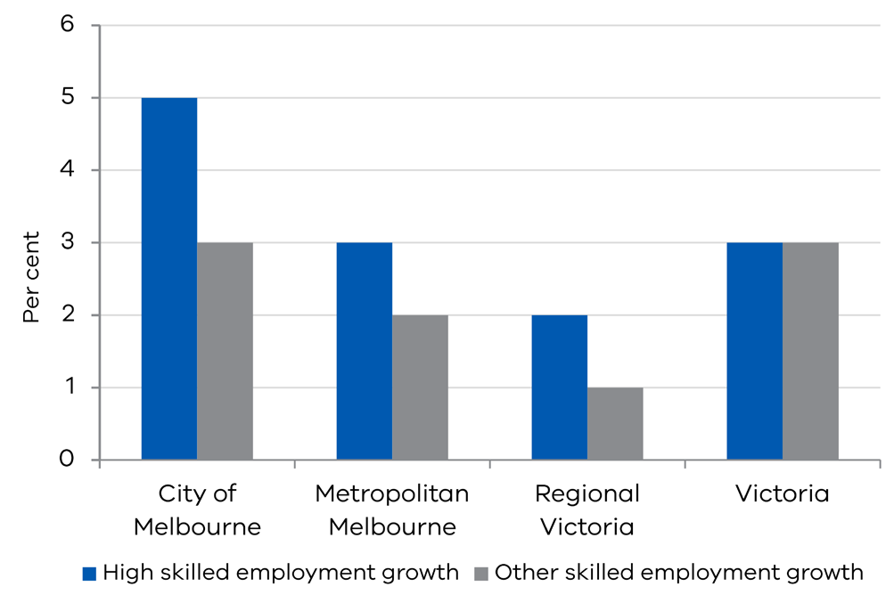

Source: ABS Census, 2006, 2011 and 2016

In comparison to the other areas in metropolitan Melbourne, the City of Melbourne has a greater proportion of high-skilled workers. In fact, the closer an LGA is to the City of Melbourne, measured by travel time, the higher the proportion of workers there are in the highly-skilled categories (as shown in Figure 4).

Figure 4. Proportion of high-skilled employment in 2016 against travel time to CBD for metropolitan LGAs

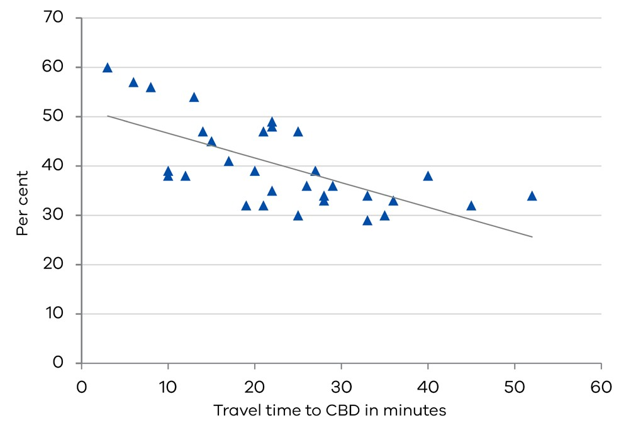

Source: Employment data from ABS Census 2016. Travel time data from DHHS LGA.

As shown in Figure 5, this relationship has remained true over the past decade. The proportion of total employment of high-skilled workers in the City of Melbourne was greater than that of metropolitan Melbourne. The increase in the proportion of high-skilled workers from 2006 to 2016 was also greater in the City of Melbourne than in other regions. Although the magnitude of this result is small, it reinforces the notion from the literature that high-skilled workers ‘sort’ into concentrated cities, perhaps drawn by the improved consumption and employment opportunities and better access to amenities.

Figure 5. Proportion of high-skilled employment by region in 2016

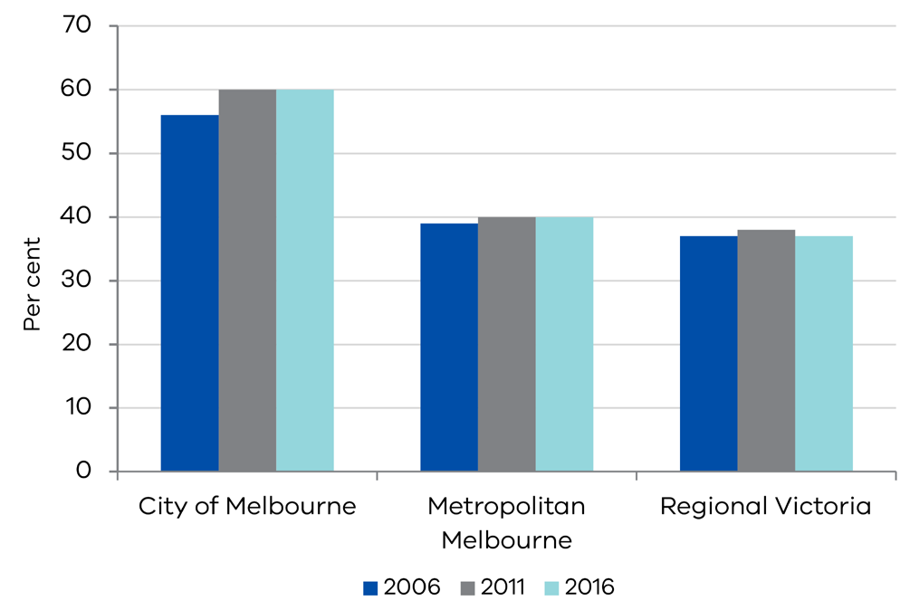

Source: ABS Census, 2006, 2011 and 2016

Our analysis indicates that, on average, locations further from Melbourne’s CBD experienced a slight decrease in the proportion of high-skilled employment opportunities. Regions closer to the CBD however, have tended to experience an increase in the proportion of high-skilled employment over the period.

The analysis between 2006 and 2016 shows that the City of Melbourne has more high-skilled workers than workers with other skill levels. Employment growth over the decade in all regions has also been greater for high-skilled workers. However, locations closer to the City of Melbourne have a much greater proportion of those classified as high-skilled, compared to those areas further away from the CBD. This is consistent with the literature suggesting that a factor determining the growth of concentrated and large cities is the increasing presence of skilled workers. The analysis of employment, population and skills variables suggest that the economic activity of Melbourne is concentrated in the centre of Melbourne.

* + 1. Measuring concentration – effective job density (EJD)

The analysis we have conducted so far however, has not allowed us to discuss the level of concentration specifically with respect to travel times. We can only observe how these variables have changed over time, with respect to physical distance. It does not provide insights around how accessible employment is or the types of employment (for example by skill level) accessed by the population. This access is facilitated through travel, indicating that to assess the concentration of economic activity, we require a measure that captures these variables with respect to travel times.

To measure economic concentration, we present EJD, which incorporates the role travel plays in accessing economic opportunities. Commonly used measures for economic concentration are simple measures of employment density, such as the number of workers per square kilometre in an area. However, such measures do not account for the role travel plays in the concentration of economic activity. This may not represent access to economic opportunity or concentration accurately as, for example someone who lives in an LGA that does not have many jobs within it, but who can quickly reach a nearby LGA that does, still has good access to employment. Conversely, if someone lives geographically near employment centres, they may still have limited access to employment, reflected in long travel times. This can occur due to natural barriers like a river, for example. Therefore, the accessibility of employment relative to travel times plays an important role, as the majority of employment requires physical attendance, which workers access through the transport system.

As such, to measure the concentration of economic activity in small areas in Melbourne, we calculate EJD, which represents employment in an area relative to how long it takes to access employment in all areas in a wider region from that specific area. In other words, the ‘economic mass’ of an area. The EJD of a specific area is measured as the sum of all jobs in each area of the wider region, weighted by the time it takes to travel from the specific area to each other area in the wider region. See Box 1 for further details of our calculation of EJD and the data used.[22]

BOX 1: METHOD FOR CALCULATION OF EFFECTIVE JOB DENSITY

Our measure of EJD is defined as:

$${EJD}_{i}=\sum_{j}^{N}{\left(\frac{{Employment}_{j}}{{Travel time}_{ij}}\right)}$$

where:

* *EJDi* is the effective job density of LGA *i*;
* *N* is the set of all LGAs in Melbourne;
* *Employmenti* is the level of employment in LGA *i*; and
* *Travel Timeij* is the time taken to travel from LGA *i* to LGA *j*.

Figure 6 provides a simple example to illustrate the calculation of EJD. Suppose that a region contains only three areas (A, B and C). To find the EJD of area A, we measure the number of jobs in each area, as well as the time it takes for someone in area A to travel to a job in each area.

Figure 6. A simple example of areas in a region used to estimate EJD

A

B

C

Travel time from A to   
a job in A = 10 minutes

Employment in   
B = 15,000 jobs

Employment in   
C = 20,000 jobs

Employment in   
A = 10,000 jobs

Travel time from A to   
a job in B = 100 minutes

Travel time from A to   
a job in C = 100 minutes

The EJD of A, then, is: ${EJD}_{A}=\frac{Employment in A}{Travel time from A to A}+\frac{Employment in B}{Travel time from A to B}+\frac{Employment in C}{Travel time from A to C}$

For our calculation of EJD, we define the wider region as metropolitan Melbourne and an area as an LGA within Melbourne.

We measure employment in each LGA using data from the ABS Census, 2006 and 2016. We include all employment equally in this measure, including both part-time and full-time employment.

We estimate the time it takes someone to travel from one area in Melbourne to another, using data from TfV VISTA. We average travel times for all people observed travelling between two LGAs in the VISTA survey to calculate EJD. VISTA survey data from 2007 is used as an approximation of travel times for our calculation of EJD for 2006, as 2007 is the earliest year VISTA data is available. Also used is an aggregated dataset of the VISTA survey from 2012 to 2016 to calculate EJD for 2016, to have the largest possible sample size to calculate average travel times.

Our estimates of EJD, mapped for metropolitan Melbourne in 2016 in Figure 7, show that the City of Melbourne had the highest EJD in 2016, and therefore it also has the greatest concentration of employment. The further out the LGA, the lower the concentration of employment was; inner city LGAs had the highest EJD, whereas the areas with the lowest EJD were in outer Melbourne. This shows greater access to employment in Melbourne is linked to proximity to the CBD.

Figure 8 maps employment per square kilometre, by LGA in 2016. Although the broad conclusions drawn are similar, the difference after accounting for travel time becomes apparent when observing individual LGAs.

Only considering employment or employment per square kilometre would also suggest that some areas have little access to employment. However, analysis of EJD reveals that this is not the case – access to employment for these areas is facilitated by travel to nearby LGAs. For example, employment numbers and employment per square kilometre suggest that the Boroondara LGA had less access to employment than the nearby Monash LGA. In terms of standard metrics, Boroondara has the 7th highest employment per square kilometre of all the 31 metropolitan Melbourne LGAs, and the 8th highest employment. This is lower than the Monash LGA (which is the site of a National Employment and Innovation Cluster and where Monash University is located) which is ranked 5th highest in employment per square kilometre and 2nd highest on employment. However, after accounting for travel times in the EJD measure, Boroondara is ranked higher than Monash (4th versus 5th) in terms of access to jobs.

Figure 7. EJD by LGA, 2016

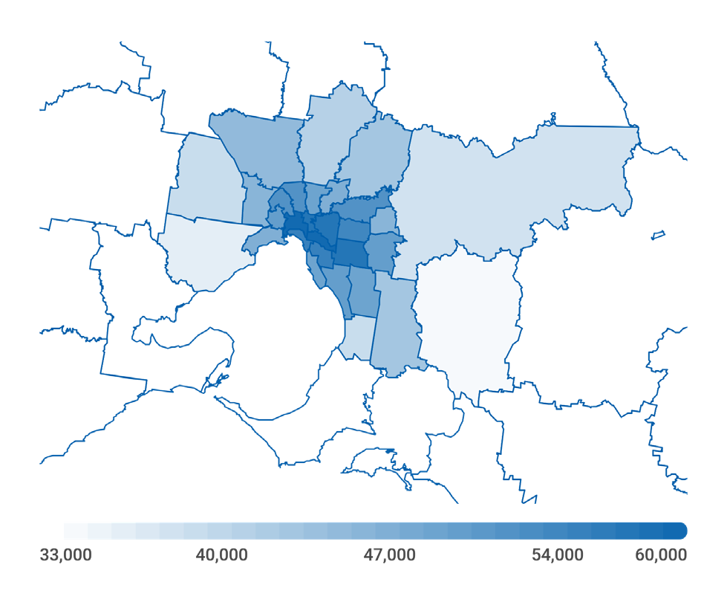

Source: ABS Census 2016 and VISTA 2012-16

Similarly, the nearby LGAs Glen Eira and Stonnington both had higher rankings in EJD than their rankings based on employment per square kilometre or employment within the LGA alone. This reflects that EJD measures the access to all of the jobs within metropolitan Melbourne. For example, being located in Boroondara provides access to the large number of jobs in both the City of Melbourne and Monash LGAs. This presents better overall access relative to being located in Monash. The higher ranking for nearby LGAs Glen Eira and Stonnnington by EJD (compared to employment or employment per square kilometre) also reflects that although employment within these LGAs is not as high, they have good access to LGAs where large numbers of jobs are available, such as in the City of Melbourne or the Monash LGA.

Considering the changes in the levels of EJD from 2006 to 2016, there were large increases in the concentration of employment in inner city LGAs and in some outer metropolitan areas. The greatest increases in the level of EJD from 2006 to 2016 were in the City of Melbourne and in the outer LGAs of Cardinia in the South East and Melton in the west.

Figure 8. Employment per kilometre squared by LGA, 2016

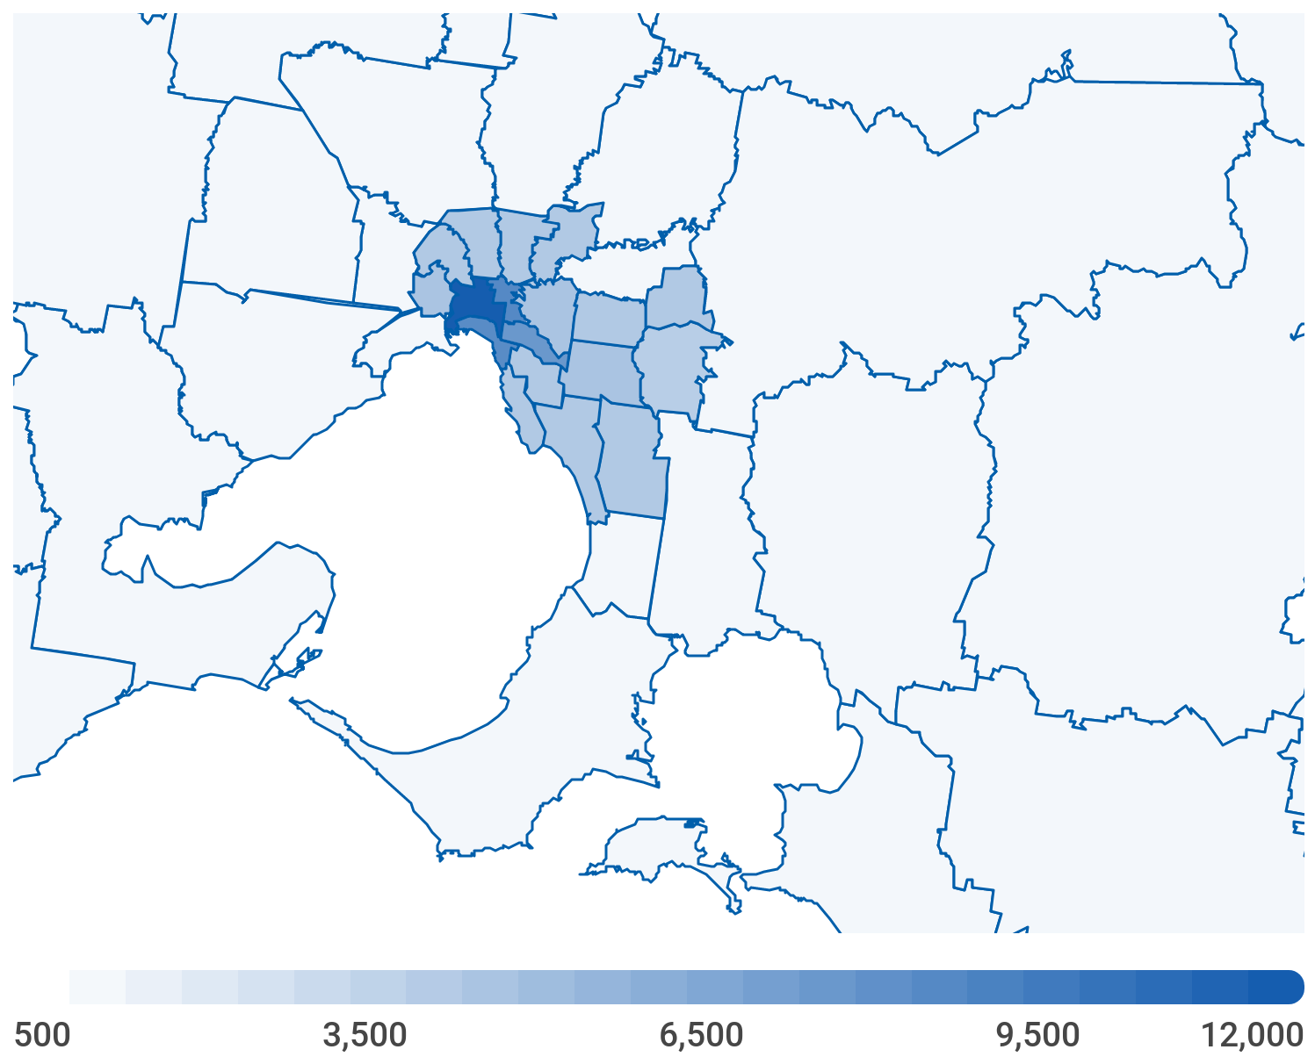

Source: ABS Census 2016

However, considering the percentage change in EJD, presented in Figure 9, the outer LGAs Cardinia and Melton had the highest growth in EJD of all the metropolitan LGAs, with growth of 60 per cent and 52 per cent respectively. Note however, that despite this high growth they remained the LGAs with the two lowest EJDs in 2016. The City of Melbourne, despite having the largest increase in the level of EJD, had a relatively low percentage growth rate of 25 per cent (compared to the average growth of 27 per cent), from 2006 to 2016. Nonetheless, the City of Melbourne remained the LGA with the highest EJD from 2006 to 2016.

The consideration of EJD, which incorporates travel times, challenges the idea that Melbourne’s economy is increasingly becoming concentrated towards the geographic centre, the City of Melbourne. Figure 7 provides a snapshot of what the economic geography currently looks like. It does not however, describe how this is changing over time. Figure 9 shows that although economic activity is concentrated in the centre of Melbourne, between 2006 and 2016, the greatest growth in EJD has been outside of the City of Melbourne.

Comparing the growth of EJD to employment per square kilometre further shows how considering access to employment through travel can provide additional insights. Several areas in metropolitan Melbourne had relatively higher growth in EJD than in employment per square kilometre. Most notably from comparing Figures 9 and 10, LGAs in the south of metropolitan Melbourne. Specifically, the Frankston and Mornington Peninsula LGAs experienced relatively low growth in employment per square kilometre of 27 and 30 per cent respectively, the 16th and 11th highest of the 31 LGAs considered. However, their EJD growth rates were the 5th and 3rd highest respectively with growth rates of 32 and 47 per cent. A similar story is true for LGAs in the inner west: Moonee Valley, Maribyrnong and Hobsons Bay, which had below average (32 per cent) employment per square kilometre growth rates of 18, 27 and 18 per cent respectively, ranking 22nd, 15th and 23rd highest. However, in terms of the EJD, they improved by 29, 32 and 28 per cent respectively, ranked 7th, 6th and 11th highest.

On the other hand, the LGA of Wyndham had a relatively high employment per square kilometre growth of 69 per cent, making it the 2nd highest in terms of employment per square kilometre growth. However, the growth rate of EJD in Wyndham was 14 per cent, the lowest growth rate of all metropolitan LGAs' EJD.

Figure 9. Percentage change in EJD by LGA from 2006 to 2016

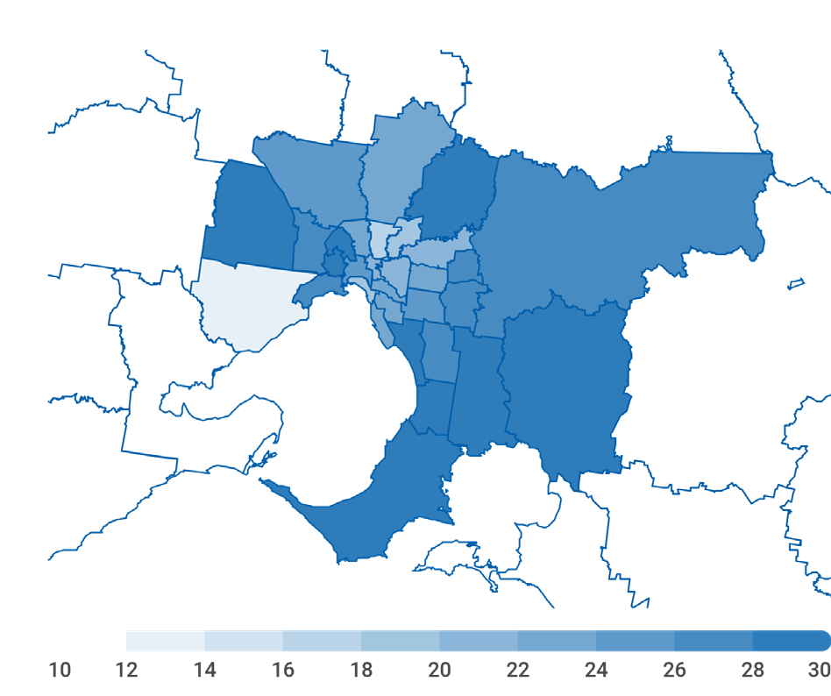

Source: ABS Census 2006 and 2016 and VISTA 2007 and 2012-16

Comparing EJD to population growth in LGAs shows why a measure like EJD can provide a different story to only looking at employment or population. For example, the City of Melbourne, had the 2nd highest population growth of all LGAs, with an increase of 85 per cent from 2006 to 2016. However, the City of Melbourne’s EJD had a slower than average growth rate of 25 per cent from 2006 to 2016, the 16th highest growth rate of the 31 metropolitan LGAs. Therefore, the ratio of EJD to population in the City of Melbourne decreased; and the City added more residents than access to employment.

The Wyndham, Melton and Cardinia LGAs appear to be similar from the population growth perspective. However, taking into account EJD allows for a different interpretation of the data. These LGAs had the highest population growth of all metropolitan LGAs, other than the City of Melbourne, and are all located on the boundary of metropolitan Melbourne and regional Victoria. Melton and Cardinia experienced the highest and 2nd highest growth in EJD along with their high population growth. However, Wyndham, which experienced the highest population growth, had the lowest growth in EJD of all metropolitan LGAs. This means that although many more people live in Wyndham, access to employment did not improve proportionally.

Figure 10. Percentage change employment per square kilometre from 2006 to 2016

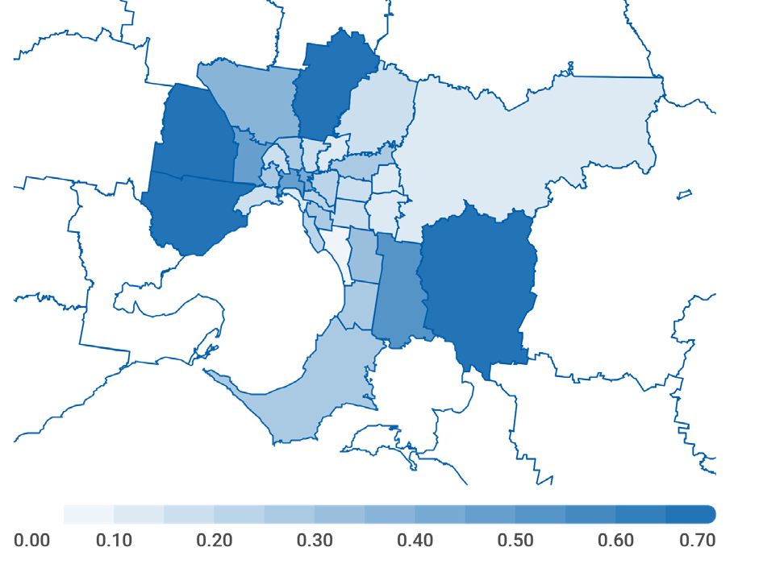

Source: ABS Census 2006 and 2016 and VISTA 2007 and 2012-16

As we have examined, changes in the employment intensity of high-skilled employment in Melbourne may have driven the changes to EJD we have observed. The travel times data currently available from VISTA do not identify what skill level people are employed in. As an approximation of skill level specific EJD, we recalculate EJD as we did before, but instead we replace all employment in an area with only employment in the two skill level groups we have defined. A measure such as EJD, which incorporates travel times, gives a different picture of the access to employment rather than only considering the high or other skilled employment numbers in an LGA.

We find that although there are LGAs that do not have large numbers of high-skilled jobs located within the boundaries of the LGA, many high-skilled jobs are still easily accessible, represented by a large high-skilled EJD. For example, Glen Eira had only the 18th largest number of high-skilled employed within the LGA, however its high-skilled EJD was 7th highest, likely due to its access and proximity to large numbers of high-skilled jobs in nearby LGAs like the City of Melbourne and Monash. On the other hand, Greater Dandenong had the 7th greatest number of high-skilled employed within the LGA, however, its high-skill EJD was only the 17th largest. This may be the case as although there are many high-skilled jobs within the Greater Dandenong LGA, there is lower access to high-skilled jobs in other LGAs, such as those in the City of Melbourne, relative to a place like Glen Eira.

This allows us to make two broad inferences. The first is that the growth of EJD between 2006 and 2016 may be driven by improved access from metropolitan LGAs to the City of Melbourne, or to surrounding LGAs. The second is that this growth may be driven by increases in employment opportunities in metropolitan LGAs, or surrounding regions. Although the purpose of this paper is not to test these inferences, it illustrates how EJD tells a different story around the concentration of economic activity, rather than only considering the population or employment in an area. It also shows the increasing significance of metropolitan Melbourne’s outer suburbs.

* + 1. Conclusion

This article has examined how Melbourne’s economic geography has changed in recent years, and how a measure of economic concentration that incorporates the role of travel such as EJD can better inform this analysis, as opposed to only considering measures like employment and population in isolation. Our analysis of EJD highlights not only where economic activity is concentrated, but more importantly, how easily this activity can be accessed by the people living in Melbourne.

We find that economic activity, as measured by EJD, has generally been concentrated around the City of Melbourne LGA and nearby LGAs. Despite high growth from 2006 to 2016 in EJD in some outer LGAs, the City of Melbourne remained the LGA with the highest access to employment, measured through EJD.

Deeper insights uncovered were, for example, that comparing population growth to EJD revealed some LGAs, like Melton and Cardinia, had both population growth with access to employment, whereas others, such as Wyndham, did not share this experience.

Turning to employment by skills, we find that high-skilled occupations have become more important for metropolitan Melbourne’s economy, which we suggest has had an effect on driving changes to the geographic distribution of work in Melbourne. We note this may have been affected by the global financial crisis, which occurred during our period of analysis. Again, we find that using the measure of EJD in the analysis allowed for a deeper understanding of the data. For example, LGAs like Glen Eira had high access to employment in particular industries, despite not having high employment in these industries within their own LGA boundaries.

With further information on the role travel plays in economic geography, governments are able to make more nuanced decisions when thinking about the economy of place. Potential future infrastructure investments, precinct developments and policies related to housing can all be better informed by thinking about economic geography in a more detailed way.

References

Carlino, G. & Hunt, R. (2009). 'What Explains the Quantity and Quality of Local Inventive Activity?'. Federal Reserve Bank of Philadelphia Working Papers.

Combes, P., Duranton, G. & Gobillon, L. (2008). 'Spatial Wage Disparities: Sorting matters!'. *Journal of Urban Economics,* vol. 63, no. 2, pp. 723–742.

Combes, P., Duranton, G., Gobillon, L., Puga, D. & Roux, S. (2012). 'The Productivity Advantages of Large Cities: Distinguishing Agglomeration from Firm Selection'. *Econometrica,* vol. 80, no. 6, pp. 2543–2594.

Department of Land, Water and Planning. Metropolitan Partnerships. Retrieved fr[om: www.suburbandevelopment.vic.gov.](http://www.suburbandevelopment.vic.gov/) au/partnerships/metropolitan-partnerships, accessed June 2018.

Florida, R. (2002). 'The Economic Geography of Talent'. *Annals of the Association of American Geographers,* vol. 92, no. 4, pp. 743–755.

Fujita, M. & Thisse, J. (2013). 'Economics of Agglomeration: Cities, Industrial Location and Globalisation'. Cambridge, Cambridge University Press.

Glaeser, E. & Resseger M. (2009). 'The Complementarity Between Cities and Skills'. NBER Working Paper Series, Working Paper 15103.

Glaeser, E., Saiz A., Burtless, G. & Strange, W. (2004). 'The Rise of the Skilled City'. *Brookings-Wharton Papers on Urban Affairs,* pp. 47–105.

Glaeser, E. & Gottlieb, J. (2009). 'The Wealth of Cities: Agglomeration Economies and Spatial Equilibrium in the United States'. *Journal of Economic Literature,* vol. 47, no. 4, pp. 983–1028.

Glaeser, E. (1998). 'Are Cities Dying?'. *The Journal of Economic Perspectives*, vol. 12, no. 2, pp. 139–160.

Glaeser, E., Gyourko, J. & Saks, R. (2006). 'Urban Growth and Housing Supply'. *Journal of Economic Geography,* vol. 6, no. 1, pp. 71–89.

Gordon, P. & Richardson, H. (1997). 'Are Compact Cities a Desirable Planning Goal?'. *Journal of the American Planning Association,* vol. 63, no. 1, pp. 95–106.

Graham, D. (2007). 'Agglomeration, Productivity and Transport Investment'. *Journal of Transport Economics and Policy*, vol. 41, no. 3, pp. 317–343.

Hanson, G. (2005). 'Market Potential, Increasing Returns and Geographic Concentration'. *Journal of International Economics,* vol. 67, no. 1, pp. 1–24.

Helsley, R. & Strange, W. (1990). 'Matching and Agglomeration Economies in a System of Cities'. *Regional Science and Urban Economics*, vol. 20, no. 2, pp. 189–212.

Henderson, J. (1975). 'Congestion and Optimum City Size'. *Journal of Urban Economics*, vol. 2, pp. 48–62.

Krugman, P. (1991). 'Increasing Returns and Economic Geography'. *Journal of Political Economy*, vol. 99, pp. 483–499.

Lakshmanan, T. (2007). 'The Wider Economic Benefits of Transportation: An Overview'. *OECD International Transport Forum*, Joint Transport Research Centre Discussion Paper, no. 2007-8.

Lin, J. (2011). 'Urban Productivity Advantages from Job Search and Matching'. Federal Reserve Bank of Philadelphia, Business Review Q1 2011.

Melo, P. Graham, D. & Noland, R. (2009). 'A Meta-Analysis of Estimates of Urban Agglomeration Economies'. *Regional Science and Urban Economics*, vol. 39, no. 3, pp. 332–342.

Rauch, J. (1993). 'Productivity Gains from Geographic Concentration of Human Capital: Evidence from Cities'. *Journal of Urban Economics*, vol. 34, pp. 380–400.

Rawnsley, T. & Szafraneic, J. (2010). 'Agglomeration and Labour Productivity in Australian Cities'. SGS Economics and Planning.

Rawnsley, T., Finney, B. & Szafraneic J. (2011). 'Riding the Smart Bus: Knowledge Workers, Agglomeration Economies and Public Transport Use'. SGS Economics and Planning, AITMP 2011 National Conference Paper.

SGS Economics and Planning. (2012). 'Productivity and Agglomeration Benefits in Australian Capital Cities'. COAG Reform Council Final Report.

Shapiro, J. (2006). 'Smart Cities: Quality of Life, Productivity, and the Growth Effects of Human Capital'. *The Review of Economics and Statistics*, vol. 88, no. 2,   
pp. 324–335.

Spiller, M. (2012). 'Measuring and Capturing the Value From Metropolitan Planning: Lessons from Melbourne and Dublin'. SGS Economics and Planning Occasional Paper.

Tolley, G. (1974). 'The Welfare Economics of City Bigness'. *Journal of Urban Economics*, vol. 1, pp. 324–45.

The role of household debt in national consumption[23]

### By Siroos Khademalomoom and Maryam Nasiri

ABSTRACT

Household consumption is the most significant component of economic activity in Australia and Victoria. This paper explores the relationship between household debt and national consumption by developing a new modelling framework that introduces financial variables. The paper examines the key determinants of consumption, as suggested in the literature, and compares alternative forecasting models. Using a vector auto-regression (VAR) framework, the forecasting performance of models using traditional variables such as compensation of employees, household net worth and mortgage interest rates is compared with an alternative approach, which includes total credit outstanding, mortgage interest rates and two components of consumer sentiment. In addition to finding a role for consumer sentiment, we find household debt is important for forecasting Australian consumption dynamics and is more important than either net worth or household assets, which have been emphasised in previous studies. This modelling framework lends itself to testing the sensitivity of consumption to changes in interest rates and credit outstanding over the past three decades. The analysis shows the sensitivity of consumption to a change in interest rates has decreased over time, even though debt to income ratios have continued to increase.

Overview

Growth in household consumption is an important component of economic activity nationally and in Victoria. Making up almost two-thirds of gross domestic product, consumption growth matters for living standards and household welfare, and represents a driver of demand for the broader economy. This paper explores ways to improve consumption forecasts at the national level by identifying changes in the economic environment to which consumption is most sensitive.

The empirical relationship between wealth, income and consumption has been widely studied. Earlier studies, such as Campbell and Mankiw (1989), discuss that expected changes in (current and permanent) income are associated with expected changes in consumption. However, more recent studies debate the link between income, wealth and consumption. Lettau and Ludvigson (2004) argue transitory shocks in wealth are unrelated to aggregate consumer spending, contemporaneously and at any future date. Although permanent changes in wealth do affect consumer spending, most changes in wealth are transitory and are uncorrelated with consumption. Applying a similar methodology to Australian data, Fisher, Otto, and Voss (2010) argue fluctuations in house prices and any associated wealth effects do not appear to have a significant effect on the consumption path chosen by Australian households.

The relationship between household debt and consumption has received less attention. Atalay, Whelan, and Yates (2017) is among the few studies that suggest household debt and consumption are correlated, both before and after the global financial crisis. These authors argue that recent concerns about economic and financial stability raise questions about the ongoing impact of housing wealth on consumption in light of associated increases in household debt.

With a number of countries experiencing household deleveraging after the global financial crisis, attention has focused increasingly on the impact of debt on consumption. For example, Kaplan, Violante, and Weidner (2014) presents a theoretical rationale for a correlation between consumption and debt – ‘the wealthy hand-to- mouth’ – and build on earlier evidence provided by Misra and Surico (2013) and Johnson, Parker, and Souleles (2006), who find that households with high mortgage debt are likely to be particularly sensitive to transitory income shocks. In a different, but not unrelated vein, Wong (2018) argues the transmission of monetary policy is strongest through younger, more indebted households, than through older households with less debt and higher assets.

Considering the importance of real estate and mortgage debt to Australian household balance sheets and the impact of highly indebted households on financial stability, we investigate whether debt dynamics are a useful variable in forecasting consumption. Figure 1a provides support for this hypothesis as the share of households’ debt to disposable income has been rising in recent years. With it, the role it plays is likely to have become more prominent as well.

With a rising household debt service ratio (DSR) illustrated in Figure 1b, a greater share of income will need to be redirected towards servicing household debt at the expense of consumption.[24]

Analysis by the Reserve Bank of Australia (RBA) in the Financial Stability Review - April 2017, based on HILDA survey data, shows the increasing level of debt is due to households becoming more leveraged between 2002 and 2014.[25] This is concentrated in high-income households, which provides some empirical support for the rationale put forth in Kaplan, Violante and Weidner (2014).

In terms of owner-occupiers, Simon and Stone (2017) finds debt as a share of income is considerably higher for first home buyers relative to all other indebted owner-occupiers. As the DSR continues to be elevated during a period of historically low interest rates, any interest rate increases could create a higher financial burden for these households and affect their consumption behaviour. This further reinforces the connection between debt and consumption.

Therefore, with regards to the rising debt to income and DSRs, an important question to ask is whether debt plays a prominent role in explaining household consumption changes. We examined this question and found household debt can predict consumption dynamics better than household assets or net worth.

Figure 1: Households' debt indicators

Figure 1a: Debt to disposable income Figure 1b: Debt service ratio

##### DecorativeDecorative

Source: DTF calculation based on the Australian Bureau of   
Statistics data Source: Bank for International Settlements (BIS)

The role of debt on national consumption has been explored within a vector auto-aggressive (VAR) framework in two ways: first, by analysing the stability of the coefficients in the consumption equation to ascertain if there is any reduced-form evidence that the propagation of shocks on consumption may have changed (timing of the consumption response); second, by analysing whether there has been any obvious change in the impulse response functions to unanticipated changes in interest rates (magnitude of the consumption response).

Focusing on the stability of the consumption equation, there is reduced-form evidence that consumption now responds more quickly to economic shocks, at least when measured according to a rising value of the first autoregressive coefficient and a declining value on the second autoregressive coefficient. While providing only summary evidence, it does suggest consumption dynamics have become less persistent, and so consumption now changes more quickly in response to economic shocks.

A similar pattern is borne out for the coefficients on the forward-looking component of consumer sentiment. Including family finances over the next 12 months as an additional explanatory variable (see for instance, Carroll et al., 1994; Acemoglu and Scott, 1994; Howrey, 2001; Slacalek, 2004), the first autoregressive coefficient on this variable has also increased over the past decade, suggesting households’ consumption decisions may becoming more responsive to near-term changes in households’ views about their own finances. In contrast, a backward-looking measure of sentiment, family finances over the past 12 months, appears to have become less important for explaining changes in consumption growth.

While theory would suggest rising household debt, relative to other economic aggregates, such as household income, could increase the sensitivity of consumption to unanticipated changes in interest rates, we do not find clear evidence to support this hypothesis. Using a standard approach to identify monetary policy shocks, we find that relative to the past, consumption now responds by less to unanticipated changes in interest rates. Even though consumption may be more sensitive to interest rate changes as household debt levels rise, it is possible this dynamic is offset by more predictable monetary policy associated with inflation targeting.

This paper augments a growing literature on the importance of debt in understanding consumption dynamics and the transmission of monetary policy. It also highlights that some measures of consumer sentiment, in particular family finances, can be useful when forecasting changes in consumption. The rest of the paper is set out as follows: in Section 1, we describe the data used in this study; in Section 2, we discuss the variables we consider as the key determinants of consumption, and then we focus on the specification and evaluation of a forecasting model. In Section 3, we investigate whether consumption is sensitive to changes in credit outstanding or interest rate changes. The final section concludes the paper with a short summary of key findings.

* + 1. Data

Descriptions of the variables used in this paper, sourced from the Australian Bureau of Statistics (ABS), the RBA and Westpac – Melbourne Institute (WMI), are as follows:

## Household final consumption expenditure

Household final consumption expenditure (HFCE) measures current expenditure by households and non-profit institutions providing services to households. HFCE is a large aggregate covering a wide range of goods and services. This excludes expenditure by unincorporated businesses and expenditure on assets by non-profit institutions (included in gross fixed capital formation). Also excluded is expenditure on the maintenance of dwellings (treated as intermediate expenses of private enterprises), but personal expenditure on motor vehicles and other durable goods and the imputed rent of owner-occupied dwellings are included. The value of 'backyard' production (including food produced and consumed on farms) is included in household final consumption expenditure, and the payment of wages and salaries in kind (e.g. food and lodging supplied free to employees) is counted in both household income and household final consumption expenditure. Data on HFCE is obtainable from the ABS catalogue number 5206.0.

## Credit outstanding

Credit outstanding represents debt funding provided by domestic financial intermediaries to the domestic private non-financial sector in the form of loans and securities. Data on credit outstanding can be obtained from the RBA.

## Consumer sentiment

The Consumer Sentiment Index is the product of five component indexes, which reflect consumers' evaluations of their household financial situation over the past year and the coming year, anticipated economic conditions over the coming year and the next five years, and buying conditions for major household items. Data on consumer sentiment is obtainable from the WMI.

## Compensation of employees (COE)

This represents total remuneration, in cash or in kind, payable by an enterprise to an employee in return for work done by the employee during the accounting period. It is further classified into two sub components: wages and salaries; and employers’ social contributions. Compensation of employees is not payable in respect of unpaid work undertaken voluntarily, including the work done by members of a household within an unincorporated enterprise owned by the same household. Compensation of employees excludes any taxes payable by the employer on the wage and salary bill (e.g. payroll tax). Data on COE is obtainable from the ABS catalogue number 5206.0.

## Household net worth

Australian household net worth is calculated as the difference between Australian household assets and liabilities. Data on Australian household assets and liabilities are obtainable from the RBA.

## Mortgage rate

The mortgage rate is the average standard variable loan rate set by Australia’s largest banks. The standard variable loan rate, and the detailed methodology, is obtainable from the RBA. Figure 2 compares growth of household consumption, credit outstanding and net household worth in real terms.

Figure 2: Real household consumption, credit outstanding and net worth (% growth)

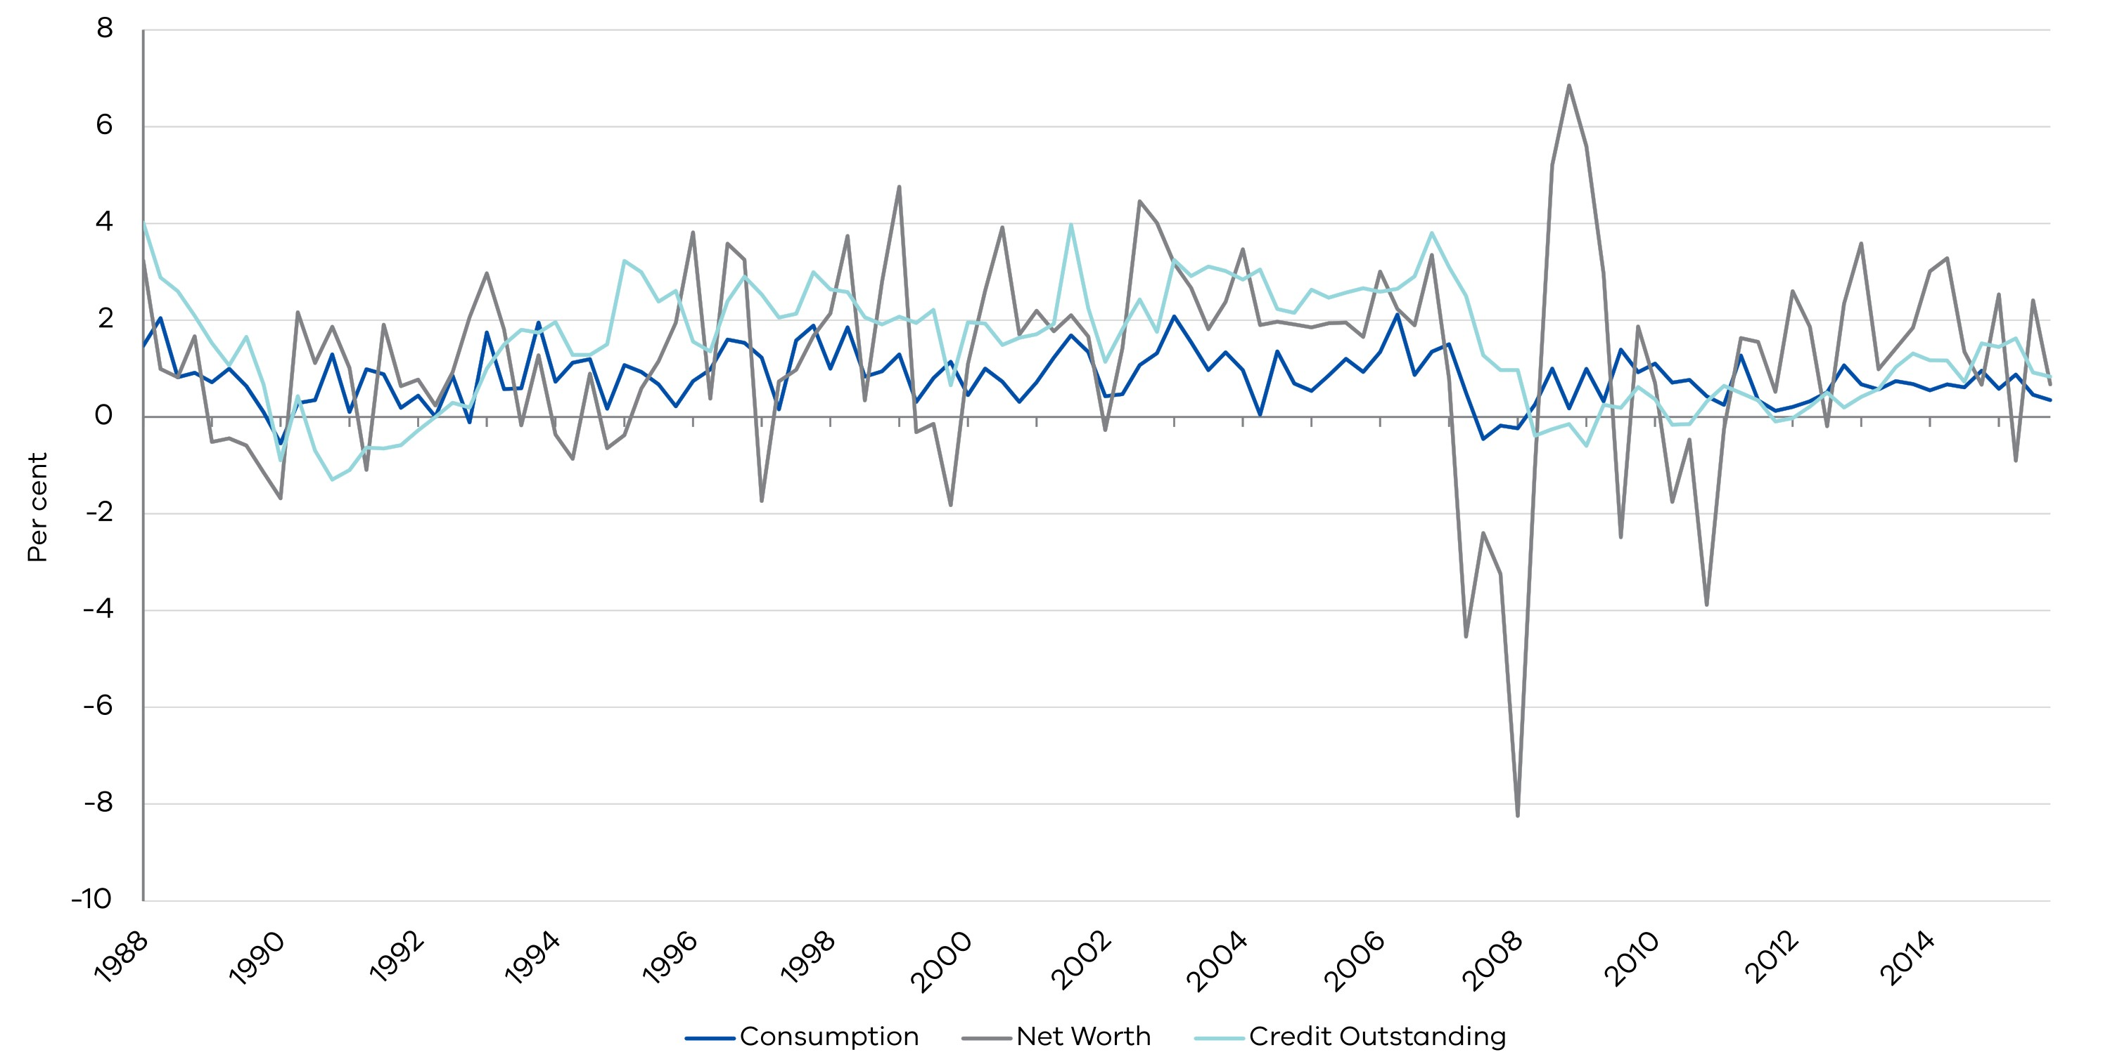

* + 1. Forecasting household consumption

A range of approaches have been used to forecast aggregate consumption growth. These include single error- correction models motivated by economic theory (Campbell and Mankiw, 1989), vector error-correction models that additionally emphasise the role of wealth and human capital (Lettau and Ludvigson, 2004), and models that attempt to include measures of expectations about future economic conditions or income (Slacalek, 2004).

We focus on forecasting performance using a small- dimension VAR model.[26] The VAR group of models can span a large set of models proposed in academic literature, while remaining agnostic about underlying economic behaviour to a certain extent. They are also consistent with common identification assumptions used to quantify the relationship between income, wealth and consumption.

* + - 1. Determinants of the consumption

We test different sets of economic variables (including measures of income, wealth, debt, consumer sentiment, interest rates and a range of other macroeconomic indicators thought to be correlated with consumption) and different sample periods to identify the main determining factors of consumption. Based on the literature, 41 variables ranging from macroeconomic to household indicators, were tested in a VAR model using different specifications and sample periods. Our results indicate credit outstanding (*CO*), family finance over the past 12 months (*FFL12*), family finance over the next 12 months (*FFN12*), and mortgage interest rates (*MORT*) perform best for predicting household consumption.

* + - 1. Model specification

VARs are commonly used for forecasting systems of interrelated time series, treating each endogenous variable as a function of the lagged values of all endogenous variables in the system. In this paper, we adopt a VAR framework to forecast consumption in Australia. Our dataset consists of 130 observations from 1985 Q3 to 2017 Q4.

* + - 1. Model evaluation

In this section, we evaluate the forecasting performance of the new model in two steps. Initially, we compare the forecasting performance of the traditional determinants of consumption such as compensation of employees (*COE*), household net worth (*HNW*) and the mortgage rate (*MORT*) with our new VAR model, which includes *CO*, *MORT*, *FFL12* and *FFN12* as the determinants of consumption. Following that, we investigate the performance of the new VAR and the model proposed by Slacalek (2004). Slacalek’s model forecasts consumption using the cash rate, unemployment rate, inflation, the spread between three-month Treasury Bills and 10-year government bonds, and overall consumer sentiment.

To evaluate the forecasting performance of the traditional and proposed models, we use 10 sets of four-year out-of- sample periods (i.e. 2003 Q3–2007 Q2 to 2012   
Q3–2016 Q2).[27] Results are presented in Table 1. We consider the root mean square error (RMSE) and average mean absolute error (MAE) to compare the performance of the models. The MAE for consumption growth based on the new model is 0.86 as opposed to 2.49 for MAE of the traditional model. This means the new model significantly outperforms the traditional model with less forecasting error. On average, over a four- year horizon, the new model predicts consumption with an estimation error of around $14 billion, while the estimation error in the traditional model is more than $40 billion. We conclude that the new variables provide important information for forecasting consumption.

BOX 1: SPECIFICATION OF VAR MODEL

The general specification of the VAR model is as follows:[28]

where is a $n×1$ vector of endogenous variables, $β_{i}$ are the $1×n$ parameter vectors assigned to each lag in the VAR, and $μ_{t}$ is the residual vector that is independently and identically distributed with zero mean and constant variance $σ_{μ}$.

$α=\left[\begin{matrix}α_{1} \\ ⋮ \\ α_{5}\end{matrix}\right]$; $β_{m}=\left[\begin{matrix}β_{1,1,m} & ⋯ & β_{1,5,m} \\ ⋮ & ⋱ & ⋮ \\ β_{5,1,m} & ⋯ & β_{5,5,m}\end{matrix}\right]$, $m=\left\{1,2,…,p\right\}$;

$$Y_{t-p}={\left[HFCE,CO, MORT, FFL12, FFN12\right]}^{'}$$

$μ_{t}=\left[\begin{matrix}μ_{1t} \\ ⋮ \\ μ_{5t}\end{matrix}\right]$; $μ_{t}\sim iid\left(0,σ_{μ}\right)$;

Table 1. Forecasting evaluation (Traditional vs. Preferred)

|  |  |  |  |
| --- | --- | --- | --- |
| OUT-OF-SAMPLE PERIOD | FORECAST EVALUATION MEASURES | TRADITIONAL MODEL *COE+HNW+MORT* | PREFERRED MODEL *CO+FFL12+FFN12+MORT* |
| 2003 Q3 – 2007 Q2 | RMSE | 2.83 | 0.72 |
| MAE | 2.75 | 0.62 |
| 2004 Q3 – 2008 Q2 | RMSE | 3.89 | 0.82 |
| MAE | 3.70 | 0.65 |
| 2005 Q3 – 2009 Q2 | RMSE | 5.16 | 0.88 |
| MAE | 4.94 | 0.68 |
| 2006 Q3 – 2010 Q2 | RMSE | 4.49 | 1.23 |
| MAE | 4.34 | 0.99 |
| 2007 Q3 – 2011 Q2 | RMSE | 3.86 | 1.91 |
| MAE | 3.80 | 1.79 |
| 2008 Q3 – 2012 Q2 | RMSE | 2.58 | 1.81 |
| MAE | 2.50 | 1.26 |
| 2009 Q3 – 2013 Q2 | RMSE | 0.42 | 0.74 |
| MAE | 0.40 | 0.63 |
| 2010 Q3 – 2014 Q2 | RMSE | 1.13 | 0.97 |
| MAE | 0.95 | 0.71 |
| 2011 Q3 – 2015 Q2 | RMSE | 1.07 | 0.89 |
| MAE | 0.91 | 0.78 |
| 2012 Q3 – 2016 Q2 | RMSE | 0.75 | 0.66 |
| MAE | 0.62 | 0.51 |
| Average |  | 2.49 | 0.86 |

Source: Department of Treasury and Finance

Next, we compare the forecasting performance of the preferred VAR with the forecasting model proposed by Slacalek (2004). In addition to comparing the RMSE and MAE based on multi-step ahead forecasts, we also use the Diebold and Mariano (1995) test (DM) with one-step ahead forecasts. This helps us evaluate the short-run and long-run performance of the models. Results are presented in Table 2. A positive DM-Test statistic signifies larger forecasting errors for Slacalek’s model compared with the preferred VAR, while a negative DM-Test statistic indicates the opposite.

According to the RMSE, MAE and DM test statistics, the forecasting error of Slacalek’s model is significantly higher than that of the preferred VAR, suggesting the new model outperforms Slacalek’s model in terms of forecasting accuracy.[29]

| OUT-OF-SAMPLE PERIOD | FORECAST EVALUATION MEASURES | SLACALEK'S (2004) MODEL | PREFERRED MODEL |
| --- | --- | --- | --- |
| 2003 Q3 – 2007 Q3 | RMSE | 7.10 | 1.27 |
| MAE | 6.27 | 1.06 |
| DM | 6.60 | |
| (p-value) | 0.00 | |
| 2004 Q3 – 2008 Q3 | RMSE | 3.72 | 3.01 |
| MAE | 2.68 | 2.73 |
| DM | 8.44 | |
| (p-value) | 0.00 | |
| 2005 Q3 – 2009 Q3 | RMSE | 5.48 | 2.77 |
| MAE | 4.63 | 2.02 |
| DM | 9.98 | |
| (p-value) | 0.00 | |
| 2006 Q3 – 2010 Q3 | RMSE | 4.12 | 3.27 |
| MAE | 3.33 | 2.78 |
| DM | 12.84 | |
| (p-value) | 0.00 | |
| 2007 Q3 – 2011 Q3 | RMSE | 4.22 | 4.62 |
| MAE | 3.70 | 3.77 |
| DM | 18.86 | |
| (p-value) | 0.00 | |
| 2008 Q3 – 2012 Q3 | RMSE | 6.27 | 4.41 |
| MAE | 5.70 | 3.96 |
| DM | 14.31 | |
| (p-value) | 0.00 | |
| 2009 Q3 – 2013 Q3 | RMSE | 10.50 | 7.07 |
| MAE | 9.40 | 5.92 |
| DM | 9.20 | |
| (p-value) | 0.00 | |
| 2010 Q3 – 2014 Q3 | RMSE | 3.48 | 9.42 |
| MAE | 2.59 | 8.56 |
| DM | 5.42 | |
| (p-value) | 0.00 | |
| 2011 Q3 – 2015 Q3 | RMSE | 3.54 | 6.67 |
| MAE | 3.04 | 6.00 |
| DM | 9.13 | |
| (p-value) | 0.00 | |
| 2012 Q3 – 2016 Q3 | RMSE | 3.77 | 2.75 |
| MAE | 3.60 | 2.30 |
| DM | 9.18 | |
| (p-value) | 0.00 | |
| **Average RMSE** |  | **5.22** | **4.53** |
| Average MAE |  | 4.50 | 3.91 |

Source: Department of Treasury and Finance

Lastly, we compare the explanatory power of debt as opposed to household net worth to investigate whether household debt dynamics are relatively more important for forecasting consumption than net worth, which also contains information on household assets. Here, we replace credit outstanding with household net worth in the proposed model. Results presented in Table 3 confirm that household debt performs better, explaining variations in national household consumption more accurately than net household worth.

Table 3. Forecasting evaluation (Debt vs. Net Worth)[30]

|  |  |  |  |
| --- | --- | --- | --- |
| OUT-OF-SAMPLE PERIOD | FORECAST EVALUATION MEASURES | MODEL WITH HNW  (HNW+FFL12+FFN12+MORT) | PROPOSED MODEL (CO+FFL12+FFN12+MORT) |
| 2003 Q3 – 2007 Q2 | RMSE | 9.60 | 3.64 |
| MAE | 8.24 | 3.33 |
| 2004 Q3 – 2008 Q2 | RMSE | 2.78 | 1.66 |
| MAE | 2.29 | 1.28 |
| 2005 Q3 – 2009 Q2 | RMSE | 2.62 | 3.15 |
| MAE | 2.38 | 2.70 |
| 2006 Q3 – 2010 Q2 | RMSE | 4.50 | 3.92 |
| MAE | 4.05 | 2.85 |
| 2007 Q3 – 2011 Q2 | RMSE | 9.47 | 8.43 |
| MAE | 8.35 | 7.42 |
| 2008 Q3 – 2012 Q2 | RMSE | 1.10 | 2.40 |
| MAE | 0.87 | 2.18 |
| 2009 Q3 – 2013 Q2 | RMSE | 7.69 | 4.73 |
| MAE | 5.22 | 3.39 |
| 2010 Q3 – 2014 Q2 | RMSE | 3.53 | 4.60 |
| MAE | 2.97 | 3.87 |
| 2011 Q3 – 2015 Q2 | RMSE | 2.22 | 3.48 |
| MAE | 1.74 | 3.09 |
| 2012 Q3 – 2016 Q2 | RMSE | 4.08 | 3.67 |
| MAE | 3.61 | 2.59 |
| Average (MAE) |  | 3.98 | 3.27 |

Source: Department of Treasury and Finance

* + 1. The role of debt dynamics for consumer sensitivity

One of the most interesting findings we came across when developing this forecasting model for consumption in the Australian context, is that household debt appears to be correlated more with consumption growth than measures of either household assets or net worth. This has traditionally been the focus of earlier theoretical and empirical work.

One explanation for this could be that when compared with other advanced economies, Australian households tend to hold a higher concentration of their wealth in housing, against which most household debt is secured. Figure 3 shows Australia is in the top quartile among Organisation for Economic Cooperation and Development (OECD) countries in terms of debt to income ratios. Combined with the idea that households with higher leverage (or debt) may be more sensitive to changes in economic conditions, and that housing debt as a share of income has been rising steadily in Australia in recent decades, we explore whether there is any evidence to suggest sensitivity of consumption to interest rate or credit outstanding changes has increased over time.[31]

This hypothesis is first explored through the parameter stability of the coefficients in the consumption equation and whether these coefficients have changed over time. The second approach is to actually recast the model as a structural VAR and identify whether the effects of unanticipated changes in interest rates (RBA cash rate) on consumption have changed.

Figure 3: Household debt as a share of net disposable income in OECD countries

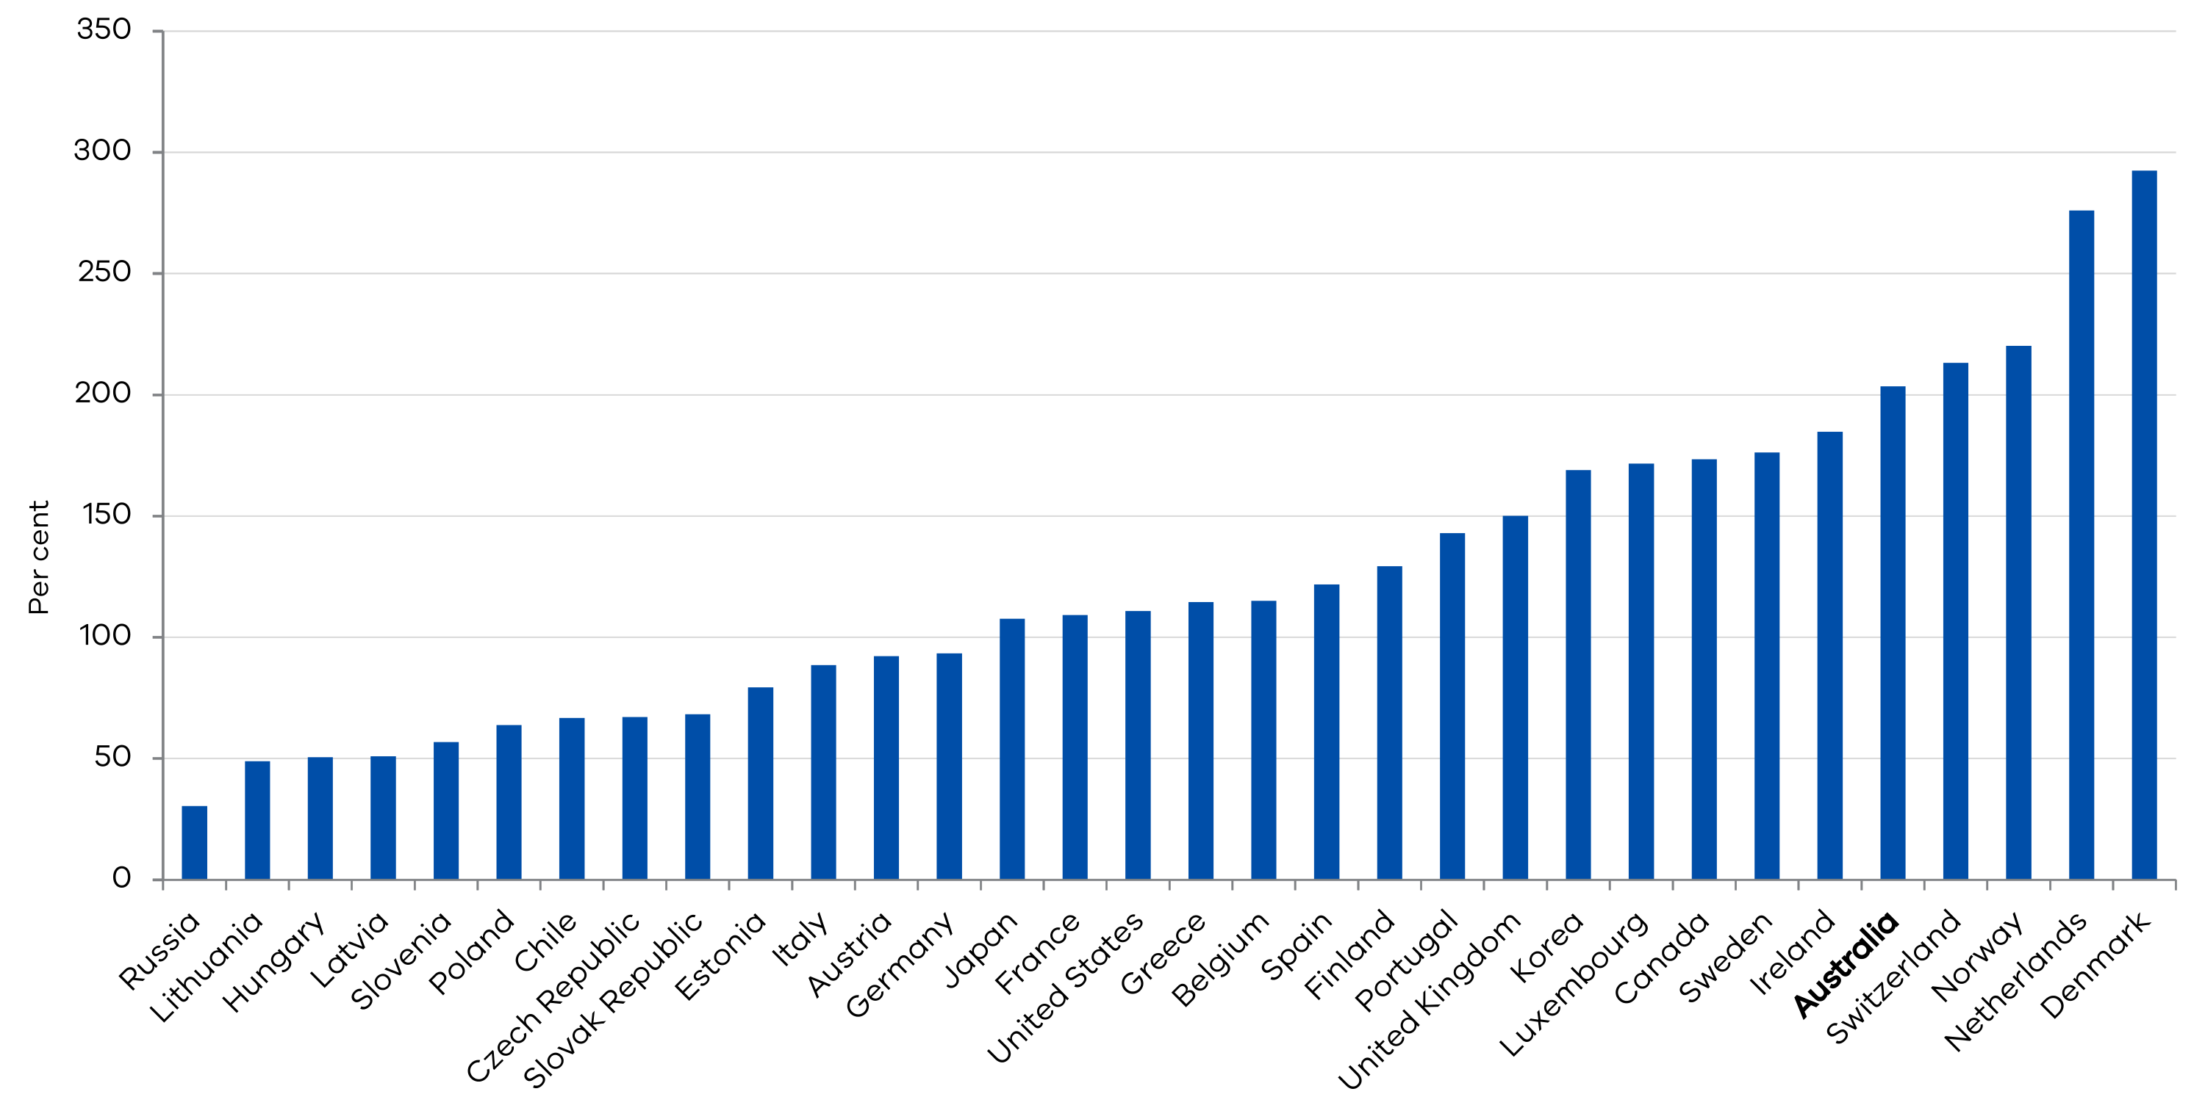

Source: OECD (2018), Household debt (indicator)

* + - 1. Parameter stability analysis

In this section we initially investigate the stability of the coefficients for variables in the proposed model and see whether these coefficients have changed over time. Preliminary results show the coefficient of the first lag has increased over time going from -0.08 in 1988 to +0.8 in 2017, while the coefficient on the second lag has decreased from +1.5 in 1988 to +0.1 in 2017 in Figure 4. This suggests consumption now appears to respond more quickly to shocks than it has in the past, noting the degree of persistence in the consumption autoregressive coefficients has declined.

Panel A in Figure 5 reveals that households have become less backward-looking with the estimated coefficient on the first lag of family finances over the previous 12 months, declining in value since 2005. Moreover, the estimated coefficient on the first lag of family finances over the next 12 months has been rising since 2005 (see Panel B in Figure 5). This is consistent with consumption becoming more responsive to changes in expected future conditions. The reasons behind households’ behaviour towards their family finance are not clear at this stage and more investigation is needed in future studies.

Figure 4: Recursive coefficient estimates

Panel A – First lag of consumption Panel B – Second lag of consumption

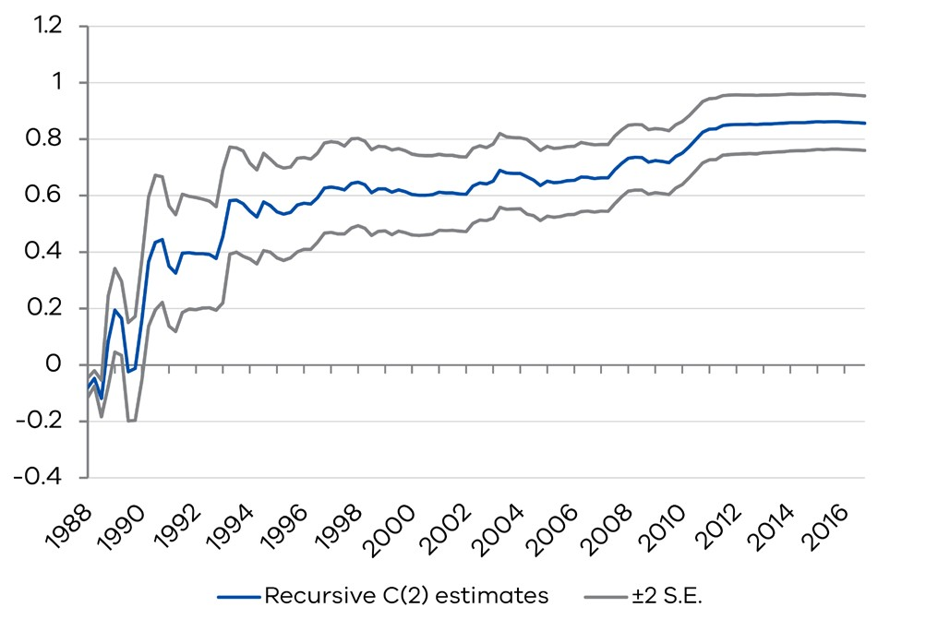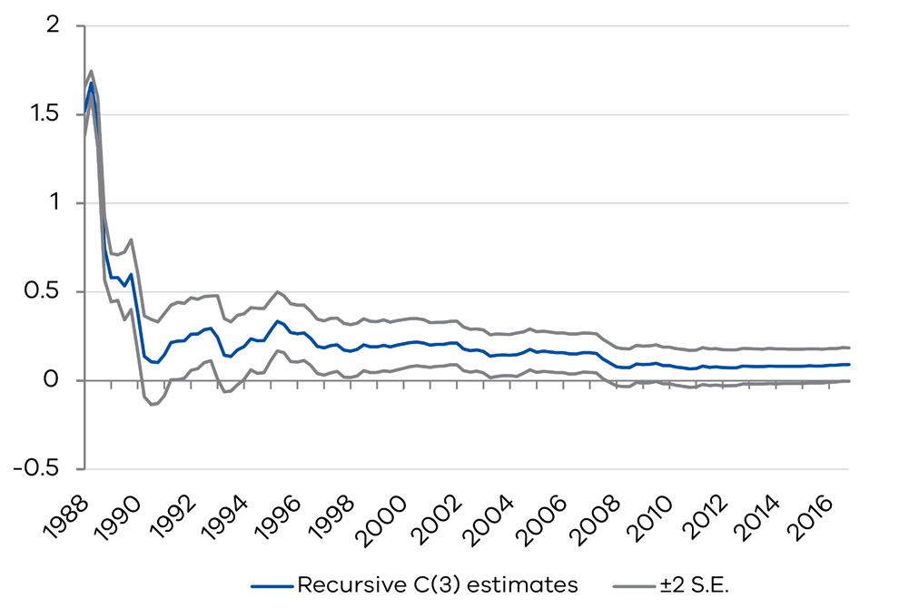

Figure 5: Recursive coefficient estimates

Panel A – First lag of family finances Panel B – First lag of family finances   
 over the previous 12 months over the next 12 months

##### DecorativeDecorative

* + - 1. Sensitivity of consumption to interest rate changes

Notwithstanding, there is weak evidence that household consumption has become more sensitive to interest rate changes. The full sample responses, based on a Choleski shock ordering where interest rates are ordered last, indicate consumption declines in response to higher interest rates (Figure 6). Ordering the variables this way is a standard approach in the literature to identify unanticipated changes in interest rates. However, when breaking the results into roughly equi proportionate sub-samples, household consumption may have become less sensitive to interest rate changes.[32]

As Figure 7 shows, the response of consumption to the shock in the interest rate (measured by one standard deviation change in the RBA official cash rate) is less in the period between 2001-2017 relative to the period between 1985-2000. One possible explanation of the decrease in the sensitivity to interest rate changes found so far is that the increased predictability of monetary policy from an anchoring of inflation expectations could be dominating any increase in the sensitivity of consumption to interest rates associated with higher levels of household debt. This is an avenue for further research.

Figure 6: Full-sample responses for the effect of an interest rate shock

Panel A – Response of consumption to interest rate Panel B – Response of interest rate to interest rate   
 innovation using Cholesky factors innovation using Cholesky factors

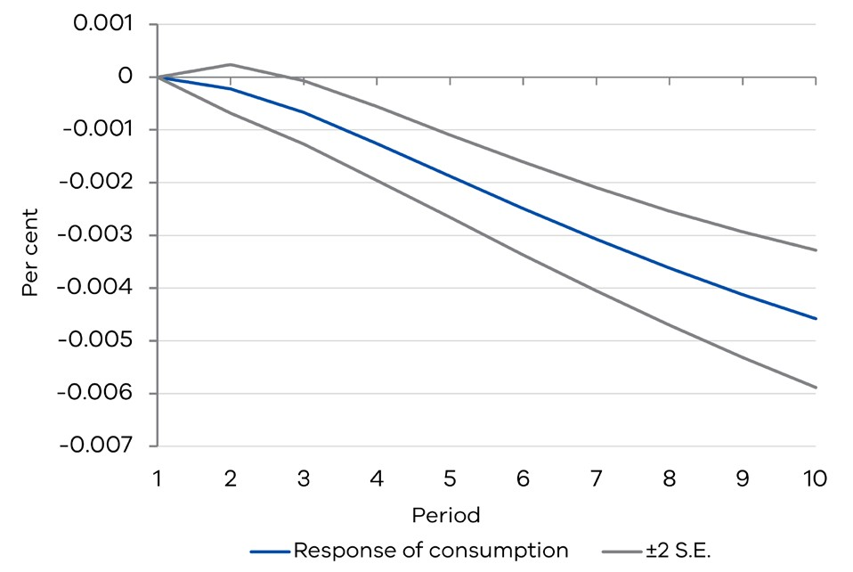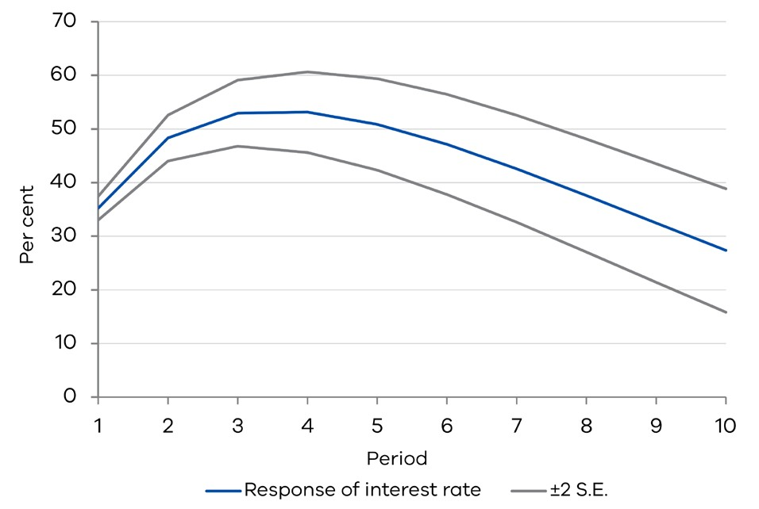

Figure 7: Responses of consumption to one standard deviation shock in interest rates[33]

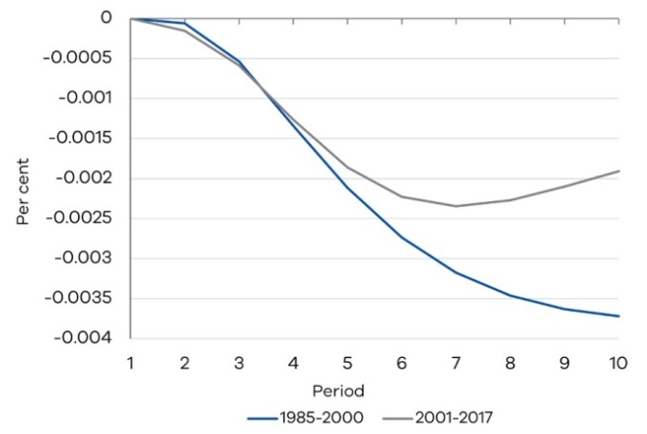

Turning to credit growth shocks – which could reflect changes in either supply of credit or demand for credit – there is some evidence these shocks flow through to consumption more quickly over time. According to Figure 8, the response of consumption to a credit shock in the period 1985-2000 increased up to period 8 (see Panel A1). However, there is only weak evidence that the total effect of a credit shock on consumption is greater in the sample from 2000 onwards. The dynamics of the credit shocks over the two time periods are roughly similar (see panels A2 and B2 in Figure 8).

The shape of the interest rate profile in response to these shocks suggests they may be more reflective of credit supply shocks, since mortgage interest rates initially fall but then subsequently rise (see Panels A3 and B3 in Figure 8). This would be consistent with a pattern where an initial increase in credit supply is at first accommodated by lower interest rates that stimulate demand for housing credit, and consumption, but then monetary policy responds with a lag to neutralise the effects on economic activity and inflation.

Figure 8: Impulse responses to one standard deviation increase in credit growth

Panel A – Response to Cholesky One S.D. (d.f. adjusted) Panel B – Response to Cholesky One S.D. (d.f. adjusted) Innovations ± 2 S.E. (1985-2000) Innovations ± 2 S.E. (2001-2017)

A1: Response of consumption to credit shock B1: Response of consumption to credit shock

##### DecorativeDecorative

A2: Response of credit to credit shock B2: Response of credit to credit shock

##### DecorativeDecorative

A3: Response of interest rate to credit shock B3: Response of interest rate to credit shock

##### DecorativeDecorative

* + 1. Conclusion

Different frameworks have been proposed and tested in the literature over the past few decades to identify the determinants of household consumption. This study introduces a new set of factors that can better forecast consumption growth for Australia. While previous studies focus on the role of households’ assets in explaining consumption, our findings indicate households’ liabilities play a more significant role.

The models discussed here were also used to determine if the sensitivity of household final consumption expenditure to changes in interest rates and credit outstanding has increased over time. We find reduced-form evidence that consumption responds more quickly to economic shocks in the recent period, possibly from consumption behaviour having become more forward looking. However, the sensitivity of consumption to a change in interest rates has decreased over time even though debt to income ratios have continued to increase.

References

Acemoglu, D. & Scott, A. (1994). 'Consumer Confidence and Rational Expectations: Are Agents' Beliefs Consistent with the Theory?'. *The Economic Journal*. vol. 104, pp. 1–19.

Atalay, K., Whelan, S. & Yates, J. (2017). 'Housing prices, household debt and household consumption'. AHURI Final Report No. 282, Australian Housing and Urban Research Institute Limited, Melbourne, doi:10.18408/ahuri-7307401.

Campbell, J.Y. & Mankiw, N.G. (1989). 'Consumption, income and interest rates: Reinterpreting the time series evidence'. In: Blanchard, O.J., Fischer, S. (Eds.), NBER Macroeconomics Annual: 1989. MIT Press, Cambridge, MA, pp. 185–216.

Carroll, C. (2004). 'Housing wealth and consumption expenditure'. Presentation at Fed Board of Governors’ Academic Consultants Meeting.

Diebold F.X. & Mariano R.S. (1995). 'Comparing Predictive Accuracy'. *Journal of Business and Economic Statistics*. vol. 13, pp. 253–263.

Fisher, A.L., Otto, G. & Voss, M.V. (2010). 'The response of Australian consumption to housing wealth'. *Journal of Macroeconomics*. vol. 32, pp. 284–299.

Howrey, E.P. (2001). 'The Predictive Power of the Index of Consumer Sentiment'. Brookings Papers on Economic Activity. vol. 1, pp. 175–207.

Johnson, D., Parker, J. & Souleles, N. (2006). 'Household Expenditure and the Income Tax Rebates of 2001'. *American Economic Review*. vol. 96, pp. 1589–1610.

Kaplan, G., Violante, G.L. & Weidner, J. (2014). 'The Wealthy Hand- to-Mouth'. Brookings Papers on Economic Activity, Vol. 1, pp. 77–138.

Kilian, L. & Lutkepohl H. (2017). 'Structural Vector Autoregressive Analysis'. Cambridge University Press.

Lettau, M. & Ludvigson, S.C. (2004). 'Understanding trend and cycle in asset values: Re-evaluating the wealth effect on consumption'. *American Economic Review*. vol. 94, pp. 276–299.

Misra, K. & Surico, P. (2013). 'Consumption, Income Changes and Heterogeneity: Evidence From Two Fiscal Stimulus Programmes'. CEPR Discussion Paper, 9530.

Simon, J. & Stone , T. (2017). 'How Much Debt Do FHBs Take On?', Research Discussion Paper, RDP 2017-05, Reserve Bank of Australia.

Sims, C.A. (1980). 'Macroeconomics and Reality'. *Econometrica*. vol. 48, pp. 1–48.

Sims, C.A., Stock, J.H. & Watson, M.W. (1990). 'Inference in Linear Time Series Models with Some Unit Roots'. *Econometrica*. vol. 58, pp. 113–144.

Slacalek, J. (2004). 'Forecasting consumption'. German Institute for Economic Research, DIW, Department of Macro Analysis and Forecasting.

Wong, A. (2018). 'Transmission of Monetary Policy to Consumption and Population Ageing', Mimeo.

Uncertainty and the value of real options in infrastructure decision-making[34]

### By Lara Morton-Cox

ABSTRACT

Our communities’ service needs, as well as how, when and where they are delivered, are constantly evolving. Yet the assets and infrastructure that enable services are typically long-lived. Government and businesses invest in infrastructure based on an assessment of future needs extrapolated from current conditions to a ‘most likely’ future state. However, the anticipated ongoing demand for, or benefits from, these services can be difficult to forecast, and can be subject to major uncertainties. Factors such as economic, environmental, demographic and social trends, as well as innovation, technological advancements and paradigm shifts, are driving rapid change to demand and supply conditions. This uncertainty can impact the uptake of asset investments and the extent to which benefits can be realised, making it difficult to select the right investment decisions.

Practitioners have often intuitively incorporated flexibility into an investment strategy to enable them to respond to changing conditions if uncertainty prevails. However, traditional frameworks for assessing and comparing investment options are limited in their ability to recognise uncertainty or to consider the value that flexibility can add to an investment. In the 1970s, practitioners applied financial options theory to asset investments, thus giving rise to ‘real options’, a branch of economic theory in which financial options analysis is applied to asset investments. Real options theory provides a quantitative approach to decision-making, incorporating uncertainty and flexibility, which previously could only be supported intuitively or qualitatively.

This paper examines the potential responses to uncertainty for successfully delivering infrastructure investments. It considers how traditional economic appraisal techniques can be extended to adequately account for the impacts of uncertainty on benefits derived from investments. It outlines the potential benefits of applying real options analysis techniques to infrastructure investment appraisal and decision-making.

# Overview

The traditional net present value (NPV) approach requires a number of simplifying assumptions including: that the investment is now or never; once started, the investment decision cannot be reversed; and the positive and negative payoffs are symmetrical. These simplifying assumptions can limit a practitioner’s ability to account for uncertainty within an investment, or for the value that could accrue through providing flexibility to respond to changing conditions. This paper considers the insights real options thinking can provide when dealing with highly uncertain exogenous factors, which can impact on how an infrastructure investment will generate future expected benefits. Dealing with uncertainty is one of a number of circumstances where real options thinking can enhance infrastructure investment decision making.

Section 1 of this paper outlines the potential impacts uncertainty can have on an investment if it is realised after a commitment to a particular course of action is made. Section 2 discusses the limitations of traditional economic appraisal methodologies in adequately accounting for the impacts of uncertainty on the benefits expected to accrue due to an investment. Sections 3 and 4 respectively introduce real options theory as a tool to augment traditional economic appraisal techniques, and outline the value real options can add to an investment. The paper concludes with a case study outlining how real options analysis can be applied both qualitatively and quantitatively to support infrastructure investment decision-making in the public sector.

* + 1. Uncertainty in infrastructure decision-making

When undertaking a traditional economic appraisal of a proposed infrastructure investment, an investor typically identifies solutions that could address a particular need or problem in the most likely future state, and calculates and compares the expected NPVs of the costs and benefits of these options to recommend the optimal solution. The analysis makes a set of assumptions about the conditions expected to prevail for a range of factors relevant to the investment. However, these assumptions can be impacted by unanticipated changes to demographic, socio-economic, environmental and technological conditions, and policy, legislative and legal controls. If unanticipated change or uncertainty is realised after a commitment to a particular investment is made, it can impact market conditions and alter the assumed ‘future state’ of the investment environment and the ultimate benefits realised (Department of Economic Development, Jobs, Transport and Resources, 2016).

These uncertainties can impact the:

* **demand** for a service (or for the value or benefits derived by providing the service), by influencing and altering the community need and therefore the case for investment; and/or
* **supply** or cost of a solution, by influencing the market’s ability and capacity to deliver the required project scope, achieve time, budget and value-for-money constraints, and realise the desired benefits and outcomes.

For example, changing demographics can influence the demand for services that target specific community sectors. If the age profile of a region significantly changes, it could impact the community need for investments in maternal health, early childhood and education services as well as for health and aged care facilities. Technological innovations and disruptions can introduce new market participants that radically change consumer behaviour or influence demand trends. Similarly, technological innovations may be able to provide alternative delivery mechanisms that are more efficient and/or effective.

Uncertainties can lead to unfavourable conditions, which present threats to achieving an investment strategy’s benefits. They can also create favourable conditions, which present opportunities for achieving cost or time savings, greater value-for-money outcomes or enhanced benefits realisation that could not have been foreseen at the time of the funding decision.

These unanticipated changes to demand and supply forces can profoundly impact an investment strategy’s feasibility: investment options that are preferred and would be successful under one set of conditions can become unviable (inappropriate, undeliverable or unaffordable) if circumstances change. This can affect an investor’s ability to achieve the desired investment outcomes and benefits (Ofgem, 2012). For example:

* Increases in desired or required levels of service or service demand can result in investments in assets that do not meet capacity.
* Decreases in required levels of service or service demand can lead to asset obsolescence, accompanied by perceptions of over-investment or inappropriate investment.
* Changes to preferred service delivery models and methods or disruptive or unexpected new technologies can result in unsuitable assets, which do not meet user needs and expectations.

In hindsight, a different investment strategy (even a ‘do nothing’ option) may have resulted in a better outcome, leading to ‘regret’ that the investment was not deferred until there was greater certainty on market conditions, an approach to adapt the strategy as conditions changed was not taken, or that things were not done differently (ACIL Tasman, 2012). In some instances, a decision-maker may take reactive, corrective action to complete or re-scope the investment at significant cost, time delay and political and/or commercial risk. In other instances, the investment may fail entirely to deliver the intended benefits. As some infrastructure investments require high sunk costs, pre-emptively planning for and effectively dealing with uncertainty may be an important determinant of investment success.

These types of exogenous uncertainties differ from most risks in that they are outside the direct control of the investor or project and therefore cannot be effectively mitigated or ameliorated by the project team. Instead, to successfully deliver investments with high degrees of uncertainty, the investor may need flexible and resilient investment strategies, which anticipate when change may impact an initiative, and allow them to respond advantageously to prevailing circumstances.

BOX 1. RISK VERSUS UNCERTAINTY

There are different definitions of ‘risk’ and ‘uncertainty’. In our framework, risks and uncertainties require fundamentally different treatments, and therefore we cannot consider and plan for uncertainties using the same tools as risks.

A typical risk management tool will identify project risks, assess their likelihood of occurring and potential impact, and suggest a course of action to address the risks if they eventuate. A successful risk mitigation strategy will usually result in the risk being managed so its impacts on the project parameters are reduced or ameliorated. The risk may have some impact on time, cost or scope parameters, but essentially under a typical mitigation strategy the project will proceed unchanged, seeking to deliver the intended benefits from an unchanged service offering. In contrast, uncertainties are events or conditions primarily driven by factors outside our control. If an uncertainty results in an alternative future state that has a material unexpected impact (for ease we refer to this as ‘if an uncertainty is realised on a project’), the approach is not to mitigate its impact on the base case project, but rather to adapt the investment strategy to respond favourably to the new conditions in the alternative future state. A successful strategy to deal with uncertainty (and indeed some risk) may result in a decision that changes the investment strategy’s course, putting it on a pathway to achieve a potentially different outcome or scope altogether (Department of Treasury and Finance, 2018).

* + 1. Limitations of traditional economic appraisal approaches to dealing with uncertainty

Investment decision-making is usually supported by developing an economic assessment for a given investment proposal, assuming a most likely future state in a business case. The appraisal involves identifying, calculating and comparing the costs and benefits of a proposal in order to evaluate its merit, either absolutely or in comparison with other options. It starts by clearly articulating the project’s role in addressing key service challenges. It also requires the full exploration of reform and investment options to address these problems to ensure the preferred project solution provides the best return on available resources.

Cost-benefit analysis (CBA) is the primary and preferred economic assessment tool used in the Victorian government to inform major public expenditure and regulatory decisions, and is commonly used in the private sector. It is a rigorous, transparent, quantitative method that measures the net benefits generated by individual projects, and allows options and projects to be compared and ranked (Department of Economic Development, Jobs, Transport and Resources, 2016). It is used to determine whether a proposal has net benefit to society or if an alternate proposal provides the greatest net benefit. The expected benefits and costs can then be used to calculate the NPV of these, the benefit cost ratio (BCR) and internal rate of return (IRR) of proposals.

When developing a CBA for an investment proposal, practitioners are usually required to value costs and benefits that are not known with certainty; known as ‘expected’ impacts. CBA techniques effectively consider **risk** by calculating the expected benefits and expected costs of a proposal, using probability weighted or most likely estimates. Risk considerations can be extended through sensitivity analysis, which considers how different assumptions or values for key variables, such as discount rates, affect the proposal’s value. Occasionally, this will be further extended into scenario analysis. This allows investors to make informed decisions about, if risk were to eventuate, what the likely impact on benefits realisation would be, and whether the preferred option would still be worthwhile pursuing (Department of Economic Development, Jobs, Transport and Resources, 2016).

However, this traditional CBA approach does not account for the potential impacts of **uncertainty** on a proposal or the value inherent in being able to adapt or respond flexibly to changing conditions. This traditional approach makes some fundamental assumptions, including that:

* the investment is now or never, and there is no value in deferring a funding decision;[35]
* delivering the approved scope is irreversible (ability to re-scope even as the ‘world’ changes around it is not considered or evaluated);
* costs and benefits have symmetrical payoffs around an unbiased central estimate; and
* the investor accounts for project risks upfront, rather than considering the value of having managerial flexibility to respond to changing conditions (Dixit and Pindyck, 1994).

This type of thinking commonly results in an investor committing to an ’all or nothing’ decision to achieve a set of desired benefits by delivering a defined project scope within a pre-determined budget and timeframe. With this type of investment thinking there is generally limited opportunity to modify the investment scope or approach once a project has commenced. If risks (or indeed uncertainties) occur, the risk mitigation approach will focus on minimising the negative impacts on project parameters, such as time, cost and scope, while still aiming to achieve the intended benefits through an unchanged service offering. If material uncertainty eventuates in an alternative future state throughout the delivery stage, prevailing conditions may have rendered the defined project scope sub-optimal. However, the investor may not have sufficient strategic, commercial, political and/or contractual flexibility to adapt or change their investment strategy or scope to respond effectively.

By ignoring the impact of uncertainty and the value of flexibility in decision making, conventional analysis ignores the value of embedding option value in project staging, contracts and design and can introduce bias towards projects that will offer decreased value for money over the long term (Department of Economic Development, Jobs, Transport and Resources, 2016). Traditional analysis of a single most likely future state is often sufficient where projections of future costs and benefits are based upon some historical context and future trends are fairly certain.

It is most valuable when volatility is low. When estimates of future costs and benefits are based on multiple assumptions about what the most likely future state may look like and are difficult to accurately forecast, an extended analysis which looks at the benefits and costs in multiple future states and the management responses necessary to optimise outcomes when the future states occur, is more likely to arrive at an optimal and adaptive investment strategy. Analysis of a single most likely future state can also lead to an unconscious bias to move away from uncertain, flexible or adaptable solutions toward familiar and previously successful approaches to solving a problem. In these circumstances, this can prove to be misleading and prompt investors to reject highly promising, if uncertain or adaptable, project paths (Mouter et al, 2015).

The traditional CBA approach is a necessary, appropriate and effective tool as a first step in any appraisal and is a sufficient tool in many instances. However, when facing highly uncertain exogenous or other factors, practitioners can benefit from using a set of additional appraisal tools and techniques, which extend CBA into considering multiple future states and contingent responses. These extended techniques enable greater flexibility and resilience to respond to unexpected change and evolving conditions. These tools will enable investors to make better decisions regarding developing, announcing, tendering, contracting and constructing projects and the services they deliver.

* + 1. Real options analysis in infrastructure

A real option is the right, but not the obligation, for an investor to undertake certain actions in the future to alter a project pathway (scope) when uncertainty impacts assumed conditions. Real options analysis is an investment evaluation and decision-making framework that specifically recognises uncertainty, and provides managerial flexibility to enable investors to respond to it advantageously (Robinson and Kyng, 2003). It can help investors to develop infrastructure investment strategies, which are adaptable and better meet evolving community needs.

Real options theory arose as a formal economic valuation technique in the 1970s through the application of financial option theory to asset investments. In 1973, Black and Scholes developed a model for valuing financial options, such as stocks and bonds, providing a method for rapidly calculating the optimal point in time to buy and sell these options. In 1977, Myers (1984) proposed that option pricing theory could be applied to non-financial, or ‘real’, investments subject to uncertainty and flexibility, thus coining the term ‘real options’ (Boden and Ahlen, 2007).

Real options theory and its applications started attracting academic interest in the 1980s. The Black-Scholes model was applied extensively to options analysis in the mining, natural resources and utility sectors. As the limitations of applying this model to infrastructure investment were recognised, the theory was extended through the development of other quantitative valuation techniques. These included decision analysis, binomial methods (of which the Cox, Ross and Rubenstein model of 1979, extended in 1985, is the most well-known) and multinomial methods (Del Giudice, Evangelista and Palmaccio, 2016). This work was pivotal in raising awareness of the limitations of applying traditional CBA to compare alternative investments in the presence of uncertainty. Myers (1984) and Hodder and Riggs (1985) outlined the limitations of traditional NPV and discounted cash flow (DCF) analysis in valuing investments subject to uncertainty. Trigeorgis and Manson (1987) argued NPV analysis contained limiting assumptions, which did not recognise the potential impacts of uncertainty on, or the value of flexibility to, investment options, and could introduce bias when applied to investments subject to significant uncertainty.

Since the 1990s, there has been increasing academic and industry interest in exploring real options theory and applying valuation techniques to support investment decision-making in infrastructure, research and development (Brealey and Myers, 1992), and corporate and strategic planning (Dixit and Pindyck, 1995). As valuation techniques can be computationally intensive, a number of tools and calculators have also been developed to enable models to be more easily applied (Sipp and Carayannis, 2013).

The real options approach recognises that, for a given investment or investment program, due to uncertainty, there may be a number of possible alternative future states to the base case assumed in a business case or at the point of the funding decision. In the face of possible alternative future states, each given solution option may be implemented in different ways to respond to the uncertainty. Therefore, each solution option might have a number of investment trajectories (a single sequence of chance events and specific decisions). Each end point of the investment trajectory is a real option. For each solution option, therefore, there will be a family of real options attached. The way the uncertainty resolves itself at each decision point (called a trigger point) will determine which pathway is taken. Each investment trajectory might have a number of trigger points. The pathway taken at each trigger point is the one that is most appropriate to the changed circumstances.

Real options thinking in decision-making can enable an investor to minimise obligations under unfavourable circumstances and to maximise opportunities, essentially ‘insuring’ investments against unforeseen change. It could potentially deliver a different outcome to that anticipated in the business case, but can provide an improved value-for- money outcome given prevailing circumstances (van Putten and MacMillan, 2004). For example, staging an investment program so each new stage is linked to a trigger point can create significant option value through its flexibility to respond to new circumstances. Similarly, embedding suitable break clauses in contracts can create value by enabling an investor to exit from project pathways, which have become unfeasible in a timely and affordable way. These approaches may have some investment consequences. For example, procuring a project in multiple stages may result in an increase in tendered bid prices. If the investment assumptions prove correct, and the future conditions occur as expected, this would result in the investor paying a premium for the investment delivery. However, if conditions do not turn out as expected, and there is a need to adapt the investment strategy to deal with uncertainties, the investor will benefit from having the ability to change the investment course at the end of each stage.

A real options approach to economic appraisal of infrastructure investments is consistent with, and builds on, a CBA framework. It is an approach for identifying, comparing, embedding and where necessary, contracting for alternative responses to a problem or an alternative future state in a way that will retest what is the optimal response at each decision point and deliver the best value for money (Dixit and Pindyck, 1994). It embeds the usual principle of seeking to ensure, at each trigger point, that a decision is made to take the pathway where the re-estimated benefits will exceed the re- estimated costs, thereby avoiding the sunk cost fallacy.

Real options analysis can augment and extend NPV and CBA analysis by providing a set of analytical tools, which enable decision-makers to consider the value of having managerial flexibility: that is, the value added to projects by allowing practitioners to respond to changing circumstances, optimise the opportunities of an investment over its lifecycle and mitigate any downside risks. In this way, a project’s total value, or total benefits, can be considered as the sum of the NPV and real options value (ROV) or value inherent due to embedded flexibility:

**Total project value (TPV) = NPV + ROV**

The NPV captures a base estimate of value, and the ROV adds in the value of having the flexibility to deal with uncertainty. The proportion of a project’s total value contributed by each component will vary according to the degree of uncertainty associated with the project. In the early stages of an innovative project, the value of the CBA component will be low because of the need to use a high discount rate to adjust for the uncertain nature of future cash flows. At the same time, the ROV will most likely be high due to that same uncertainty. As project certainty increases over time, the value of the real option(s) will decrease (van Putten and MacMillan, 2004). This approach enables investors to consider the potential value of proposals impacted by a high degree of uncertainty, which is lost through a traditional CBA valuation, while still protecting against the considerable risks of pursuing highly uncertain projects. It can be used to address some of the recognised limitations in the conventional use of CBA.

* + 1. The value of flexibility in decision-making

Real options analysis can benefit an investment at multiple points within the investment lifecycle. The following sections outline the potential ways in which enhanced flexibility can add value prior to committing to an investment, during project delivery and during the asset’s operational life.

* + - 1. Delaying decision-making until more detailed information is available

For many infrastructure investment decisions, particularly those that involve high upfront or sunk costs and have uncertain consequences, it may be valuable to have the option to ‘wait and see’ before committing to an investment, or to undertake research and development to obtain greater information and certainty about an investment. In option terms, an infrastructure investment with a positive BCR is an ‘in the money’ option, which could be exercised now or at any point in the future.

The traditional CBA approach focuses on the net value of delivering an investment now, based on the information currently known. Real options analysis recognises there may be increased value in delaying an investment decision to a future date when further information is known and project determinants are more certain, or when conditions are more favourable. Consideration of the optimal time to invest can be supported by qualitative or quantitative real options analysis. However, simply questioning whether an investment should commence now or be deferred is a valuable thought process in and of itself. In options parlance, a simplifying assumption in a CBA approach is that the date of expiry of the option to proceed with the investment is today – it is now or never.

Reserving a future transport corridor wider than required for projected future demand, or building a hospital with a flexible floor plate to enable easier adaptation to changing service delivery models, are real life examples of implicit real options in which a decision to invest is deferred until greater investment certainty is obtained, but where the right to take action is reserved in advance. A traditional CBA approach could reject an investment proposal to acquire, protect and retain land for a future road or rail reservation where the market value of the land is greater than the NPV of the land costs, and future CBA of possible future road or rail projects. A real options approach would be to view the costs of protecting, retaining or acquiring the land as the purchase price of an ‘out of the money’ option on a future at-grade rail or road project (with highly uncertain costs and benefits), compared to both a do-nothing or sell the land option and a future option of an alternative tunnel instead.

Figures 1a and 1b show how deferring an investment until there is greater certainty regarding market conditions can add value by reducing the likelihood of regret in under or over-investment. Figure 1a depicts the investment process under a traditional decision-making framework, in which a commitment to invest or not invest in a specific course of action is made up front. Under this framework, if uncertainty arises after the commitment is made, and conditions do not turn out as expected, there can be significant impacts on investment outcomes and benefit delivery. Under a real options framework, the decision-maker can defer an investment until there is greater certainty regarding future market conditions. Figure 1b shows how the investment strategy can then be adapted to better address the prevailing conditions, allowing the decision-maker to avoid a regretted investment. This may involve an upfront cost to preserve flexibility, but may also provide significantly greater value by providing the right to change the investment direction if warranted by the prevailing conditions.

The potential value this flexibility can add to an investment is demonstrated in a case study of the Hohe See Wind Farm. In 2012, a German utility company, Energie Baden-Wurttemberg (EnBW), delayed its planned €1.5 billion investment to construct a new commercial offshore wind farm in the North sea until 2016. EnBW initially proposed to begin procuring the facility in late 2012. However, at this time, the German Government commenced a review of its Renewable Energy Act, creating a level of legislative and regulatory uncertainty for market participants. Operators were unable to set binding dates for when the proposed wind farm could be connected to the electricity grid and commence operations. EnBW decided to postpone the investment due to legislative uncertainty. However, it retained the right to undertake the investment at a future date, when legislative conditions and legal requirements were more certain. The German Government approved amendments to its Renewable Energy Act in 2014, and EnBW subsequently reconsidered its proposed Hohe See wind farm. It committed €1.8 billion to the investment in 2016 and expects to complete the project by 2019.

EnBW deferred a significant investment decision until it had greater clarity regarding regulations and legal requirements, and a better understanding of when it could commence operations. If the company had continued with its planned 2012 investment, the facility may have been completed well in advance of any agreed binding dates, not allowing it to be connected to the grid and leaving the company with a temporarily unserviceable asset. Legislative changes may have rendered the asset no longer fit for purpose, requiring costly retrofitting to comply with any new legal requirements. By delaying the investment, EnBW reduced its risk of an irreversible and regretted investment decision (Energie Baden-Wurttemberg, 2012).

Figure 1a: The potential value of deferring an investment until uncertainty is resolved – Traditional CBA thinking

Traditional CBA thinking

Decorative

Figure 1b: The potential value of deferring an investment until uncertainty is resolved – real options thinking (Robinson and Kyng, 2003).

Real options thinking

Decorative

* + - 1. Providing flexibility in investment strategies to allow investors to respond to prevailing conditions during project delivery

An investor may be required to respond to changing circumstances during project delivery by taking various actions, such as to stage, expand or contract the project, switch inputs and/or outputs or even abandon the investment project. The traditional CBA/NPV approach assumes a set investment strategy and a risk mitigation strategy to get things back to how they were. This can lead to a bias towards projects or contracts, which do not provide flexibility (such as large-scale capital investments) relative to more flexible options (such as demand-side options, interruptible contracts or sunset clauses). If uncertainty manifests in an alternative future state where what is expected to be realised on a project is rendered sub-optimal, the investor may face additional financial (and political) costs or other penalties in order to deal with those events, if flexibility options have not been built into the original scope, contract or delivery approach.

Real options analysis provides an approach to deal with the complexity that further information and future decisions can introduce. It recognises the decision-making process, scope, contracts and design for large projects must enable their objectives and progress to be regularly recalibrated to account for changing conditions, thus creating space for adaptation before there are irreversible physical and political consequences. Rather than making a one-time go or no-go decision, real options analysis enables the investor to stage decision-making, or make decisions at certain times to adjust for emerging developments or evolving future states (Dixit and Pindyck, 1994). By providing the flexibility to take action to respond to change, real options analysis may contribute to achieving a superior investment outcome.

Figure 2 considers an investment that encounters unexpected conditions, or uncertainty, once a decision to invest has been made. It compares how this uncertainty is dealt with within both a traditional CBA framework and a real options framework. Under a traditional model, the investor is committed to deliver a specific set of outcomes regardless of how the market (demand and supply) conditions are changing. Under a real options model, the investor may be able to exercise flexibility options, which enable them to modify the investment strategy to better respond to prevailing market conditions. This may result in delivering a different set of outcomes than originally proposed, but will have a greater likelihood of achieving the desired benefits if the investment is impacted by uncertainty (Robinson and Kyng, 2003).

Figure 2: Option to alter investment strategy during project delivery (ACIL Tasman, 2012)

Traditional CBA thinking Real options thinking

Decorative

Invest now and hope for the best Provide flexibility to respond to changing conditions

* + - 1. Options that provide flexibility during the operational phase of an asset: Investing in infrastructure that is more resilient to change

Infrastructure tends to have a long useful life. However, it is often designed and constructed to meet only projected future base case uses and conditions. Changing service demand, and fluctuations in how services are delivered, can cause functional obsolescence.

Real options analysis encourages the investor to think about the long-term sustainability of the investments in different future scenarios. It recognises value can be added to an investment by ensuring the resulting asset is resilient to changing service needs and can stand the test of time. It enables the investor to consider and value the cost, not only to deliver an asset, but to manage it over its operational lifecycle. Value can be added to an investment through building in future decision opportunities, which can extend an asset’s service capability (ACIL Tasman, 2012).

* + 1. Applying real options analysis techniques to infrastructure investment decision-making

Real options analysis incorporates a broad range of strategic approaches, economic concepts, statistical models and other tools that vary in purpose and complexity, and can be applied differentially to best suit a particular investment’s requirements. The real options tools and techniques may support qualitative and/or quantitative analysis. In this section, a fictional case study of a hospital upgrade is used to demonstrate the benefits of applying both qualitative and quantitative real options analysis approaches to infrastructure investments.

Qualitative approaches, such as decision trees, can be used to map, and subsequently navigate, the potential investment outcomes of alternative investment approaches or trajectories under different sets of conditions. They can be used to identify future strategic decision points or triggers, which could alter an investment strategy and the outcomes of the potential choices. This provides practitioners with a visual and more intuitive view of the likely future outcomes resulting from decisions taken now. This process can allow practitioners to better plan how they could respond if certain events or trigger conditions occur and, where necessary, build this into procurements and contracts. It may identify some managerial or contractual actions that can be taken to improve the likely success of a project, and reduce the likelihood of needing to make unplanned decisions in reaction to an unforeseen event. Managerial real options approaches are useful for highlighting and communicating any possible disruptions to investment delivery or opportunities that could be leveraged. This managerial application of real options thinking (an uncertainty management plan) is akin to developing a risk management plan for considering potential project risks, and can be of high value. It may result in a restated version of the key problem to be addressed, typically in a form that builds uncertainty into the question, and may allow for early prioritisation of strategy decisions that allows quite robust conclusions to be drawn. (Sipp and Carayannis, 2013). Part A of the fictional case study demonstrates the value of using qualitative, or strategic, methods to consider uncertainty in an investment strategy and identify opportunities for incorporating flexibility to adapt to changing conditions.

## Case study: Part A – Qualitative options analysis of a fi hospital upgrade

The fictional location of Roptionville is a new outer suburb in a high-growth area with an average annual population growth of 15 per cent over the past five years. The closest hospital is a 45-minute drive away, and the Government has approved a new hospital to service the area.

There is uncertainty about whether population growth will continue at current levels, slow, or stagnate and the Government is unclear about the size of the hospital to build, and is considering the following options:[36]

* Option 1 involves building a base, non-upgradable, hospital. This hospital will take five years to complete, and has capacity to service the existing population plus an additional 10 per cent population growth, which is in line with medium-term growth expectations for the State.
* Option 2 involves building a hospital that meets the same capacity requirements as Option 1, but invests in a stronger foundation and structure. This will facilitate future upwards expansion of the hospital if population growth exceeds forecasts.

Figure 3 shows how this information can be set out in a decision tree to help the Government visualise the impacts of its decisions:

Figure 3: Using qualitative real options analysis to inform decision-making

Decorative

**Lesson**: This simple decision tree is used to map the uncertainty nodes (circles), the series of decision nodes (squares) where uncertainty may impact a project and a decision is required, the course of action possible at each decision point (branches), and the investment outcome (termination point).

Figure 3 shows how decision trees can be used without numerical analysis to clearly visualise the key decision points within an investment strategy, the conditions or triggers that have the potential to change the investment trajectory, and the likely investment outcomes if uncertainties are realised in an alternative future state.

The decision tree can be as simple or as complex as the situation requires. While Figure 3 identifies the decision points to consider the availability of a real option, there are likely to be multiple decision points and triggers for exercising a real option, each with their own probabilities and cost estimates. Building on the above example, this could include the level, or types of demand required before the real option is exercised, and the impact on different decision points, including whether to invest in one or multiple floors to meet additional demand.

Options valuation approaches are mathematical models, which empirically estimate the monetary value of real options to an investment. A quantitative real options appraisal builds on the same principles as a CBA of a base case. In essence, it models a number of scenarios within an overall evaluation methodology. Streams of costs and benefits for each alternative future state or scenario should be compared over time and discounted to generate a NPV. However, the real options approach also considers the value that can be attributed to having increased flexibility to respond to prevailing conditions. Quantitative approaches can be used to augment a proposal’s CBA to quantify: the impacts of uncertainty on a comparison of potential solution options or scenarios; and the value that a real option could add to an investment (Department of Treasury and Finance, 2018).

Part B of the fictional case study shows how quantitative real options analysis techniques can be used to account for the value that could accrue to an investment through flexibility options.

## Case study: Part B – Quantitative options analysis of a hospital upgrade

If we consider our example again:

* **Option 1** (building a base, non-upgradable, hospital) will cost $75 million. If demand is stable, Option 1 will deliver benefits of $100 million due to improved health outcomes and timely provision of health services. However, if the population increases above expectations, Option 1 will only deliver benefits of $50 million as timely provision of care will diminish and full benefits will not be realised.
* **Option 2** (building an upgradable hospital) will cost $95 million, with an additional $5 million required if a decision is made to undertake the upgrade. If demand is stable, Option 2 will deliver benefits of $100 million as per Option 1. However, if demand exceeds expectations and a further hospital upgrade is required, the expected benefits increase to $150 million as a result of enabling a quicker and more cost effective upwards expansion (as opposed to a new build or horizontal expansion), which will provide more timely health benefits to the community.
* Evidence suggests there is a 50 per cent probability of population growing above expectations in the medium to long term.

Using the above parameters, we can construct a decision tree that maps the level of total investment we will need under different future states, as shown in Figure 4:

Figure 4: Using quantitative real options analysis to inform decision-making

Decorative

If we proceed with Option 1, we will pay a lower cost of $75 million. If demand is in line with expectations, this option will achieve the full suite of anticipated benefits and will represent the cheapest and best value-for-money solution, with a payoff of $25 million.

However, there is a 50 per cent chance population growth will exceed expectations, and this investment will not adequately meet medium to long-term demand for health services. In this event, the net benefits delivered by the investment is -$25 million. This represents an underinvestment in the problem and government may need to consider taking further action to address the service need. Under these conditions, we would likely regret investing in Option 1. If we proceed with Option 2, we will pay a higher upfront cost of $95 million. This includes the base cost ($75 million) to build a hospital that meets expected demand, as well as the ‘option cost’ ($20 million) to provide the right, though not the obligation, to cost-effectively expand the facility later if demand growth is greater than expected. In this option, we are paying $20 million to future-proof our investment against unexpected demand growth. If demand is in line with expectations, we will have over-invested in a hospital that exceeds requirements. In this instance, the solution accrues the same benefits as Option 1, but these are more than offset by additional construction costs (payoff is $5 million).

However, if demand exceeds expectations, we can exercise our right to upgrade the hospital. We will be required to pay an additional investment of $5 million to upgrade the hospital at this time, known as the ‘exercise cost’. In this scenario, the total investment ($95 million initially then $5 million) offers the greatest benefits and value for money (payoff is $50 million). The solution will have cost $25 million more than Option 1, however upgrading the existing facility will offer a far more cost-effective and timely solution than building another hospital at a different site, or purchasing adjoining land to expand the current hospital. It will also address long-term service delivery requirements.

The difference in the net benefits offered by Option 1 and Option 2 under uncertain conditions represents the value of having the flexibility to adapt the investment strategy if conditions change (the ROV). In this instance, Option 1 will deliver net benefits of -$25 million if demand exceeds expectations and Option 2 will deliver net benefits of $50 million. Therefore, the option to alter the scale of the investment at a later date has net value of $75 million.

In this way, we have used a simple decision tree to augment options analysis by considering the costs and benefits of including flexibility in an investment strategy to deal with uncertain conditions. It clearly identifies which investment strategies would be preferred under different sets of conditions or future states, and the conditions that could lead us to regret an investment decision (Department of Treasury and Finance, 2018).

Practitioners in infrastructure delivery have, historically, often incorporated flexibility options into their investments intuitively. However, due to the limitations outlined above, traditional economic models have not enabled them to formally account for the value, which could accrue to these investments as a result of the enhanced flexibility. As academic interest in applying real options theory to infrastructure investments has increased over time, there has been an increased interest in applying both qualitative and quantitative real options approaches to improve government investment decision-making. A number of government jurisdictions have begun to reference real options theory and case studies within their investment management guidance. For example, the United Kingdom’s Department for Environment, Food and Rural Affairs published supplementary guidance, *Accounting for Climate Change* *(2009),* which demonstrated the benefits of using real options analysis to manage climate uncertainty in infrastructure projects. Similarly, the New Zealand Government’s Ministry of Transport published a real options paper (2016) to encourage decision-makers to consider uncertainty and flexibility in transport investments.

In June 2018, the Department of Treasury and Finance (DTF) published *Investing under uncertainty*, a real options technical supplement to its *Investment Lifecycle* and *High* *Value High Risk Guidelines*. This reference provides practical guidance and tools to support Victorian Government departments and agencies incorporate real options analysis into government investment management practices across all stages of the investment lifecycle. It suggests all infrastructure investments can benefit from qualitative analysis of the potential impacts of uncertainty on the demand and supply conditions relevant to an investment, and the flow-on effects of these changing conditions on realising the value of the investment benefits. It further adds that all investments could benefit from thinking about any opportunities for enhanced flexibility to respond to these changing conditions. For those infrastructure projects that are exposed to significant uncertainty, in either the market’s ability to supply a viable solution or the community’s likely ongoing need for the resulting service offering, the guide suggests that a traditional CBA could be augmented with quantitative real options analysis to formally account for the value, which would accrue to an investment from any flexibility options.

While traditional CBA considers the net benefits an investment will deliver given an assumed future state, real options thinking can help practitioners analyse the investment outcomes, which can be expected given a range of alternative futures. This can help investors clarify the conditions in which an investment is likely to be successful, result in sub-optimal outcomes or be regretted, and to define the triggers or market forces driving those conditions and outcomes. In turn, this can be useful in identifying and evaluating adaptive strategies, which can be deployed as necessary to respond advantageously to the prevailing conditions. By clarifying an investment’s alternate trajectories in this way, real options analysis can provide investors with additional insights to inform their economic appraisals and decision-making. Real options can also provide a framework for developing, communicating and delivering adaptive investment strategies, which seek to minimise an investor’s loss under unfavourable conditions and improve benefits realisation under favourable conditions. In an investment environment increasingly impacted by uncertainty, real options analysis provides a set of tools to help government future-proof its investment decisions and the resulting infrastructure.

* + 1. Conclusions

Our communities’ service requirements are constantly evolving, driven by changes in economic, social, environmental, legislative and technological trends and controls. As a result, investments in infrastructure to support services are increasingly being impacted by uncertainty.

This paper examines the limitations of using traditional NPV analysis to address uncertainty in infrastructure investment appraisal and decision-making. It proposes that NPV analysis ignores the potential value in having increased flexibility to respond to changing conditions, and introduces bias towards proposals that do not offer flexibility.

This paper also suggests real options analysis provides a theoretical framework that accounts for the value flexibility can add to an investment. It shows how both qualitative and quantitative real options analysis can be used to support improved infrastructure appraisal and decision-makingby applying both methodologies to a simple, fictional case study. The Department of Treasury and Finance encourages Victorian Government departments and agencies to apply real options thinking and valuations to infrastructure investments to better future-proof government investments.

References

ACIL Tasman (2012). 'Real Options Framework and Tools: Opportunities for the Department of Treasury and Finance', internal document prepared for the Department of Treasury and Finance.

Boden, B., & Ahlen, A. (2007). 'Real Options Analysis – A study of implementation impediments'. Research Dissertation, School of Business, Economics and Law, Goteborg University.

Brealey, M. & Myers, S. (1992). 'Principles of Corporate Finance'. McGraw-Hill, New York.

Cox, JC., Ross, SA., & Rubinstein, M. (1979). 'Option pricing: A simplified approach'. *Journal of Financial Economics*.

Del Giudice, M., Evangelista, F., & Palmaccio, M. (2016). 'Defining the Black and Scholes Approach: A first systematic literature review'. *Journal of Innovation and Entrepreneurship*, SpringerOpen Journal.

Department of Economic Development, Jobs, Transport and Resources (2016). 'Guidance on addressing risk and uncertainty in economic assessments'. Internal guidance document.

Department of Environment, Food and Rural Affairs (2009). 'Accounting for the effects of climate change – Supplementary Green Book Guidance'. United Kingdom Government, assets.publishing.service.gov.uk/government/uploads/system/ uploads/attachment_data/file/191501/Accounting_for_the_effects_ of_climate_change.pdf

Department of Treasury and Finance (2018). 'Investing under uncertainty – a real options technical guide to the Investment Lifecycle and High V[alue High Risk Guidelines'. www.dtf.vic.gov.au/](http://www.dtf.vic.gov.au/) infrastructure-investment/investment-lifecycle-and-high-value- high-risk-guidelines.

Dixit, A., & Pindyck, R. (1994). 'Investment under uncertainty'. Princeton University Press, press.princeton.edu/titles/5474.html

Energie Baden-Wurttemberg, (2012). 'Uncertain underlying conditions delay investment decision for the offshore wind farm EnBW Hohe See – wind power remains a central plank of expanding renewable ener[gies'. www.enbw.com/company/press/](http://www.enbw.com/company/press/) press-releases/press-release-details_10734.html

Hodder, J., & Riggs, H., (1985). 'Pitfalls in evaluating risky projects'. *Harvard Business Reviews*, vol  63, no. 1, pp. 128-135.

Ministry of Transport, (2016). 'Adaptive Investment Management – Using a real options approach in transport planning'. New Zealand Government[, www.transport.govt.nz/](http://www.transport.govt.nz/) assets/Uploads/Our-Work/Documents/MOT-Real-Options.pdf

Mouter, N., Holleman, M., Calvert, S., & Annema, J. (2015). 'Towards improved handling of uncertainty in cost-benefit analysis: addressing the ‘price-quality’ and ‘communication’ dilemmas'. *European Journal of Transport and Infrastructure Research*, Issue 15(3), pp. 341-361.

Myers, S. (1984). 'Finance theory and financial strategy'. Sloan School of Management, Massachusetts Institute of Technology, pdfs.semanticscholar.org/7253/ b9152d5298c16c2e777f94283a47652abd10.pdf

Ofgem (2012). 'Real Options and Investment Decision Making'. [www.ofgem.gov.uk/sites/default/files/docs/2012/03/](http://www.ofgem.gov.uk/sites/default/files/docs/2012/03/) real_options_investment_decision_making.pdf

Robinson, I., & Kyng, T. (2003). 'Real options analysis: The challenge and the opportunity'. Institute of Actuaries of Australia, 2013 Biennial Convention, actuaries.asn.au/Library/Events/ Conventions/2003/6e-conv03presrobinson.pdf

Sipp, C.M. and Carayannis, E.G. (2013). 'Real options and strategic technology venturing: A new paradigm in decision making'. Springer Briefs in Business.

Trigeorgis, L. & Mason, S. (1987). 'Valuing Managerial Flexibility'. *Midland Corporate Finance Journal*, vol. 5, pp. 14-21.

Van Putten, A., & MacMillan, I. (2004). 'Making real options really work'. *Harvard Business Review*, December 2004 Issue.

Zeng, S., & Zhang, S. (2010). 'Real Options Literature Review'. Research dissertation, Finance Department of Economics Management School, Beijing University of Technology.

[end of file]

1. This is measured in real United States (US) dollars and in constant purchasing-power-parity (PPP) terms.
2. They reflect the views of the authors and not necessarily those of the Department.
3. The authors would like to thank James Hansen and David Hedley for their comments and input. The views expressed in this paper are those of the authors and do not necessarily reflthe views of the Department of Treasury and Finance (DTF).
4. See the RBA (2006), ‘Measuring Housing Prices: An Update’, RBA Bulletin, June and the study by Knoll, Schularick and Steger (2014) for a list of house price measurement approaches are used by selected countries in the world. www.rba.gov.au/publications/bulletin/2006/jun/pdf/bu-0606-1.pdf.
5. When the hedonic approach was compared against both the repeat-sale and stratified median methods, Hill (2011) concluded the advantages of the hedonic approach still outweighs its disadvantages. Using data for the Brisbane property market, Rambaldi et al (2011) developed a spatio-temporal model of hedonic pricing that separates the land and the structure components of property prices, while Rambaldi and Rao (2011) presents a model that accounts for the presence of spatial correlation in prices, reflecting the role of locational characteristics.
6. The DTF hedonic price index generated was found to be robust. Including other additional variables, such as floor area and age of structure to the specification did not significantly improve nor alter the result.
7. There are much more sophisticated techniques for controlling for location, but using a simple postcode level fixed effect is a straight forward but effective control for the location of where homes are sold. The R-squared with only postcode level fixed effects came up to 0.78, which means approximately 78 per cent of the variation can be explained by the postcode level fixed effects.
8. This measure is not as reliable for units and occasionally reflects the footprint of the whole apartment block.
9. Property price growth is volatile and is also subject to seasonal patterns. Therefore, we consider the two-quarter average through-the-year growth as it provides a better indication of property price growth over time.
10. Statistical Areas Level 4 (SA4) are geographical areas built from whole Statistical Areas Level 3 (SA3s). The SA4 regions are the largest sub-State regions in the main structure of the Australian Statistical Geography Standard (ASGS).
11. This approach utilising the distance to the CBD as a determinant of price growth has precedents in the literature i.e. the Alonso Muth-Mills model formalised by Wheaton (1974) from work by Alonso (1964), Muth (1969) and Mills (1967). This would be reflective of Greater Melbourne as well.
12. Schwarz Information Criterion (SIC).
13. The larger the Wald statistic, the more the lags of the right-hand-side series explains the contemporaneous left-hand-side variable. In other words, the larger the Wald statistic, the higher the information content of the right-hand-side variable in predicting the left-hand-side variable.
14. One reason for this could be that a smaller share of properties are sold through auction in Sydney when compared with Melbourne.
15. Akaike information criterion (AIC).
16. Either case is possible, in that income shocks could be felt asymmetrically, or that symmetric income shocks would impact on the property price distribution asymmetrically.
17. A similar stratification approach based on median prices in each postcode is used by Prasad and Richards (2006). They used this approach to construct a stratification‑based price measure that accounts for the compositional change.
18. Although the analysis originally considered using the top 25th and bottom 25th percentile for every year, new postcodes or postcodes that were phased out over time presented challenges.
19. The authors would like to thank the following Department of Treasury and Finance (DTF) staff for their comments: Cathie Close, Mike Pottenger, Paul Donegan, Esther Duroux and David Hedley. The views expressed in this paper are those of the authors and do not necessarily reflect the views of DTF.
20. Note that metropolitan LGAs are defined as LGAs considered to be in metropolitan Melbourne according to the Victorian Department of Environment, Land, Water and Planning’s Metropolitan Partnerships.
21. Note that the source of population data is ABS catalogue 3218.0.
22. This is the method suggested by SGS Economics and Planning (2012).
23. The authors would like to thank the following Department of Treasury and Finance (DTF) staff for their comments and input: James Hansen and David Hedley. The views expressed in this paper are those of the authors and do not necessarily reflect the views of DTF.
24. The DSR reflects the share of income used to service debt including interest and principal repayments, and loan maturities.
25. See RBA (2017), ‘Box C: Household and Business Finances’ , Financial Stability Review, April, pp 29–32.
26. There is a vast amount of literature supporting the restricted-VAR model (VECM) where non-stationary series in the regression are co-integrating. Importantly, many other studies (see for instance, Sims, 1980; Sims, Stock, and Watson, 1990; Kilian and Lutkepohl, 2017) recommend against differencing. These studies argue the goal of VAR analysis is to determine the interrelationships among the variables, not to determine parameter estimates. The main argument against differencing is that it ‘throws away’ information concerning co-movements in the data (such as the possibility of co-integrating relationships). Following these studies, we compare the forecasting performance of the two models (VAR and VECM). The results (not presented in this paper) show the VAR model significantly outperforms the VECM.
27. We perform additional tests to evaluate the short-run and long-run performance of the models/variables. Results (not presented in this paper) are in favour of the proposed model. Following the requirements of the Victorian budget process, we present four-year forecasts in this paper
28. Optimal lag length has been selected based on the Schwarz criterion.
29. We evaluate the DM test using a squared-error loss function. We also evaluate the forecasting performance of the models based on the absolute-error loss function and find similar results.
30. Results of this section are based on the Australian National Accounts data released on 7 March 2018 by the Australian Bureau of Statistics. An optimal lag length of 3 has been selected based on the Schwarz criterion for both models.
31. See www.rba.gov.au/chart-pack/household-sector.html
32. Impulse responses trace out the response of current and future values of each of the variables to one unit increase in the current value of one of the VAR errors.
33. We normalised the response of consumption to one standard deviation change in the interest rate over two sub-samples to make them comparable.
34. The views expressed in this paper are those of the author and do not necessarily reflect the views of the Department of Treasury and Finance (DTF).
35. In option terms the option is at its expiry date and there is no ability to defer the option to exercise.
36. An additional option that could be considered is to build a larger hospital upfront with more limited scope for upgrading. This may be the preferred strategy if there is a high likelihood that demand growth will be strong early and there is a low likelihood of technological development. However, it is not considered here so as not to over-complicate the example.