Community Support Fund

Final Outcomes Summary for Projects Completed in 2019-20

Contents

South Oakleigh Wildlife Shelter 2

Mitcham Cricket Club - New uniforms 2

Collingwood College Indoor Sports Facilities - Redevelopment 3

Northern Futures - Identifying job opportunities, providing employment and training for people in Geelong 5

Justice Connect’s Not-for-profit Law Program 2018-19 to 2019-20 6

Carrum Downs Salvation Army - Food relief and community support program 7

Orygen, the National Centre of Excellence in Youth Mental Health 8

Northern Community CareWorks - Community lunch program 9

North Melbourne Football Club, The Huddle - Community program 9

Big Group Hug - Community program 10

Victorian Tamil Community Centre - upgrade 11

Ten Years On, Foggy Mountain School Project - Recording of songs by six primary schools 12

Friends of the Heidelberg School - Website 12

The Music Victoria Awards 2019 13

Carnegie Lions Club - Purchase of a new trailer 13

Project REAL - Re engage at risk students with education 14

Enabling Vulnerable Students to Get to School Program 15

Carrum Downs Scout Group - New facility 18

Lake Wendouree - Community outdoor gym facilities 19

Port Fairy - Streetscape renewal stage 3 20

Leopold Community Hall - Upgrade 21

Rosebud Soccer Club - Installation of CCTV Cameras 22

CM ref: D21/53573

# South Oakleigh Wildlife Shelter

The South Oakleigh Wildlife Shelter (the shelter) is a Not-for-profit organisation that rescues and cares for injured wildlife throughout the South East of Melbourne. It also helps educate children to learn about wildlife and what to do in case they find injured animals.

The Community Support Fund enabled the South Oakleigh Wildlife Shelter to purchase a new vehicle to replace their old and unreliable vehicle. The Mitsubishi Triton displays the shelter’s name and phone number and has been equipped to better rescue and transport wildlife, collect wildlife food including fresh branches, and take displays to education events. The new vehicle allows volunteers to rescue more animals, and it has made their travel more safe, reliable, and comfortable for both people and wildlife.

Below are some photos provided by South Oakleigh Wildlife Shelter:

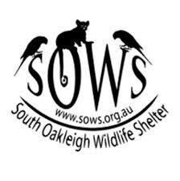

Disclaimer: The above information was provided by the Department of Environment, Land, Water and Planning.

# Mitcham Cricket Club New Uniforms

The Community Support Fund provided a grant to the Mitcham Cricket Club to allow the club to purchase new uniforms for their Girls’ teams, to wear while representing the Club.

Disclaimer: The above information was provided by the Department of Treasury and Finance.

# Collingwood College Indoor Sports Facilities Redevelopment

This project was a partnership between Collingwood College and the Collingwood Basketball Association (CBA). It proposed the redevelopment of the existing 1 ¾ basketball courts at the College.

The redevelopment provides a purpose-built indoor sports centre with three courts including two compliant netball courts and three compliant basketball courts. The facility is designed to serve the College, the regional school community, the City of Yarra and the CBA. The catchment includes the immediate social housing areas of Collingwood and Richmond, as well as a wider catchment not currently served by indoor sports courts.

The partners of the project were taken through a collaborative and consultative masterplan and design process to explore and develop the most appropriate design solution for the various stakeholders and ultimate building users. The existing facilities were in desperate need of refurbishment or replacement in part and so the design journey considered retention and upgrade of the existing full-size court, with a new two court stadium including fixed tiered seating and necessary support facilities, creating a new modern indoor sports centre.

The building was designed to meet the needs for sporting excellence for the College and CBA, and to provide a community activity hub for the local area. The building provides connection and transparency to allow the internal sport and activities to be a celebration and beacon to the community.

The Collingwood College Indoor Sports Centre works included:

* + - demolition of an existing ¾ basketball court and the associated administration and amenities facilities, a second existing basketball court was retained.
    - construction of a new two basketball court facility with tiered spectator seating and equipment storerooms.
    - refurbishment of the existing basketball court with the installation of new equipment and construction storerooms.
    - construction of new front of house facilities including an entrance foyer, reception, and kiosk/cafe.
    - construction of new back of house facilities including offices, referee area, kiosk preparation/store and staff amenities.
    - construction of a new multipurpose community space, breakout space and weights room.
    - construction of four new change rooms with amenities which are separated by operable walls allowing these to be opened into two separate larger change rooms.
    - construction of male, female and accessible amenities which can be accessed externally for events in the opposite Performing Arts building.
    - the external areas surrounding the new Indoor Sports Centre included new concrete paving, landscaping, raised garden beds, fixed tables and seating.

.

Here are some photos provided by DET:

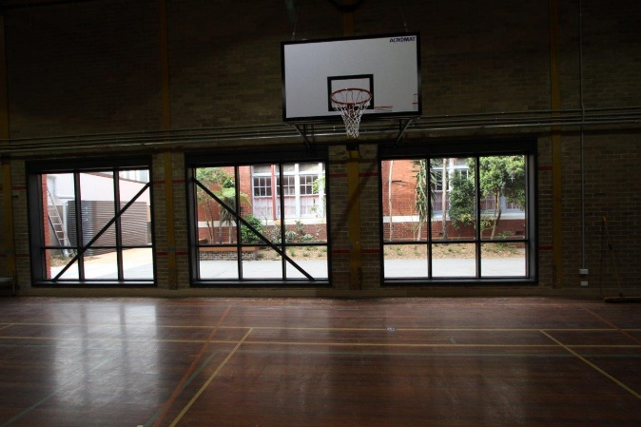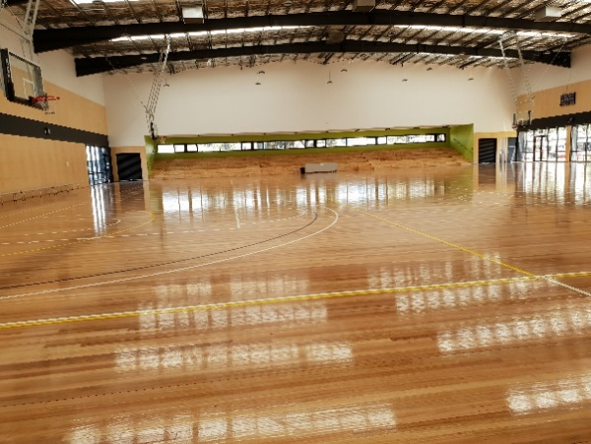

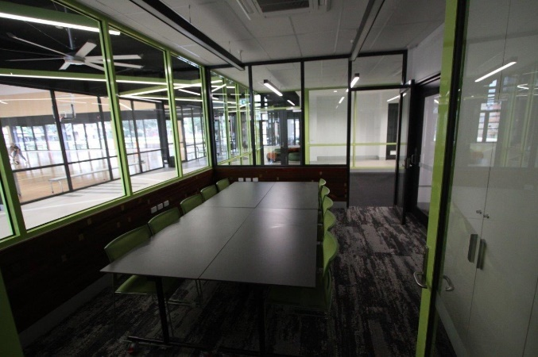

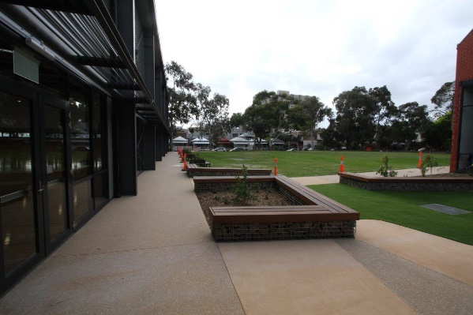

Disclaimer: The above information was provided by the Department of Education and Training.

# Northern Futures – Job Opportunities, Training Programs

The objective of this project was to support the work of Northern Futures in identifying job opportunities and local employment gaps, and to deliver targeted training programs. Specifically, to support Northern Futures to develop a transition plan that identifies alternative sources of funding and a sustainable business model for 2019-20 and beyond.

This project successfully case managed 23 participants on their unique pathway through initial engagement, training, and the exploration of their next steps to employment. A productive partnership with Cloverdale Community Centre facilitated the development of a suite of government subsidised Pre-accredited courses, co-designed in partnership with industry and training providers, to deliver locally relevant content for these individuals.

Three courses were developed called, “My Life Now”, “Hidden Rules” and “Resources”. These modules are based on ‘Bridges Out of Poverty’, by Dr Ruby K. Payne's A Framework for Understanding Poverty.

The insecurities and anxiety levels created due to social disadvantage meant that the timeline for the program had to be extended to allow for the extra supports put in place to provide effective results in the individuals. Originally, volunteering opportunities and community connection activities were planned to facilitate the individual pathways for participants, but it became apparent that one on one mentoring sessions had to be employed instead, initially to address their barriers to fuller engagement.

A sustainable delivery model has been established with Cloverdale Community Centre, a registered Learn Local provider with the Victorian Adult, Community and Further Education board.

All outcomes for the project have been achieved including a comprehensive Sustainability Plan and Transition Plan.

The CSF was acknowledged at the Graduation Ceremony verbally by Lynne Morgan – Executive Officer Northern Futures.



Disclaimer: The above information was provided by the Department of Education and Training.

# Justice Connect’s Not-for-profit Law Program 2018‑19 to 2019-20

Not-for-profit Law is a service that provides free and low-cost support to Victorian Not-for-profit community organisations on a range of legal, governance and regulatory matters.

In October 2020, the Department of Health and Human Services undertook an evaluation of Justice Connect’s Not-for-profit Law Program to determine the extent to which it achieved the Community Support Fund funding objectives for 2018-19 and 2019-20, how well it performed compared to similar programs and its contribution toward the aims of the Victorian Public Health and Wellbeing Outcomes Framework.

To fulfil these aims the evaluation reviewed all relevant program documentation, and prior evaluations and reports, to analyse findings from the quantitative and qualitative data. It also sought additional data from Not-for-profit Law.

The evaluation found Not-for-profit Law consistently delivered above and beyond the funding objectives and performance milestones despite a reduction in funding of $75,000 per year compared to the prior two years ($410,000 per annum versus $480,000). Not-for-profit Law:

* + - supported and enhanced delivery of all its services (legal information and assistance, training, pro bono referrals) for the benefit of Victorian public interest Not-for-profit entities
    - substantially increased usage of almost all services across the two years
    - expanded the pool of lawyers who could undertake work in relevant areas
    - was successful in increasing the availability of legal help for Not-for-profit organisations in outer metro and regional areas
    - contributed to improved data and knowledge on not-for-profits, and particularly in relation to compliance challenges
    - engaged in a range of systemic advocacy that helped create smarter and more proportionate regulation for the Not-for-profit sector.

It was clear from quantitative and qualitative data that Not-for-profit Law’s services were highly valued by public interest Not-for-profit entities, its expertise was sought by peak bodies and government stakeholders, and it demonstrated exceptional capacity to respond to emerging sector needs in the face of multiple crises. There was no comparable organisation identified capable of delivering the range of specialist services provided by Not-for-profit Law.

For every dollar of Community Support Fund funding provided, Not-for-profit Law delivered value likely to be from $34.80 to $46.60 to the Victorian Not-for-profit sector and community. Social benefits made up the largest component of Not-for-profit Law’s economic and social impact and through these impacts Not-for-profit Law delivered benefits that contributed to multiple aims of the Victorian Public Health and Wellbeing Outcomes Framework. Given its focus on organisations supporting people who are marginalised and disadvantaged it is likely to have had the greatest impact on the outcomes below:

* + - Domain 1: Victorians are healthy and well - Outcome Victorians have good mental health
    - Domain 2: Victorians are safe and secure - Outcome Victorians live free from abuse and violence
    - Domain 3: Victorians have the capabilities to participate/contribute - Outcome Victorians participate in learning and education and contribute to the economy
    - Domain 4: Victorians are connected to culture and community - Outcome Victorians are socially engaged and live in inclusive communities - Outcome Victorians can safely identify and connect with their culture and identity
    - Domain 5: Victoria is liveable Indicators Increase healthy eating and active living -Outcome Victorians belong to resilient and liveable communities.

Not-for-profit Law acknowledged Victorian Government funding in all of its publications.



Disclaimer: The above information was provided by the Department of Health and Human Services.

# 

# Carrum Downs Salvation Army Food Relief and Community Support Program

This project has supported the Salvation Army at Carrum Downs to continue their food relief and community support program in 2019-20.

The objective of the initiative was to enable the Carrum Downs Salvation Army food relief service to continue to operate during 2019-20 to support vulnerable people of the community. This objective was achieved with approximately 60 to 120 households assisted per week.

The funding also enabled the Carrum Downs Salvation Army to purchase a refrigerator and freezer, which will improve the effectiveness of the food relief service in the future.

Ms Sonya Kilkenny MP, Member for Carrum visited the service and the CSF grant was acknowledged. The Carrum Downs Salvation Army acknowledged the CSF grant on its Facebook page.

Disclaimer: The above information was provided by the Department of Health and Human Services.

# Orygen, the National Centre of Excellence in Youth Mental Health

The Orygen Parkville facility, completed in November 2018, houses clinical, research, policy, education, and training services to improve mental health outcomes for young Victorians.

Up to 5,000 young people each year will benefit from this new facility. It combines acute community-based care, psychological treatment, psychosocial programs and peer and family support.

The facility also acts as a centre of research for health professionals in search of new and better treatments for young people living with mental illness. The same expertise will be used to deliver world-class education and training for workers in the mental health sector.

Over the past 12 months Orygen has:

* + - 250 youth partners
    - 1640 training participants
    - 37 research projects
    - 17 clinical trials

Funding was provided by the Victorian Government to support:

* + - Utility costs
    - Maintenance and repairs
    - Information technology infrastructure costs
    - Corporate overheads

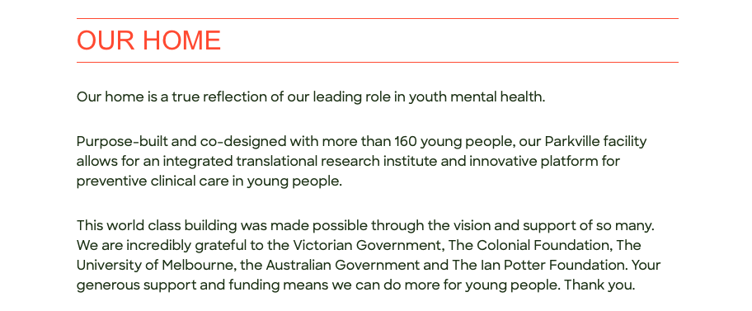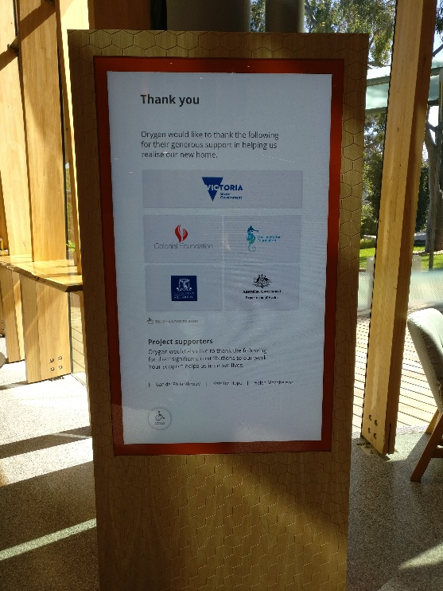

Disclaimer: The above information was provided by the Department of Health and Human Services.

# Northern Community Care Works - Community Lunch Program

The Northern Community Care Works - community lunch program provides low-cost nutritious meals to vulnerable members of the community and offers a place of community connection while seeking to improve overall wellbeing and mental health. The project assisted the program to continue to operate during 2019-20. This objective was achieved.

A variety of activities were provided under this program to the community, Food insecure people were provided with meals. People were provided with other services, including referrals to and direct provision of health services, provision of general well- being activities, diversion therapy. Approximately 70 people per week participated in this program.

Overall, this program improved mental health, physical health and community connectedness through the provision of healthy food, engagement with health and other community resource and support services.

The CSF funding was acknowledged during a visit by the local members, Kat Theophanous, to the Preston centre. The funding was also acknowledged in social media and on page seven of the organisation’s annual report.

Disclaimer: The above information was provided by the Department of Health and Human Services.

# North Melbourne Football Club, The Huddle

The Huddle is a Not-for-profit entity established by the North Melbourne Football Cub in partnership with Scanion Foundation and the Australian Multicultural Foundation.

Funding received from the CSF was used to deliver programs that support young people from refugee and migrant communities within the Wyndham area. The program was designed to build on participants’ strengths, increase their ability to participate in society and contribute to more socially inclusive communities.

Disclaimer: The above information was provided by the Department of Health and Human Services.

# Big Group Hug (BGH)

BGH services are largely concentrated in the northern suburbs of Melbourne, with approximately 80 percent of families they support residing in the Local Government Areas of Hume, Whittlesea, Nillumbik, Banyule, Darebin, and Moreland. BGH identified the need for improved IT infrastructure and working conditions for volunteers to efficiently process requests to meet the material needs of families.

The $29,000 in one‐off funding from the CSF was expended consistent with the project objectives. BGH upgraded their IT infrastructure and purchased additional IT equipment they required. Several volunteers can now process requests with additional computers available, whereas this function was previously undertaken using one outdated computer. BGH is now experiencing faster turnaround times for requests, meaning families have access to material aid much quicker than before.

The purchase of new warehouse equipment such as tubs and ladders has improved the working conditions for volunteers. These purchases have also contributed to time efficiencies e.g. purchase of label printer. Due to COVID‐19 restrictions impacting delivery of First Aid training, four volunteers are registered to complete this once permitted. This will ensure a safer working environment for volunteers.

The purchase quantities of IT and warehouse equipment is consistent with BGH’s operating environment and the number of volunteers involved in managing the warehouse. These functions range from sorting donated items through to processing and fulfilling requests for families.

The itemised expenditure reported to the department is considered fair and appropriate. Expenditure is strongly aligned to the project objectives with no portion of the funding absorbed towards project administration costs.

BGH completed the project within a timely manner whilst navigating the additional challenges due to COVID‐19. Installation delays due to COVID‐19 restrictions were well managed. During this time, BGH continued to meet an increase in requests for support despite restrictions impacting the number of volunteers permitted onsite.

The CSF funding was acknowledged in a post on the Big Group Hug FaceBook page on 17th September 2020.

The State Government has internally evaluated the Big Group Hug (BGH) project and is satisfied with the organisation’s performance in completing this whilst navigating the additional challenges presented by COVID‐19.



Disclaimer: The above information was provided by the Department of Health and Human Services.

# Victorian Tamil Community Centre

Program objectives for this CSF funding were to:

* + - support a culturally diverse community to feel connected with their traditional cultural and identity, as they participate and contribute to wider Victorian society;
    - support the delivery of a new facility and spaces for a culturally diverse community;
    - receive project planning documentation and quotations for budget items $10,000 and above;
    - deliver the project on time and budget; and
    - ensure the final project report was submitted to DPC, including the financial acquittal and evidence that the project has been delivered.

Overall, the CSF funding objectives have been successfully achieved. The organisation has installed a fire protection system that meets safety standards, upgraded the fire hydrant service infrastructure and the electrical power and cabling to ensure the building is safe.

The organisation has also installed a new audio-visual system as part of the project which means when social distancing restrictions are eased, the community will be able to gather, share and celebrate cultural traditions and practices.

The total amount of funds awarded were spent and the Tamil Community contributed a total of $39,669 themselves to complete this portion of the project.

The organisation is now eagerly awaiting the time where they can have an official opening of the first Tamil Community Centre in Victoria and share the space with their community, other multicultural organisations, and the broader Victorian community. The space will be used to hold language classes, women’s, and seniors’ groups, to host weddings and larger cultural functions and events among an array of other programs and activities.

This project has three partner organisations and required the time and work of 18 volunteers among other professional tradespeople.

While no office opening was carried out due to COVID-19 restrictions, the CSF has been acknowledged on a plaque installed by the organisation.

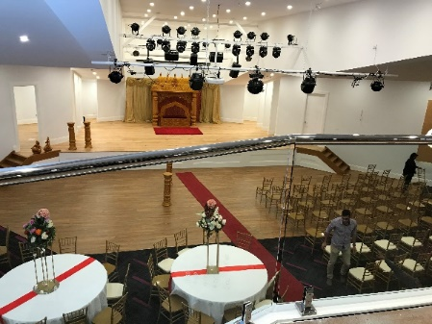Below are some photos provided by DPC:

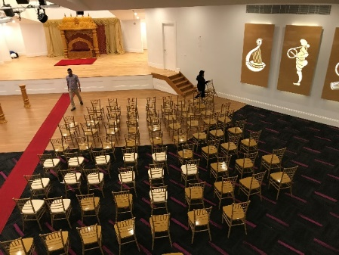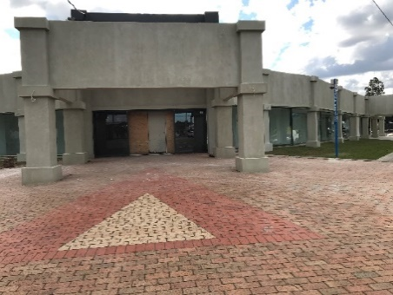

Disclaimer: The above information was provided by the Department of Premier and Cabinet.

# Ten Years On, Foggy Mountain School Project

The Ten Years On, Foggy Mountain Primary School Project provided the opportunity for children that had been impacted by the Black Saturday Bushfire to professionally record songs written by the six participating primary schools throughout the Kinglake Ranges which involved; Kinglake Primary School, Middle Kinglake Primary School, Kinglake West Primary School, Flowerdale Primary School, Toolangi Primary School, Strathewen Primary School. Current and past students were invited in the Primary Schools Song Writing project.

Under the professional guidance of musical artists David and Merelyn Carter, students from the six participating primary schools in the Kinglake area recorded the songs written and performed at the Foggy Mountain Bluegrass Festival.

Disclaimer: The above information was provided by the Department of Jobs, Precincts and Regions.

# Friends of the Heidelberg School Website

The objective of this project was the development of the Friends of the Heidelberg School website, dedicated to the artists of the Heidelberg School and their works, by Andrew Mackenzie.

From the artist *“What began as the project “Friends of the Heidelberg School Website”, due to coronavirus, turned into an opportunity to provide the NGV and Victoria with a new and larger project with the production of two “Registers of Students enrolled in the School of Design/School of Drawing and School of Painting, National Gallery of Victoria, 1867-1925 inclusive” to be presented on a USB to the NGV as a gift to help celebrate the historic occasion on 20th June 2020 of the 150th Anniversary of Eugene Von Guerard being appointed the First Master of the NGV Schools of Art.”*

The website is still in development and is yet to be published.

From the artist: “*These Registers will not only benefit Art Historians and researchers in Galleries and Auction Houses but also should interest Family Historians and Australian Military Historians, given that a number of students recorded in the Registers enlisted in the First World War and several were among the first Australian Official War Artists.*

*In all, these two Registers record over 12,000 individual enrolment entries, covering the enrolment of approximately 4,000 students, with two thirds of these being women, including many talented artists of this period still to be recognized*.”

Disclaimer: The above information was provided by the Department of Jobs, Precincts and Regions.

# The Music Victoria Awards 2019

The Music Victoria Awards 2019 is an event to celebrate and acknowledge the Victorian music industry.

The aim of the project was to build upon the Victorian Government’s support of the Victorian contemporary music sector.

The CSF grant funded two artist awards (prizes) and some operational support for the awards event.

The $30,000 grant was spent as follows:

* The Premier’s Prize for the Best Victorian Album of 2019 -$10,000 cash prize

Awarded to The Teskey Brothers - Run Home Slow

* The Premier’s Prize for the Best Victorian Breakthrough Act of 2019 - $5000 cash prize

Awarded to G Flip

* Funding also provided $15,000 towards operational support for the event

The awards were presented to the two winners at the Music Victoria Awards 2019, held at the Melbourne Recital Centre on 20 November 2019.

These cash prizes offered a rare opportunity for the winning musicians, recognizing their achievements and supporting them to make more music, continue to tour and maintain career momentum.

Disclaimer: The above information is provided by the Department of Jobs, Precincts and Regions.

# Carnegie Lions Club, Purchase of a New Trailer

The Carnegie Lions Club (The Club) is a not-for-profit community organisation, as part of 1,200 clubs under Lions Australia, the Carnegie Lions Club contribute to national and international assistance projects.

The Club required a new BBQ trailer to be purchased and fitted for fundraising activities at community markets, they raised funds through sponsorships and donations in addition to a Commonwealth grant. The Community Support Fund provided The Club with $1,504 to meet their funding shortfall as the BBQ trailer is the Club’s primary source of fundraising for their community projects.

To date the new BBQ trailer has been used at multiple community events, including a BBQ at Government House on Australia Day to support new citizens and a community ‘get-together’ to celebrate the clean-up and beautification of a number of local laneways and walk throughs completed by the local residents.

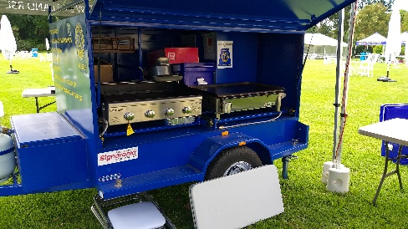

Disclaimer: The above information was provided by the Department of Treasury and Finance.

# Project REAL

Banksia Gardens Community Services (BGCS) initiated the design and establishment of Project REAL (Re-engagement in Education and Learning) in order to address exclusion from primary school experiences by students aged 9-12 whose behaviours were found to be extremely challenging, mostly as a result of previous experiences of trauma, abuse or neglect.

Project REAL aims to:

* address the issue of youth disengagement in the City of Hume by delivering a flexible re-engagement program to children (grades 4-6) with complex behaviours in the Broadmeadows area
* align the program model with evidence and best practice and engage with relevant DET policies and frameworks
* build the capacity of its partner schools in trauma-informed education and improve student attendance, both during the program and after the student has returned to their home school, improve student wellbeing, engagement, and achievement in the Broadmeadows area.

In August 2019, an evaluation of Project REAL was finalised by the Research and Policy Centre at the Brotherhood of St Laurence. The Project REAL evaluation found:

* that parents of Project REAL students identified improvements in their child’s social and emotional learning, engagement in learning, and promising signs of progress in reading, writing and numeracy;
* teachers observed students’ capacity to engage with formal learning as they gradually showed signs of improved self-awareness and ability to identify their physical and emotional needs;
* the average school attendance rate (up to 30 June 2019) for the five participants was 79 per cent. All but one of the students attended for more than 80 per cent of each day. In contrast, attendance at the referring schools averaged 59 per cent; and
* principals interviewed expressed support for Project REAL as a service providing support for primary school-aged children dealing with severe hardship and/or trauma.

Specific trends towards achievement of key indicators, such as literacy, numeracy and teacher judgements were not reported in the evaluation. However, BGCS have recently implemented a new approach to measuring a range of metrics in relation to language and communication, attention and working memory, emotions, and self-regulation.

Banksia Gardens Community Centre has acknowledged the CSF funding on their webpage.



Disclaimer: The above information was provided by the Department of Education and Training.

# Enabling Vulnerable Students to Get to School Program

#### 1. Background of the Project:

1. Following the launch of the Couch Surfing Limbo report and subsequent research conducted by the Public Transport Ombudsman, the Schools-myki Pilot Project was established in 2018. This project involved trialling a solution to the problem of couch surfing high school students in the City of Wyndham receiving public transport fines due to an inability to pay for travel. The pilot project ran over six months in 2018 and involved over 40 students from four schools.
2. Following the success of the pilot project, the Victorian Government, through the Community Support Fund, provided funding through a grant to WEstjustice to extend the project to all state schools in the Wyndham Council area in 2019. The extended project was called the Travel Assistance Program (the Project).
3. The Project distributed myki cards or Travel Passes to students who were at risk of disengaging from education, as assessed by each school’s Health and Wellbeing Officer against specified Project criteria.
4. The Project ran throughout the 2019 school year from March until December.
5. The Project was delivered by WEstjustice in partnership with Wyndham Vale Council, and guided and governed by a steering committee consisting of:
   * + WEstjustice
     + Public Transport Ombudsman
     + Department of Transport (DoT)
     + Department of Education and Training (DET)
     + Wyndham Vale Council
     + Victorian Council of Social Service
     + Metro Trains Melbourne.
6. The Project’s objectives were to:
   * + enable vulnerable students at risk of disengaging from education due to unstable housing and family situations to stay in education; and
     + measure the effectiveness of creating a pathway of education and transport compliance for these students.
7. WEstjustice delivered and coordinated the Project’s rollout to the schools, distributed mykis and Travel Passes to schools’ Health and Wellbeing teams and reported progress to the steering committee on a quarterly basis. The schools, via their Health and Wellbeing teams, engaged with their students to identify eligible participants who would benefit from the program, providing monthly reporting to WEstjustice and supporting students with any issues.

#### 2. Program performance

1. 13 schools joined the Project, with one school withdrawing in Term 3.
2. A total of 747 30-Day Travel Passes were distributed to 266 students, and 2 myki top-ups were provided to two students. Just over half of the students were female (51 per cent), with the remaining 49 per cent male students. Two thirds of the students were aged 17 to 19 years and one third were between 11 and 16 years old.
3. The Project met its objectives of keeping children in education and reducing the number of public transport fines issued to students by providing them with a valid, free, public transport ticket to travel to school.
   * + The main outcome was that 77 per cent of students were able to either improve (23 per cent), or maintain (54 per cent), their school attendance. Only 15 per cent of students’ participation declined, however, this was mainly attributed to health and family issues rather than housing or financial instability.
     + In addition to improved attendance, 15 per cent of students (40 students) were reported to increase their punctuality, although this metric was only measured in six schools.
     + The number of public transport fines collected by participating students reduced from 36 for the year prior to joining the Project to two for the year of the Project.
     + The students reported being less stressed about travelling to school and navigating the public transport network when having a valid ticket. Students also noted that they were more confident when dealing with Authorised Officers.
     + The students were happy and grateful to be provided with an avenue to attend school.
     + The schools’ Health and Wellbeing teams reported they were able to direct more students to necessary support services to assist with their circumstances. Wellbeing teams also observed that students’ mental health improved as a result of the Project.
     + Overall, the Project met its objectives and delivered some additional qualitative outcomes, such as improved mental health and reduced stress for students.
4. The program was undertaken and delivered in compliance with the Grant Agreement between DoT and WEstjustice, apart from three exceptions:
   * + Schools only reported Travel Passes that were distributed to the students. 643 Travel Passes remain unallocated to students with schools’ Health and Wellbeing teams. The undistributed Travel Passes were not reported. As the Project was a short-term program conducted as a trial, DoT deemed it unnecessary to retrieve the undistributed passes from the schools. In addition, the effort involved in retrieving the passes, especially for the schools, does not have sufficient public value to justify the additional burden on schools.
     + WEstjustice did not report the dates that Travel Passes were distributed to individual schools but reported the total number of Travel Passes distributed to each school.
     + Some of the Travel Passes issued to students, six per cent (46), were not reported against the month they were issued in. This can be attributed to human error, where the school Health and Wellbeing Officers did not record the date that some passes were issued.
5. The grant from the Community Support Fund was approved for $175,000. The total expenditure for the Project was just under $75,000. Two reasons contributed to the significant underspend of grant funds:
   * + The grant application was made prior to the trial of 7- and 30-Day Travel Passes. Consequently, the grant funding was calculated on the basis of covering the cost of issuing students with myki cards. When the grant was approved at the end of February 2019, it was decided that this Project would also trial the 30-Day Travel Passes, which are paper tickets and sold at a heavily discounted price to community organisations. A 30-Day Travel Pass costs $38.85, does not incur separate card or processing fees, and the fare is lower than the current student concession. These measures saved the Project at least $12 per student of myki card costs (student myki card costs $3 with a $9 processing fee), $20 of passport photo costs and further savings in fares.
     + The Project did not achieve full engagement until May 2019. The delay in receiving Project approval (not until end February 2019) meant that schools were still working through the implementation stages during Term 1 of the 2019 school year.

#### 3. Broader implications/learnings

1. As part of the Project, students had to be initially assessed by the school’s Health and Wellbeing Officer and have continued a monthly engagement to receive subsequent 30-Day Travel Passes. This increased the profile and effectiveness of the schools’ Wellbeing teams as they could offer and connect students with other necessary services to assist with their circumstances.
2. The Travel Passes also enabled students to attend any external support services they were referred to and to connect socially with family and friends on weekends.
3. These aspects lead to general reduced anxiety and students being less stressed about getting to school and travelling on public transport as they were no longer forced to fare evade to attend school or appointments. Students’ feedback points to them wanting to go to school and wanting to be compliant on the public transport network.
4. During the 7- and 30-Day Travel Pass trial in 2019 of which the Project was a part, participating students reported incidents with Authorised Officers (AOs) who mistakenly construed that Travel Passes were not valid tickets. This resulted in stressful experiences for the students involved. As soon as DoT was notified of these instances, the AOs were contacted, and further communication and training was provided to the AOs and other frontline transport staff about the products and how to recognise and communicate with vulnerable customers. As a result, there were no incidents with AOs reported in Term 4. Regular follow-up communication throughout the Travel Pass trial period could have minimised such incidents from occurring.
5. As part of the Grant Agreement, there was various data which needed to be collected to adequately assess the progress and results of the Project. WEstjustice advised that the schools’ Health and Wellbeing teams found the reporting requirements onerous and that it was difficult to collect and update all the required data.
6. As a result of the success of the 7- and 30-Day Travel Pass trial, and supported by the preliminary results of the Project, these passes were approved to remain as part of a suite of products targeted at assisting vulnerable Victorians. Also, the design of the Travel Pass books was improved such that tearing out individual Travel Passes is now easier.
7. The Travel Passes used in the Project allowed the issuing schools to set their own eligibility benchmarks, reflective of the demographic and responding to the specific needs of the school population. This flexibility will allow Travel Passes to be used more widely in schools as a low-cost emergency measure to assist children to continue their education.

The Treasurer announced the awarding of the Community Support Fund grant to WEstjustice on   
29 October 2018 via a media release.

Disclaimer: The above information was provided by the Department of Education and Training.

# Carrum Downs Scout Group’s New Facility

On 10 September 2018 Scouts Victoria were awarded a $250,000 grant from the Community Support Fund to fit out their new, permanent home on Arbor Way for the first Carrum Downs Scout Group.

The warehouse fit out has delivered a multipurpose, multiuse community facility with flexibly designed spaces to accommodate large and small group meetings. The office spaces, kitchen facilities, and amenities are accessible to all, and in addition, the facility space includes a roll in/out store to cater for scout program equipment and trailer storage, and a large mezzanine and ground level space that caters for community meetings, scout programs, recreation activities, and adventure education programs.

The $250,000 Community Support Fund grant has support Scouts Victoria to continue to provide Scout services to the 1st Carrum Downs Scouts and means that the Joeys, Cubs, Scouts, Venturers and Rovers continue to develop significant life skills and take park in diverse educational opportunities.

Works to fully fit out the warehouse included:

* Community kitchen fit out
* Flooring
* Internal painting
* Installation of heating and cooling systems
* Shelving throughout equipment storage rooms
* Foyer fit out
* Lighting
* Installation of a mezzanine floor
* External signage
* Scout motifs on windows

This project was successfully delivered by Scouts Victoria, in partnership with the Victorian Government through the Community Support Fund.

The funding was acknowledged through a media release by Treasurer Tim Pallas on 12 September 2018, through a social media announcement by Scouts Victoria on 11 September 2018 and through a media release via Bayside News ‘New Home Scouted Out’ published 19 September 2018.

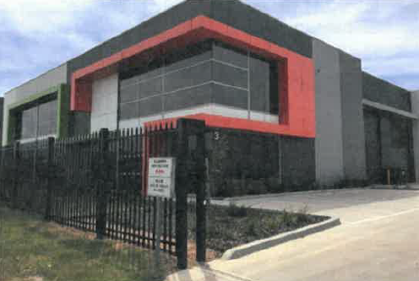

Disclaimer: The above information was provided by the Department of Environment, Land, Water and Planning.

# Lake Wendouree Community Outdoor Gym Facilities

The project involved the installation of four outdoor gym equipment stations at various locations around the Lake Wendouree foreshore as per the Lake Wendouree Masterplan.

The funding was provided to support community development projects. This project aimed to increase additional recreational attractions of Lake Wendouree and enhance the community’s health and wellbeing.

Project construction was completed in June 2020 during the COVID-19 pandemic. Due to the Victorian Government’s COVID-19 restrictions on human movement, the equipment was deemed off limits and unable to be used. Therefore, it was not suitable to conduct a project evaluation directly after project completion. A project evaluation will be undertaken in May 2021.

The completed gym stations were officially opened by Ms Julianna Addison MP, Member for Wendouree and City of Ballarat Mayor, Cr Ben Taylor in May 2019. As restrictions ease City of Ballarat will promote the gym equipment further.

Signage promoting the Victorian Government funding has been erected at all four sites.

Below are some photos of the sites provided by DJPR.

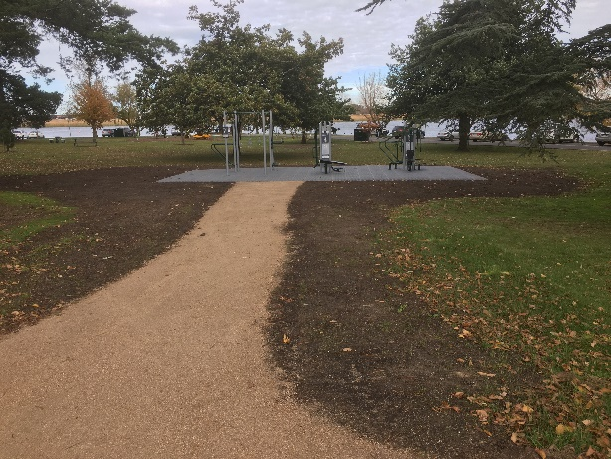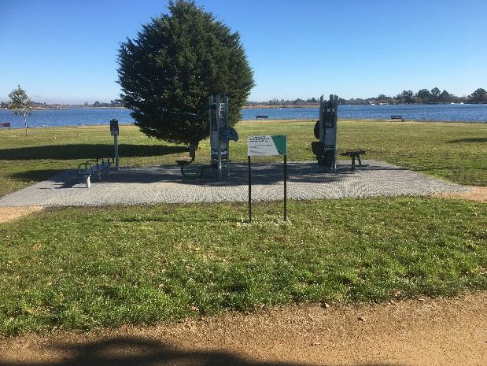

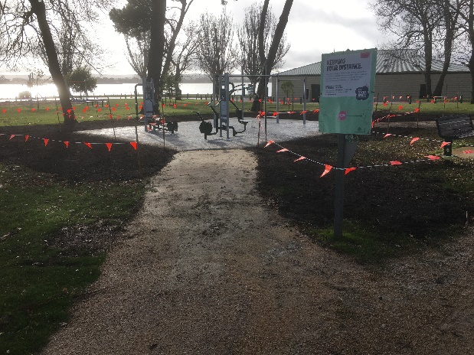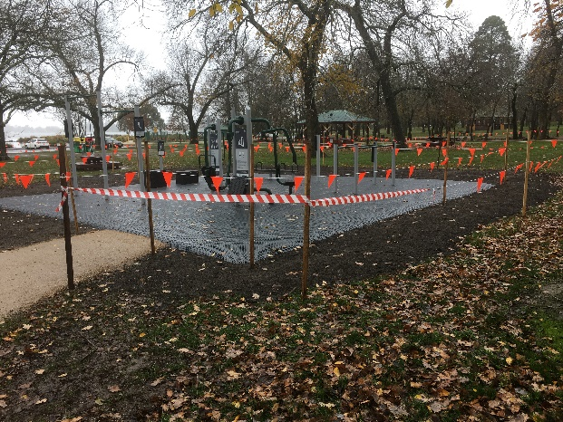

Disclaimer: The above information was provided by the Department of Jobs, Precincts and Regions.

# Port Fairy Streetscape Renewal Stage 3

The Port Fairy Stage 3 streetscape revitalisation works improved the streetscape in the top end of the main retail and business precinct of Port Fairy and included:

* renewal of street furniture including seats and bike racks
* vegetation and tree works
* conversion of the existing asphalt footpaths to bluestone paving to match Stages one and two of the streetscape works
* new kerb and channel to match Stages one and two of the streetscape works
* road pavement improvements and maximisation of parking
* service improvements for power and telecommunications

The project supported 30 local construction jobs during the 18-month project. Additionally, as with stages one and two of the streetscape works, co-located businesses have continued to upgrade their facades. Moyne Shire anticipates more commercial planning and business development activity in Bank Street in line with the pattern seen once the first two stages were completed.

Port Fairy township is one of Moyne Shire’s key assets. The town draws significant visitation year-round, particularly over the summer months and for the annual Port Fairy Folk Festival. Moyne Shire also has a broad suite of events aimed at attracting and retaining visitors over the winter months and maintaining and enhancing the attractive town centre is key to the Shire’s tourism strategy.

Below are some photos provided by DJPR.

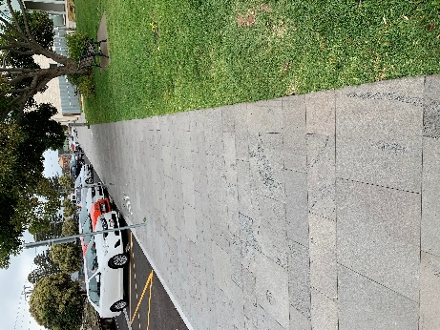

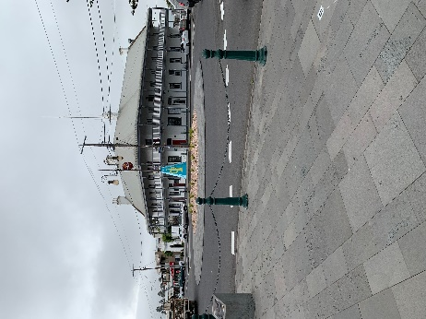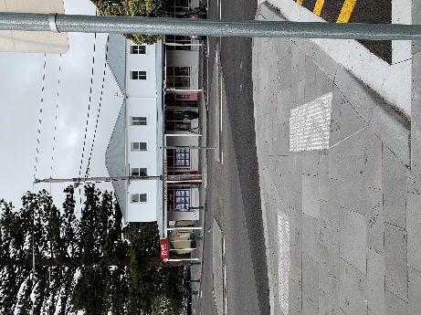

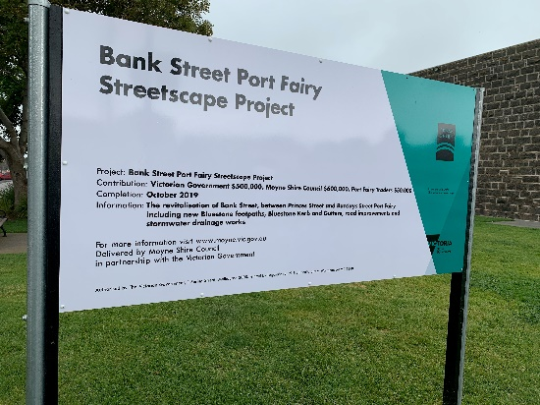



Disclaimer: The above information was provided by the Department of Jobs, Precincts and Regions.

# Leopold Community Hall Upgrade

The project enables new activities to be introduced at the hall to meet the future needs of the community and surrounding districts.

The addition of the disabled toilet provided a facility that meets occupational health and safety requirements and allows the hall to be more accessible for all.

The new activities benefit people of all ages and abilities. There has been a marked increase in enquiries and in the hiring of the hall.

**Success Factors:**

Communication between all parties relating to the project from the construction company, Hall Committee Management and Hirers of the Hall enabled the project to be achieved within the allocated time frame and budget.

**Challenges:**

The biggest challenges and learnings of the project related to updating the building to meet the required Building Code regulations within the Project Commencement and Completions Funding Schedule.

Another challenge was communicating with the Hirers during the construction period so as not to interfere with the project milestone daily activities.

Below are some photos provided by DJPR.

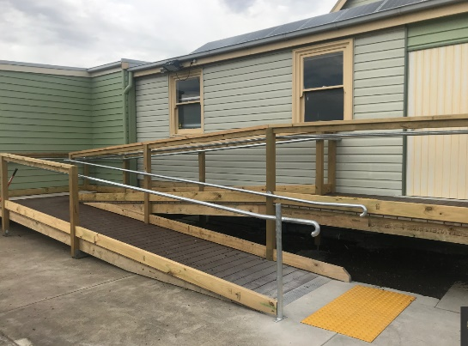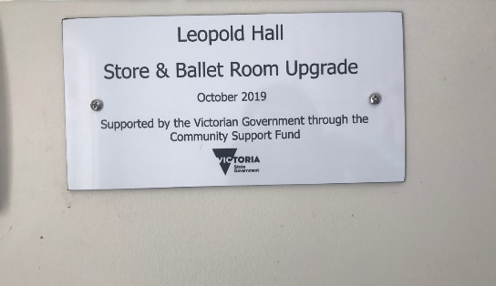

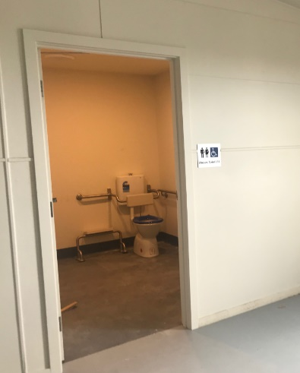

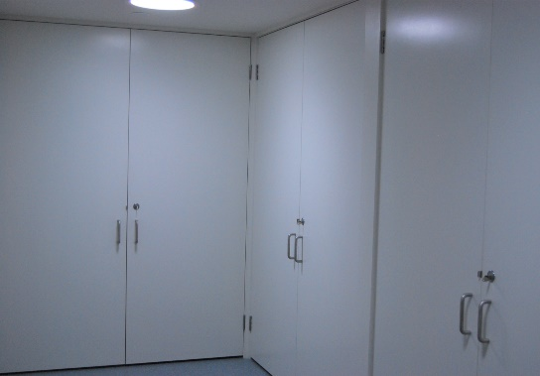

Disclaimer: The above information was provided by the Department of Jobs, Precincts and Regions.

# Installation of CCTV Cameras for Rosebud Soccer Club

The Rosebud Soccer Club located at the Olympic Park Reserve is very active in encouraging community participation and promoting social inclusiveness, especially for families from low socioeconomic backgrounds. In 2019 their clubrooms were broken into and items were stolen, windows were smashed with doors and light fittings broken. The installation of CCTV cameras will help to deter criminal behaviour and prosecute offenders.

Disclaimer: The above information was provided by the Department of Treasury and Finance.