Enhanced Design and Construct Deed
Commercial Principles

The Secretary
Department of Treasury and Finance
1 Treasury Place
Melbourne Victoria 3002
Australia
Telephone: +61 3 9651 5111
dtf.vic.gov.au

Authorised by the Victorian Government
1 Treasury Place, Melbourne, 3002

© State of Victoria 2023
You are free to re-use this work under a Creative Commons Attribution 4.0 licence, provided you credit the State of Victoria (Department of Treasury and Finance) as author, indicate if changes were made and comply with the other licence terms. The licence does not apply to any branding, including Government logos.

Copyright queries may be directed to IPpolicy@dtf.vic.gov.au

ISBN 978-1-925551-89-1
Published September 2023

If you would like to receive this publication in an accessible format please email information@dtf.vic.gov.au

This document is also available in Word and PDF format at dtf.vic.gov.au

Contents
1. Introduction 1
1.1 Purpose 1
1.2 Context 1
2. Overview of the Enhanced D&C Deed 3
2.1 Key features 4
2.2 Assumed application 4
2.3 Contractual framework 5
2.3.1 Collaborative framework 5
2.3.2 Issue resolution 7
2.3.3 Performance regime 8
2.3.4 Design management 8
2.4 Approach to key risk areas 9
2.4.1 Site Condition 9
2.4.2 Contamination 10
2.4.3 Utilities 13
2.5 Time 13
2.5.1 Liquidated damages 13
2.6 Risk 14
2.6.1 Indemnity 14
2.6.2 Insurance 14
2.6.3 Limits of liability 14
2.7 Security 15
2.7.1 Bonds 15
2.7.2 Parent Company Guarantee 15
2.8 Payment regime 15
2.8.1 Fixed price 15
2.8.2 Escalation 15
2.9 Adjustment Events 15
2.10 Delivery features 17
2.10.1 Subcontracting 17
2.10.2 Defect rectification 18
2.10.3 Fit For Purpose Warranty 18
Appendix A – Key risk allocations 19
Appendix B – Detailed overview of Issue Resolution Process 24

    - Introduction
      - Purpose
This document is one of a suite of publications that comprise the Department of Treasury and Finance’s (DTFs) whole of government infrastructure procurement framework (Framework).
It sets out the Victorian Government’s key commercial principles underpinning the Enhanced Design and Construct (D&C) Deed and the rationale for their inclusion.
The document is for use by Victorian Government delivery agencies to assist understanding and support strategic decision-making around when to use the Enhanced D&C Deed for a particular project. Key differences between this contract form and traditional D&C deeds are also highlighted.
The Enhanced D&C Deed forms part of the suite of standard form contracts. This contract form is supported by detailed guidance notes.
This document is not intended to be used to inform procurement model selection.
      - Context
The Enhanced Design and Construct Deed fits within the Framework.
The Framework includes three categories of procurement, including whole-of-life, lump sum and cost reimbursable, with each category containing a set of approved procurement models for use on Victorian Government infrastructure projects.
It consists of the following policy, guidance and standard form contracts:
    - the Ministerial Directions and Instructions for Public Construction Procurement (Ministerial Directions), established under Part 4 of the Project Development and Construction Management Act 1994 (Vic)
    - the Procurement - Investment Lifecycle Guideline, which outlines the three procurement categories and a set of approved procurement models
    - a procurement requirements document for each of the three procurement categories
    - standard form contracts and guidance for a subset of the approved procurement models.
Figure 1 provides an overview of the Framework and indicates where the Enhanced D&C Deed sits within it.
Figure 1 – Whole of government infrastructure procurement framework
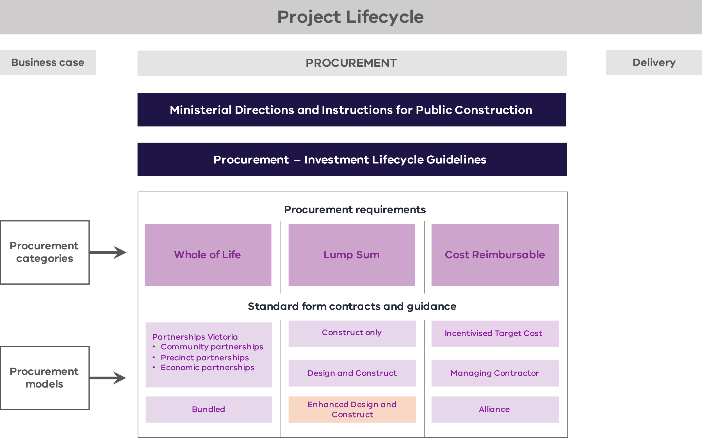

Other Victorian Government legislation, policies and frameworks that are applicable across the project lifecycle include:
- the Standing Directions 2018 under the Financial Management Act 1994 (Vic)
- the Investment Lifecycle Guideline series
- the Asset Management Accountability Framework, Investment Management Standard and Bid Cost Reimbursement Policy for Major Construction Projects
- the High Value High Risk (HVHR) project assurance framework and associated Gateway Review Process.
National policies, such as the National Alliance Contracting Guidelines and the National Public Private Partnership Policy, may also be applicable.
Where there is a difference in the application of this document from other policies and guidelines, the requirements in this document take precedence.
    - Overview of the Enhanced D&C Deed
The Enhanced D&C Deed has been developed by DTF to provide a modern contract based on a fixed price D&C model. The contract also includes targeted collaborative and risk sharing elements which respond to delivery issues and market concerns about standard D&C delivery models. The Enhanced D&C model also offers a robust alternative to Cost Reimbursable procurement models such as project alliances or ITC models where a significant portion of project risks are retained by the State. It does not replace the existing DTF approved standard form AS4300-1995 Design and Construct Deed, but provides an alternative to this and other existing standard form contracts.
Central to the Enhanced D&C Deed is the proposed allocation of risk whereby the risks that contractors are best placed to manage – and typically are willing to accept – are allocated to the Contractor. In response to industry concerns, specific risks that contractors are typically less willing to accept are treated collaboratively in the contract. Inter alia, this allows the Contractor to undertake further investigations and either reprice through an updated fixed price or a Targeted Outturn Cost (TOC) with a Gainshare/Painshare Adjustment mechanism. These relevant risks relate to elected contamination risks (soil and groundwater).
The Enhanced D&C Deed also includes a bespoke utilities risk sharing regime based on market tolerance for accepting utilities risks on certain types of projects (such as, utilities interface risks on linear infrastructure projects). There is potential for the risk sharing regime to be expanded to other risks to reflect individual project characteristics (such as the management of occupations in transport projects) but this would require delivery agency consultation with DTF to make adjustment to the drafting of the deed.
The Enhanced D&C Deed provides for the preparation of a Reference Design by the Principal. The tenderer would tender its design management plan and be responsible for design decisions to ensure Design Documentation is prepared in accordance with the Enhanced D&C Deed.
The structure of the Enhanced D&C Deed is based on the D&C elements in the Harmonised PPP Project Deed, with several modifications to remove operational phase and financing elements and reflect the Enhanced D&C Deed risk allocation.
The Enhanced D&C Deed also adopts applicable Partnerships Victoria standard terms (where consistent with generally accepted market terms for similar contracts) to promote greater consistency in forms of contract used in Victorian infrastructure projects.
The Enhanced D&C Deed is owned and managed by DTF.
Technical end user guidance is available to support implementation. For more details, please refer to the Enhanced Design and Construct Deed – Guidance Notes available on the Lump Sum Procurement Category webpage.
DTF sought advice from MinterEllison and EY to develop the Enhanced D&C Deed and Guidance Notes.
      - Key features
The Enhanced D&C Deed includes the following features:
    - A bespoke contamination regime for agreed types of Contamination which includes a ‘rebaselining’ mechanism with volume caps that allows for price adjustments after contract award. This includes options for the rebaselining mechanism to be on a fixed price or TOC basis depending on project characteristics.
    - A non-binding behavioural framework to support collaboration and incentivise proactive Principal engagement.
    - A bespoke issue resolution process, which provides for a commitment by the parties to early identification and collaborative resolution of issues including through an option for a resolution process tailored to the Project, and the establishment of an Issue Resolution Team (IRT).
    - A risk sharing regime for Principal Geotechnical Data where the Contractor is entitled to time and cost (as a modification) for Unknown Inaccurate Principal Geotechnical Data and an option for a geotechnical baseline regime.
    - A bespoke utilities risk sharing regime that can be adopted as an option by the State depending on the utilities risk. It provides the Contractor time and cost relief (as a Variation) for Unknown Utilities and in circumstances where utilities betterment is required during delivery, and if selected, time and Delay Costs for Critical Non-Contestable Utilities Delay with a further option to treat any Critical Non-Contestable Utilities Work as a Provisional Sum.
    - A regime dealing with brownfield developments, which includes interfacing with existing operations.
      - Assumed application
The Enhanced D&C Deed is to be used for major transport or social infrastructure projects where most of the scope of works can be competitively tendered to provide a fixed (lump sum) price, with the exception the proposed risk sharing mechanisms for utilities, contamination and geotechnical risks. The pricing for these items would be preliminary only and subject to final pricing post-contract award, based on the findings of further investigation.
The model requires a sophisticated client capable of ensuring value-for-money outcomes, including through potentially managing a TOC process for the Contamination regime.
      - Contractual framework
After the Principal has selected a tenderer as the successful tenderer, that party will be engaged as the Contractor under the Enhanced D&C Deed to deliver the Project. The Contractor:
    - designs and constructs the Project in line with the risk profile of the Enhanced D&C Deed;
    - is paid the Contract Sum as adjusted in accordance with the Deed (which includes Adjustment Events and payment for management of contamination in accordance with the risk sharing regime); and
    - is required to achieve completion by the relevant date, hand over the Project to the Principal and rectify any Defects identified during the Defect Liability Period.
        - Collaborative framework
Why include this concept?
The collaborative framework has been introduced to ensure stakeholders are working towards best-for-project objectives. This mitigates Contractor concerns that the State can be reluctant to assist in resolving issues, such as planning approvals, when it may be able to readily do so but is concerned about trigging contractual consequences. Instead, there is a mechanism for the Contractor to provide feedback on the State’s performance and collaboration through a regular review of the KRAs.
The Enhanced D&C Deed contains a collaborative framework to better align the objectives of the Principal and the Contractor so that all decisions are made for the benefit of the Project. This approach is intended to reduce or eliminate the adversarial relationship that can emerge between principals and contractors under traditional forms of project delivery.
The parties are encouraged to manage and resolve difficulties and conflicts proactively for their mutual benefit. The Enhanced D&C Deed facilitates this more cooperative relationship between the project participants by providing clear objectives and behavioural principles. Some of these principles include:
    - maintaining a culture of cooperating to achieve objectives;
    - ensuring safety;
    - resolving differences early;
    - striving for value for money for the Principal;
    - exchanging information and learnings transparently; and
    - developing capacity.
These principles are evident through initiatives such as:
    - the Senior Representatives Group (SRG);
    - the Handover Induction Workshop;
    - Key Result Areas (KRAs); and
    - proactive Principal engagement.
The Principal’s KRAs are ‘soft’ KRAs which are not linked to any financial incentive regime and do not provide the Contractor with any relief should the Principal fail to meet its KRAs (sample KRAs are included in Schedule 8 – Key Result Areas). The Principal’s KRAs form an important part of the collaborative nature of the Enhanced D&C Deed and seek to achieve proactive Principal engagement throughout delivery of the Project and to facilitate achievement of the Project Objectives.
There should not be an increased risk of dispute through the use of the Principal’s KRAs given it is clear that the Contractor has no claim against the Principal in respect of them and there is no operative obligation on the Principal to meet the KRAs. Instead, they are assessed by the Contractor in the Regular Performance Reports which are submitted to the SRG for consideration, with the intent that any issues raised in those reports would be addressed at a senior level before any issues became formal disputes.
Principal’s KRAs should be considered on a project-specific basis. These KRAs are intended to cover (among other things):
    - how the Contractor rates the performance of the SRG in discharging its functions;
    - how the Contractor rates the performance of the Principal in proactively engaging with those matters referred to in clause 4.6 (proactive Principal engagement). This includes:
      - the provision of information;
      - the facilitative exercise of powers by third parties;
      - stakeholder management;
      - the coordination of interfaces; and
      - the resolution of impediments to the Project Objectives;
    - how many referred issues have been raised to the IRT; and
    - how successfully these issues have been resolved by the IRT (including whether a Bespoke Resolution Procedure was agreed upon).
Why include this concept?
It is best to have a process in place that allows issues to be brought to the attention of those who have power to resolve them as they arise. This bespoke process can rapidly resolve issues in a manner that is sensitive to project circumstances before applying traditional dispute resolution processes.
        - Issue resolution
The Enhanced D&C Deed provides for a time-limited bespoke issue resolution process. This involves a commitment by the parties to early identification and collaborative resolution of issues. This is consistent with the overall collaborative nature of the Enhanced D&C Deed and the behavioural principles that underpin it. The establishment of an IRT, which includes an evenly divided team of Principal and Contractor Representatives, encourages parties to agree on a bespoke process prior to pursuing more formal resolution processes.
If the bespoke process is not used, the more formal resolution process applies.
An overview of the dispute resolution process is provided in Figure 2. A detailed overview is also at Appendix B.
Figure 2 – Overview of the issue resolution process
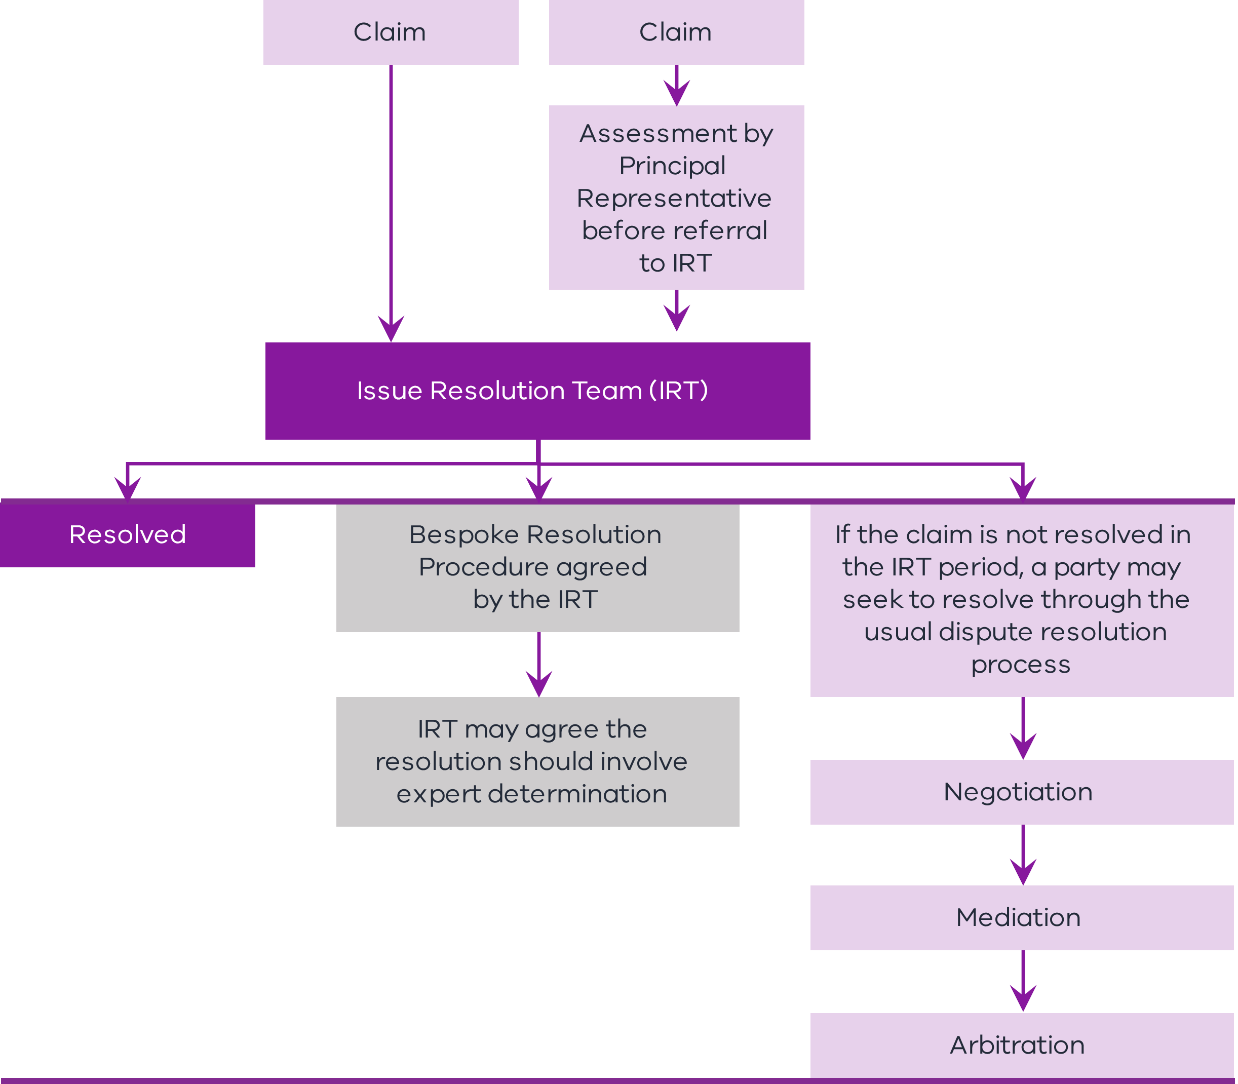
        - Performance regime
Standard D&C contracts do not generally provide additional incentives for timely delivery, only consequences for late delivery. The Enhanced D&C Deed allows project teams to establish a discretionary performance pool which incentivises contractors to manage specific events which are above and beyond core contractual requirements.
Project teams will need to consult with DTF to put together a proposal which outlines the need for a performance pool and the rationale for its size. The performance pool should address specific events or activities such as:
    - incentivising the timely delivery of major project milestones;
    - managing major interfaces; and
    - managing disruption to the community.
Figure 3 outlines the proposed process.
Figure 3 – Performance regime process
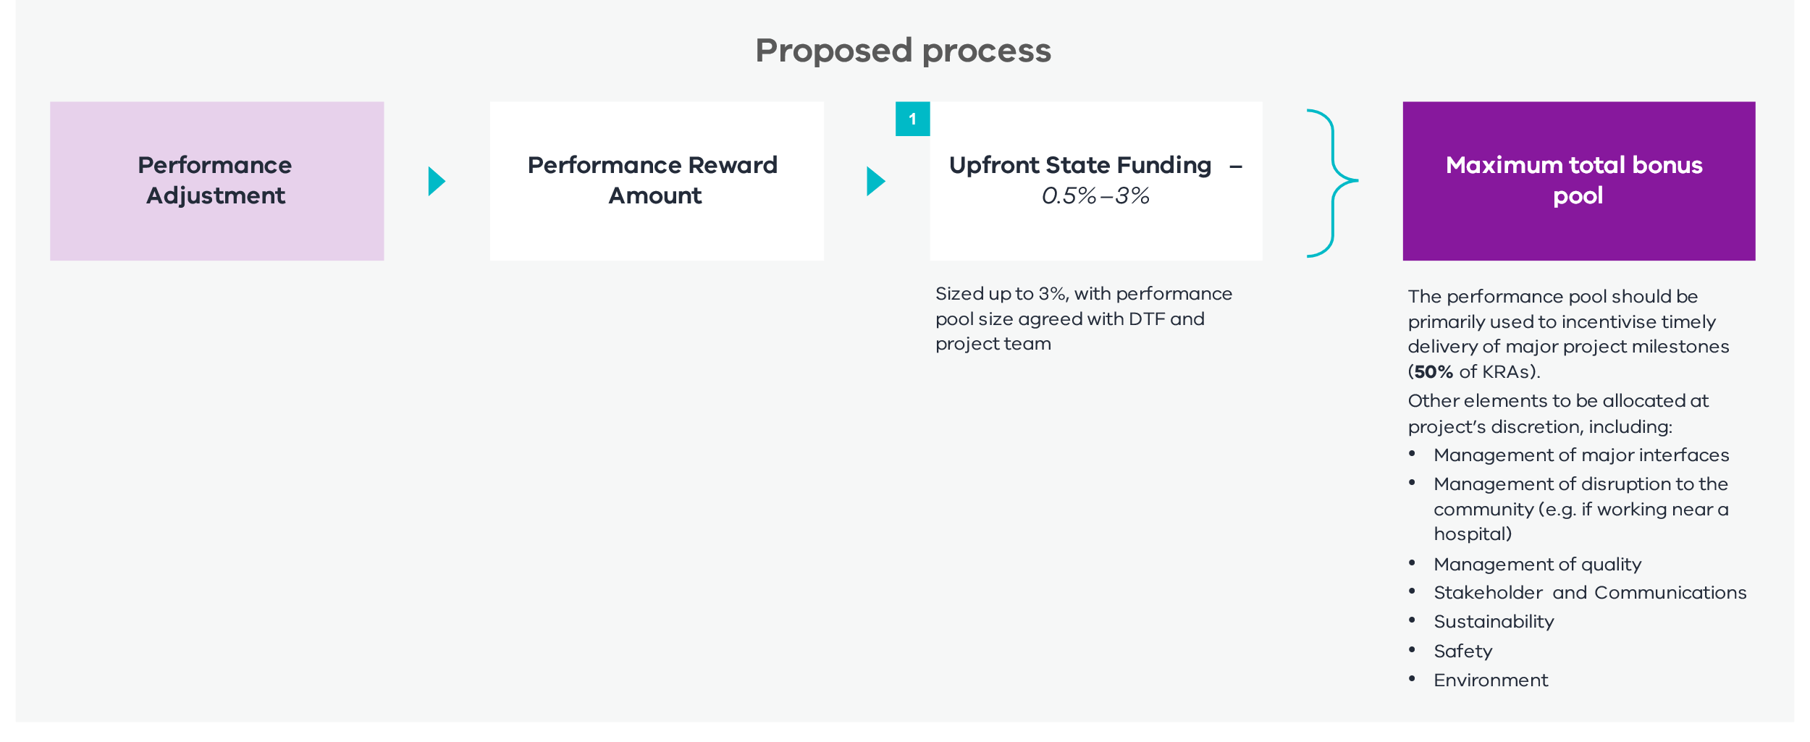
        - Design management
The Enhanced D&C Deed includes a ‘Reference Design’. The requirements of the Reference Design should be considered on a project-specific basis. This may be a preliminary design provided by the Principal or a design provided by the Contractor as part of its proposal. The inclusion of a Reference Design means the Enhanced D&C Deed may be employed on projects where a sufficient level of project development and due diligence has been undertaken prior to the award of the contract.
The Enhanced D&C Deed contains a general novation clause which allows the Principal to direct the Contractor to enter into a deed of novation between the Principal, the Contractor and a selected Subcontractor (i.e. the Principal’s design consultant) for particular selected Subcontract work.
The Contractor is required to prepare the Design Documentation (incorporating any necessary design development of the Reference Design) and submit the Design Documentation for review by the Principal Representative and the Principal in accordance with the Design Development Process in the Project Scope and Delivery Requirements (PSDR). The content of the PSDR and the Design Development Process are to be developed on a project-specific basis. The Design Development Process can be tailored to reflect the required level of Principal involvement in reviewing and commenting on the Design Documentation. For example, the Design Development Process may give the Principal the right to comment or place conditions on the Design Documentation received from the Contractor. The Contractor must address these comments before that Design Documentation can progress to the next stage in the Design Development Process.
The Contractor is also required to appoint a Design Development Coordinator (who will be part of the Project Control Group) to manage the Design Development Process.
      - Approach to key risk areas
Information on the approach to risk allocation for key areas, and the rationale for this approach, is discussed below. Annexure A contains a further summary of the risk allocations in the Enhanced D&C Deed.
        - Site Condition
The Contractor assumes all Site Condition risks other than where it is expressly stated otherwise in the Enhanced D&C Deed. The Contractor warrants that it has been given the opportunity to undertake tests, enquiries and investigations of the Site and its surroundings, including all Site Conditions and the existence or availability of Utility Infrastructure.
If a risk sharing option is selected, the Contractor is entitled to time and cost (as a Principal Initiated Variation) if there is Unknown Inaccurate Principal Geotechnical Data which results in increased time or cost to the Contractor. If adopted, this regime would apply to factual accuracy with respect to specified Principal-provided geotechnical data and is not intended to apply to any interpretation of such data.
The Enhanced Design and Construct Deed – Guidance Notes, available on DTF’s Lump Sum Procurement Category webpage, provide another option for a geotechnical baseline approach that can be discussed with DTF when there are specific concerns about geotechnical issues or access to the Site. This involves the Principal establishing a baseline of data which the Contractor then adds what it could reasonably know about the geotechnical conditions including from site investigations. If the Contractor then encounters geotechnical conditions that are different from what could reasonably have been anticipated and these conditions have a material impact on the Project, then the Contractor is entitled to relief through a Variation.
        - Contamination
Why include this concept?
Contamination risks cannot always be transparently and efficiently priced at contract award, as in certain cases further onsite due diligence may be required. This has meant that (at times) projects dealing with Contamination risks have elected not to use a D&C model. In these circumstances, these projects forgo the benefits associated with obtaining price competition and time certainty. The Enhanced D&C Deed allows for most of the Project’s scope and risks to be competitively priced at contract award, while maintaining flexibility through the Contamination rebaselining mechanism to adjust the cost based on the type and quantum of Contamination found. It is also expected to result in less contingency being added to the Contract Sum as the Contractor is not being asked to take Contamination risk that it cannot reasonably scope and price (including through the introduction of an Unknown Contamination regime).
The Enhanced D&C Deed includes a bespoke Contamination regime in response to industry concerns. This allows the Contractor to work collaboratively to price for Contamination risks relating to both soil and groundwater.
The contract form provides flexibility for this regime to apply to the whole Site or to key Contamination areas only, and flexibility as to whether it applies on a fixed price or TOC basis. DTF should be involved in decisions on how the Contamination regime applies for High Value High Risk projects.
Prior to contract award, tenderers are required to bid back volume caps and rates for Contamination based on different classifications of soil and methods to treat groundwater. Following contract award, the successful Contractor may undertake investigations and reprice through a rebaselining mechanism. This allows the Contractor to update volume cap values after investigations, which results in a price adjustment post-contract award.
The benefit of this regime over a traditional Provisional Sum mechanism is that rates and volumes are competitively bid and the rates are locked in. Additionally, whether the TOC or fixed price option applies, the Contractor's costs are controlled rather than being open-ended as per a Provisional Sum regime. In this way, the Contractor is either held to a fixed price or a TOC regime applies and the Contractor is incentivised to reduce costs. For example, because there are rules around the method of Remediation having regard to the cost impact, the Principal retains an element of control through review of the contamination management plan.
The rebaselining mechanism functions on either a fixed price or TOC basis with a Gainshare/Painshare Adjustment mechanism as determined by the State. See Figure 4.
It is up to delivery agencies to decide to adopt either a fixed price or TOC option. This decision should be made in consultation with DTF, on a case-by-case basis dependent on the risk of Contamination. Where there is more information available as to the Contamination risks (or a less contaminated Site generally) it is likely that a fixed price option is more appropriate. Delivery agencies should seek to adopt a fixed price where possible.
Figure 4 – Operation of rebaselining mechanism in the Contamination risk sharing regime
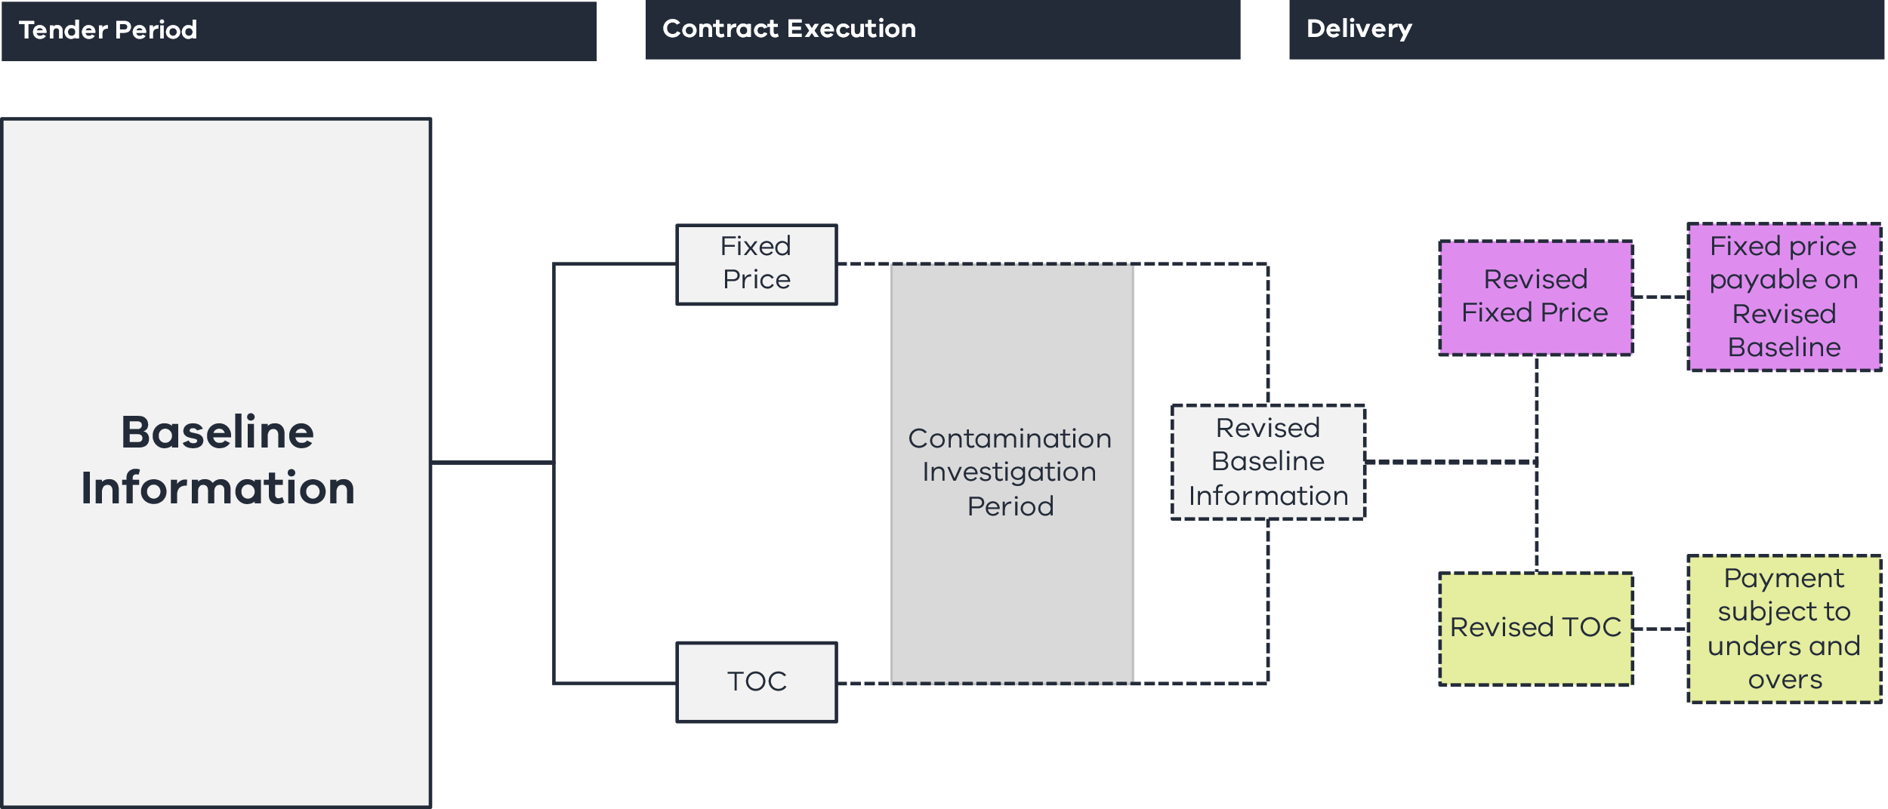
Under the fixed price regime, the Contractor is entitled to a share of the cost savings or cost overrun calculated on the difference between the estimated and revised budgets for soil and groundwater and is entitled to a monthly payment amount based on the fixed revised budget.
Under the TOC regime, the Contractor is entitled to the same cost savings or cost overrun share. However, the monthly payment amount is calculated using the volume of groundwater or soil actually treated or managed by the Contractor multiplied by the bid back rates up to the revised budget which acts as a TOC. Any volumes treated in excess of the TOC are paid based on a share of the cost overrun. There is also a Gainshare Adjustment mechanism at Practical Completion whereby if the aggregate of all monthly amounts paid is less than the revised budget, the Contractor is entitled to a share in the cost savings.
The operation of the rebaselining mechanism and payment to the Contractor under the fixed price and TOC regime is illustrated in the key steps diagram in Figure 5.
Under each of the groundwater and soil regimes, the Contractor is required to submit management plans to the Principal which outline their management strategies and methods used to determine volumes requiring treatment. This is reviewed by the Principal and requires approval in accordance with the Review Procedures under the Deed.
Figure 5 – Key steps in the Contamination risk sharing regime
Tender
phase
Post execution investigations
Remediation activities
- Decision on whether the risk sharing regime applies to the whole site or just key contaminated areas and whether the fixed price or TOC contamination risk sharing regime applies.
- Tenderers competitively bid back rates, risk sharing percentages and volume caps for disposal and treatment of solid waste and groundwater contamination based on contamination information provided.
- The successful tenderer enters a contract with rates, risk sharing percentages and volume caps locked in (on the basis of an agreed contamination baseline) – with an estimated budget for the remediation works.
- The Contractor has the option to perform additional Contamination Investigations.
- If it does perform additional investigations, the Contractor must update the contamination baseline (including volume caps) and as a result provide a revised budget.
- Depending on whether the fixed price or TOC option has been selected, the revised budget either becomes the fixed price for the remediation or becomes a TOC.
- There is a share of the cost savings or overrun based on the difference between the estimated budget and revised budget.
- If a fixed price option is selected, the Contractor will be paid the revised budget for any remediation activities.
- If a TOC option is selected, the Contractor is paid on a rates basis for the quantities remediated subject to a Gainshare/Painshare Adjustment mechansim dependent on whether actual remediated quantities are more or less than the TOC.
The Contractor’s obligations to Remediate for Contamination are determined on a location basis, and the Contractor must comply with all obligations in respect of any notifiable Contamination under the Environment Protection Act 2017 (Vic). Where the Principal directs the Contractor to Remediate or is required by law or an Authority to Remediate where it would otherwise not be required to Remediate, the Contractor is entitled to an Adjustment Event and relief as a Principal Initiated Variation.
Additionally, regardless of whether a fixed price or TOC regime applies, the Enhanced D&C Deed includes an Unknown Contamination regime under which the Contractor is entitled to claim, by way of a Principal Initiated Variation, for any Unknown Contamination discovered (any Contamination that differs materially from what could reasonably have been anticipated at the date of the Deed).
The Contractor indemnifies the Principal and the Principal Associate and the interface parties for Contamination caused or contributed to by the Contractor.
        - Utilities
Why include this concept?
In response to market feedback for certain types of projects, the Enhanced D&C Deed provides relief for the Contractor when the management of utilities is not reasonably within their control. This includes when Unknown Utility Services are found (time and cost relief) and for Critical Non-Contestable Utilities Delays (time relief).
In the Enhanced D&C Deed:
    - Unknown Utility Services will be treated as a Principal Initiated Variation and will entitle the Contractor to time and cost; and
    - Unavoidable Utilities betterment will be treated as a Principal Initiated Variation and will entitle the Contractor to time and cost.
If the risk sharing option is selected:
    - Critical Non-Contestable Utility Delays will entitle the Contractor to an extension of time and Delay Costs (where Critical Non-Contestable Utilities Works are not complete by a specified date); and
    - there is also the option to treat any Critical Non-Contestable Utility Works as a Provisional Sum and reimburse the Contractor for the costs of such work.
There will be an opportunity for contractors to bid back against utilities risks in relation to which utilities providers should be regarded as ‘Critical’ and ‘Non-Contestable’.
      - Time
        - Liquidated damages
If the Contractor fails to complete the Project by the relevant Date for Completion, the Enhanced D&C Deed sets out that the Principal is entitled to be paid an agreed, liquidated sum by the Contractor. This regime is a key feature to incentivise timely completion and will typically be capped at 10 per cent of the Contract Sum.
As outlined earlier, some projects may benefit from establishing a performance pool. Time based KRAs are assumed to be a core component of this pool. Payments would be made to contractors who achieve timely delivery of key milestones in accordance with the performance pool.
      - Risk
        - Indemnity
The Enhanced D&C Deed sets out several indemnities which the Contractor must provide, including in relation to:
    - property damage and personal injury or death in connection with any act or omission of the Contractor or any Contractor Associate;
    - breach of a Principal Project Document by the Contractor or a Contractor Associate;
    - provision and use of Project Information by the Contractor;
    - disruption, damage, removal and relocation of Utility Infrastructure to the extent caused or contributed to by a Contractor Act or Omission;
    - Contamination caused or contributed to by the Contractor or any Contractor Associate; and
    - any Claim or Liability arising in connection with any breach of representation, warranty or obligation in relation to Intellectual Property Rights (other than in relation to any Principal IP).
The indemnity in respect of Utility Infrastructure may be removed on a project-specific basis if it is not warranted in the circumstances.
        - Insurance
The Enhanced D&C Deed provides for a hybrid approach to insurances. This involves the Principal effecting insurances for the construction works and public liability. The Contractor effects insurances for transportation of Plant, Equipment and Material, insurance of employees, professional indemnity, motor vehicle insurance and Constructional Plant.
        - Limits of liability
The Contractor's liability in connection with the Enhanced D&C Deed is capped at 50 per cent of the Contract Sum, subject to standard exclusions.
The Contractor is not liable for any Indirect or Consequential Loss, subject to standard exclusions.
      - Security
        - Bonds
The Principal requires the Contractor to provide Performance Bonds in favour of the Principal prior to commencement of the Contractor's Activities in a form approved by the Principal. The contract will set out an approved form that may be used. Provision of the Performance Bonds is a Condition Precedent to the Enhanced D&C Deed.
        - Parent Company Guarantee
The Principal will require the Contractor to provide a Parent Company Guarantee. If the proposed Parent Guarantor is not the ultimate holding company, the Principal will need to be satisfied that the assets of that Parent Guarantor are retained for the duration of the Parent Company Guarantee. This will be a matter of evaluation.
      - Payment regime
        - Fixed price
The Contractor is paid a fixed price for the performance of the Contractor's Activities, subject to any Adjustment Events or the payment mechanism in respect of Contamination risk.
        - Escalation
Noting that escalation rates fluctuate over time, as a base position, escalation risk will be transferred to the Contractor.
DTF can provide advice on whether a rise and fall regime or alternative mechanism should be applied for specific materials that are subject to price volatility.
      - Adjustment Events
The Enhanced D&C Deed provides for a mechanism to adjust the Dates for Completion and an entitlement to Delay Costs.
Table 1 summarises the events that constitute such Adjustment Events. This table is subject to any other exclusions contained in the Adjustment Event Guidelines themselves (which are to be developed on a project-specific basis).
Table 1: Adjustment Events
Item | Event | Adjustment Event (Cost) | Adjustment Event (Time)
 | A breach by the Principal of any Principal Project Document, or any act or omission by the Principal or any Principal Associate that is not:  - a Permitted Act; or  - an Act where the Authority is acting in accordance with its statutory powers. | ü | ü
 | Any proximate Interface Works that are not part of the interface party's Business As Usual Work, were not reasonably foreseeable by the Contractor at the date of the Deed or are not performed in a manner of a prudent, experienced and competent contractor. | ü | ü
 | Any Site Interface Works that are not part of the interface party’s Business As Usual Works, were not reasonably foreseeable by the Contractor at the date of the Deed or are not performed in a manner of a prudent, experienced and competent contractor. | ü | ü
 | Failure by a Critical Interface Works Contractor to complete Critical Interface Works by the relevant Critical Interface Works Date and to a standard consistent with Best D&C Practices.^ | ü | ü
 | Destruction, loss or damage to any part of the Works caused by a Direct Interface Works Contractor.^ | ü | ü
 | Cessation or suspension of any part of the Contractor's Activities in connection with a Heritage Claim or Native Title Claim. | ü | ü
 | A material change to the way in which the Contractor's Activities are carried out in connection with a Heritage Claim or Native Title Claim, unless such change is the subject of a Variation Order. On a project-by-project basis, this may be extended to include Artefacts. | ü | ü
 | Industrial Action which occurs at or in the direct vicinity of the Site and is a direct result of an act or omission of the Principal, which is not a Permitted Act, undertaken as part of any Interface Works or by an Authority acting in accordance with its statutory powers. | ü | ü
 | Contractor entitled to prepare a Variation Proposal requiring engagement of a third party consultant. | ü | ü
 | Suspension of the Contractor's Activities not caused by a Contractor Act or Omission or Force Majeure Event. | ü | ü
 | A delay to the Contractor carrying out the Contractor's Activities due to a Critical Non-Contestable Utilities Delay. | ü | ü
 | The occurrence of a Pandemic Compensation Event. | ü | ü
 | A Pandemic Change in Law. | ü | ü
 | A breach of a Direct Interface Deed by a Direct Interface Party. | x | ü
 | A Force Majeure Event. | x | ü
 | Any other event expressly stated to be an Adjustment Event (Cost) in the Enhanced D&C Deed. | ü | ü
 | Any other event expressly stated to be an Adjustment Event (Time) in the Enhanced D&C Deed. | x | ü
Note:
^ Item 4 and 5 to be considered on a project-specific basis.
      - Delivery features
        - Subcontracting
Given that the Enhanced D&C Deed is a fixed price contract, its approach to Subcontracting does not require as extensive Principal management and control as the ITC Delivery Deed. In this way it reflects the Harmonised PPP Project Deed.
The Principal must be provided with notice of any proposed Significant Subcontractors. Copies of the Significant Subcontracts must be provided to the Principal (and copies of any other Subcontracts if requested by the Principal) and prescribed terms must be included in Significant Subcontracts. The Principal may require a Probity Investigation in respect of a Subcontractor which may result in the Subcontractor being terminated (or not engaged).
        - Defect rectification
The Enhanced D&C Deed provides for a Defects Liability Period (DLP) of 12 or 24 months commencing on the Date of Practical Completion. Any rectified works are subject to a further 12 month DLP with a cap on the overall DLP of 24 or 36 months after the Date of Practical Completion. The Contractor is required to provide security for the DLP, and if there are claims outstanding 24 months after the Date of Practical Completion, the DLP Bond will be reduced to the higher of 120 per cent of the reasonable cost of completing the rectification of the relevant Defects and a monetary threshold. This will be released 20 Business Days after Final Certificate or final completion.
        - Fit For Purpose Warranty
The Contractor provides the usual contractual warranties as to fitness for purpose and design and is responsible for the overall delivery of the Project.

Appendix A – Key risk allocations
No. | Type of risk | Description | Allocation
 |  |  | Principal | Shared | Contractor
Land acquisition and planning risk
 | Land acquisition | Risk associated with acquiring land identified at Contract Date as required for the Contractor’s design accepted by the Principal. | ü
 | Extra Land | Any Extra Land required by the Contractor above the land made available by the Principal. |  |  | ü
 | Planning approvals | Obtaining planning approvals for the Project in relation to Project Land. | ü
 |  | Changes to planning approvals required following a Principal Initiated Variation or Adjustment Event (Time). | ü
 |  | Obtaining planning approvals for the Project in relation to any Extra Land required by the Contractor. |  |  | ü
 |  | Changes to planning approvals proposed by the Contractor after Contract Date. |  |  | ü
 | Compliance with planning approvals | Obligation to comply with relevant planning approval conditions. |  |  | ü
Site risks
 | Contamination that is disturbed or interfered with, caused by, contributed to, or exacerbated by the Contractor or the Contractor Associate in carrying out the Contractor's Activities, or impacts the Contractor's Activities or the Site to the extent required:  - to meet the requirements of Approvals and Laws;  - to allow the Contractor's Activities to be carried out in a manner that is safe;  - to ensure that the Site and the Works are fit for purpose; and  - to ensure that the Contamination does not cause, or is not likely to cause, any loss or damage to a third party. | Cost relating to the management and removal of such Contamination (on the Site/in the Key Contamination Risk Areas). |  | ü (see Contamination risk sharing regime)
 | Contamination which the Principal directs the Contractor to Remediate:  - which it is not otherwise obliged to manage; or  - which is the subject of a Contamination Notice (not issued as a result of the Contractor's Activities and where the Contractor is not otherwise required to Remediate). | Cost relating to the management and removal of such Contamination on the Site. | ü
 | Contamination which Contractor must Remediate (statutory duty not covered by item 5 and 6) | Cost relating to the management and removal of such Contamination on the Site. |  | ü
 | Unknown Contamination which Contractor must Remediate | Cost relating to the management and removal of such Contamination on the Site. | ü
 | Native Title Claims | Risk of cost and delay if native title claims are made in respect of the land made available by the Principal (to the extent the relevant Adjustment Event (Cost) applies). | ü
 |  | Risk of cost and delay if Native Title Claims are made in respect of any Extra Land required by the Contractor (to the extent the relevant Adjustment Event (Cost) applies). | ü
 | Aboriginal Cultural Heritage and Artefacts | Risk of cost and delay resulting from a Heritage Claim (to the extent the relevant Adjustment Event (Cost) applies). | ü
 | Site Conditions | Risk of general Site and environmental conditions (excluding those specifically identified). |  |  | ü
 | Unknown Inaccurate Principal Geotechnical Data* | Risk of material inaccuracies in the Principal Geotechnical Data that was not known and could not have been reasonably anticipated or foreseen. | ü
 | Adverse Geotechnical Condition (if risk sharing option selected) | Risk of a subsurface Site Condition which was not known and could not have been reasonably anticipated or foreseen. | ü
 | Unknown Utility Service (including betterment) | Risk of nature, scope, location or condition of utilities differing materially to what could have been reasonably foreseen, and existence of the utility could not have been reasonably foreseen. | ü
 | Critical Non-Contestable Utility Works and Critical Non-Contestable Utility Delay (if risk sharing option selected) | The cost of the Critical Non-Contestable Works and the time taken for the Critical Non-Contestable Works to be completed taking longer than expected. | ü
Design & Construction risks
 | Force Majeure | Risk of delay caused by force majeure events which prevent construction milestones being met. |  | ü
 | Design risk | Risk that the Design Development Process cannot be completed on time or to budget or that the design does not meet the PSDR. |  |  | ü
 | Construction risk | Risk that construction cannot be completed on time (subject to Adjustment Events (Time)). |  |  | ü
 | Construction risk | Risk that construction cannot be completed to budget (subject to Adjustment Events (Cost) and if the TOC Contamination regime is selected). |  |  | ü
 | Defects | Risk that Defects are identified following completion of construction. |  |  | ü
 | FFP Warranty | Risk that the Works are not fit for purpose or do not comply with contractual obligations. |  |  | ü
 | Principal Initiated Variations | If the Principal elects to make a Variation to the Works. | ü
 | KRAs | Meeting required standards with respect to KRAs. These apply only to Enhanced behaviour. |  | ü
Industrial relations
 | Industrial relations risk | Risks of industrial action in respect of the Project. |  | ü  (Definition of Adjustment Event (Cost) limb (h) – exclusions)
Change in Law or Policy risks
 | Change in Law or Change in Policy which is not a Change in Mandatory Requirements | Risk of a change in law during the Project. |  |  | ü
 | Change in Mandatory Requirements (a subset of certain Change in Law and Change in Policy) |  | ü
COVID-19 and any future Pandemics
 | Pandemic Relief Event | Risk of cost and delay in relation to a Pandemic Relief Event. | ü
 | Pandemic Construction Site Closure | Additional mitigation costs associated with closure or part-closure of construction site as result of a Pandemic. | ü
Tax
 | Tax | Tax payable in respect of Contractor's Activities including any customs duty, tariffs and primage applicable to imported materials. |  |  | ü

Appendix B – Detailed overview of Issue Resolution Process
