Future directions for Partnerships Addressing Disadvantage
Consultation paper

The Secretary
Department of Treasury and Finance
1 Treasury Place
Melbourne Victoria 3002
Australia
Telephone: +61 3 9651 5111
dtf.vic.gov.au

Authorised by the Victorian Government
1 Treasury Place, Melbourne, 3002

© State of Victoria 2022
You are free to re-use this work under a Creative Commons Attribution 4.0 licence, provided you credit the State of Victoria (Department of Treasury and Finance) as author, indicate if changes were made and comply with the other licence terms. The licence does not apply to any branding, including Government logos.

Copyright queries may be directed to IPpolicy@dtf.vic.gov.au

Published March 2022

Where the term ‘Aboriginal’ in this document is used it refers to both Aboriginal and Torres Strait Islander people. Indigenous is retained where it is part of the title of a report, program, or quotation.

If you would like to receive this publication in an accessible format please email information@dtf.vic.gov.au

This document is also available in Word and PDF format at dtf.vic.gov.au

Contents
Key areas for feedback 1
Introduction 2
How to participate in this consultation 3
The PADs model 4
Key learnings applied to date 4
Streamlining the PAD development process 4
Reduced information requirements in applications 5
Clarity on government roles and responsibilities in PADs 5
PADs: The next stage 6
Consultation theme 1: The focus of future PADs 7
Future PADs focus 7
Pre-existing non-government programs 9
Consultation theme 2: How government engages on the development
of new PADs 10
Making the PAD process more accessible 10
Approach to future PADs 11
Consultation theme 3: Leveraging the Early Intervention Investment Framework 12
Closing 14
Glossary 15
Appendix A: Further information 17
Key principles of PADs 17
The stages in the PAD development 18
Improving outcomes 19
Other considerations 19
Independent evaluation 20
The PADs story so far 21

Key areas for feedback
The Partnerships Addressing Disadvantage (PAD) initiative is supporting social policy reform in Victoria. The Department of Treasury and Finance (DTF), in partnership with other Victorian Government departments, has now delivered four PADs to improve outcomes for vulnerable Victorians, which are all showing promising signs of success.
The purpose of this consultation paper is to take stock of what has been achieved to date with the PAD initiative, and to seek direct input from you to inform our approach to the next suite of PADs.
The consultation paper is designed to complement individual evaluations of existing PADs. It incorporates the feedback received to date on these PADs – including what we have done to address this feedback - and seeks to bring out perspectives on some key issues to inform potential next stages of PAD development.
To assist you, we have provided the following themes and key questions to prompt your feedback. We are not necessarily seeking answers to all questions, and any response should feel free to target those questions of most interest to you.
Further context for these key questions is outlined in the consultation paper.
Consultation theme 1: The future focus of new PADs
    - Is there a particular target cohort, or social policy area, that you think should be investigated for a PAD?
    - Does your organisation have a program idea not currently receiving government funding that you think could be scaled up for delivery as a PAD?
Consultation theme 2: How government engages on the development of new PADs
    - Are there other ways that government can engage with the sector, including ways to make it easier for smaller non-government organisations and Aboriginal organisations to participate, or ways to support greater levels of social investment?
    - Would your organisation be ready to provide a submission to a Request for Proposal for a PAD? If not, what type of support would your organisation need to feel ready?
    - How much would the Government publishing a forward pipeline of PADs support you in getting involved compared with a year-to-year announcement and what challenges could this pose?
    - Do you have any feedback on our approach to PADs or other areas for refinement?
Consultation theme 3: Leveraging the Early Intervention Investment Framework
    - In what ways do you think the EIIF enables the Government to approach outcomes-based funding differently?
    - Does having a potential pathway to embed PADs, via the scale-up of funding for successful programs through EIIF, change your approach to how you might develop a PAD?

Introduction
Partnerships Addressing Disadvantage (PADs), previously known as Social Impacts Bonds (SIBs) or social impact investments, establish partnerships between government, service providers and investors to improve social outcomes for Victorians experiencing vulnerability.
PADs aim to improve outcomes for disadvantaged groups in society and avoid government costs through reducing the use of acute and expensive government services.
After five years of delivery and the first wave of PADs, the Government is keen to identify learnings to guide its strategy for social investing and future PADs. To do this, we seek your input through this consultation paper.
The consultation paper provides a summary of:
- the PADs model, its key principles, and its importance to government
- the PADs journey and experiences from our first wave of PADs
- key learnings that have been applied so far.
The consultation paper then seeks your views and input on the following key themes:
- potential focus areas of new PADs (page 7)
- how government engages on the development of potential new PADs (page 10)
- leveraging opportunities provided by the Early Intervention and Investment Framework (EIIF) (page 12).
We are seeking views and input from the not-for-profit sector, investors and any other parties with an interest or involvement in social investment to inform an approach that guides the preparation and management of future PADs.
We welcome ideas from a wide range of perspectives – including from those of you who are less familiar with PADs but are interested in potentially being involved in a future PAD, through to those of you who are existing PAD partners with the Government.
We want to understand your perspectives on potential future PADs, given their viability and success depends on our partnership with you.
We invite your feedback through this consultation paper to inform potential next steps for Victoria’s PAD initiative.

How to participate in this consultation
We welcome feedback from anyone interested or involved in social investment.
Feedback can be emailed to pads@dtf.vic.gov.au
We expect only short responses (1-2 pages) in recognition of the competing demands on your time but welcome all feedback.
DTF will receive submissions until Friday 12th August 2022. DTF will use the feedback received to prepare advice on the direction and approach to future PADs and inform longer-term PAD strategic planning.
We may refer to your submission as part of any DTF response to the feedback received during the consultation. When providing your submission, please let us know if you are not comfortable with material from your submission being made public.
DTF encourages written feedback to the consultation paper from all interested parties.
DTF will also provide opportunities for input via ‘open door’ sessions over the consultation period targeted at those who are less familiar with the PAD process, including those from smaller non-government organisations. These sessions will provide you with an opportunity to ask questions about the PAD model to gauge whether it may be suitable to you, and contribute ideas to the way that PADs could be made more accessible. If you are interested in hearing more about the ‘open door’ session, please register your interest via pads@dtf.vic.gov.au. More information on these sessions will also be made available on the DTF website.
Further queries on the process or to discuss issues raised within this paper can be directed to Hugh Macintosh, Manager, Early Intervention and Reform on 03 7005 8906 or Matt Donoghue, Director, Early Intervention and Reform on 03 7005 8968.

The PADs model
PADs present the opportunity to develop innovative services that generate better social outcomes. PADs bring together capital and expertise from public, private, and not-for-profit sectors to achieve improved social outcomes.
Payments to service providers and investors are, in part, based on achieving agreed social outcomes rather than focusing on inputs or activities.
Improved social outcomes means improving quality of life for individuals.
Improved social outcomes can reduce an individual’s need to access government services such as hospitals, police, and crisis accommodation. This saves the Government money over the long-term, which can be used to provide a return on investment to reward proponents and investors.
PADs complement, rather than compete with, existing service offerings. They offer the opportunity to test a market-led payment by results model while working alongside other government services and programs.
For those of you who are less familiar with the PADs concept and processes, please see Appendix A for further contextual information. Appendix A also describes the existing PADs currently in operation in Victoria.

Key learnings applied to date
We are committed to continuing to refine our PAD processes based on our evaluations and on feedback received and have already taken steps to apply the learnings gained through the first wave of PADs. In this consultation paper, we want to show how we have applied learnings to date before seeking your further feedback. These learnings are outlined below.

Streamlining the PAD development process
We recognise that the procurement phase and Joint Development Phase associated with PADs development has been time consuming and administratively burdensome.
In the past, the focus of the PAD and outcome measures sought have been kept intentionally broad through the Request for Proposal (RFP) phase.
While this open-ended approach has enabled a greater range of responses, feedback suggested that this has come with the impost of additional administrative costs and time, given the need to undertake a lengthy Joint Development Phase with the Government.
To account for this, as part of the most recent RFP release for our new PAD, we have more explicitly specified the target cohort, and indicated the type of outcome measures that the Government is likely to be interested in.
These upfront specifications are intended to provide a head start on the work that is generally undertaken during the Joint Development Phase. It is anticipated that this will reduce the time and costs associated with this phase of the PAD development.

Reduced information requirements in applications
We have heard from proponents that preparing proposals can involve considerable administrative effort, especially through the development of avoided cost modelling, for which organisations may have to turn to specialist advisors.
We have taken this feedback on board and are no longer asking proponents to submit avoided cost modelling as part of their proposal. Proponents are now only required to provide a reduced set of core data inputs, along with general financial modelling, to support their applications.
We will continue to consider our RFP requirements to ensure we obtain sufficient information to assess proposals, while reducing the burden on interested service providers as much as possible.

Clarity on government roles and responsibilities in PADs
We have received feedback from our stakeholders and through initial evaluation reports that the Victorian Government departmental governance arrangements in PADs could be clearer.
We recognise that the various responsibilities of different government departments during the creation and implementation of PADs can cause confusion. Figure 1 illustrates the key roles of government departments through the PAD development process. This information will be included as part of the documentation for future PADs.
We will also work with proponents involved in the preparation of future PADs to ensure there is clear guidance on the roles of government partners through the process.
Figure 1: Roles of government departments through the PAD process
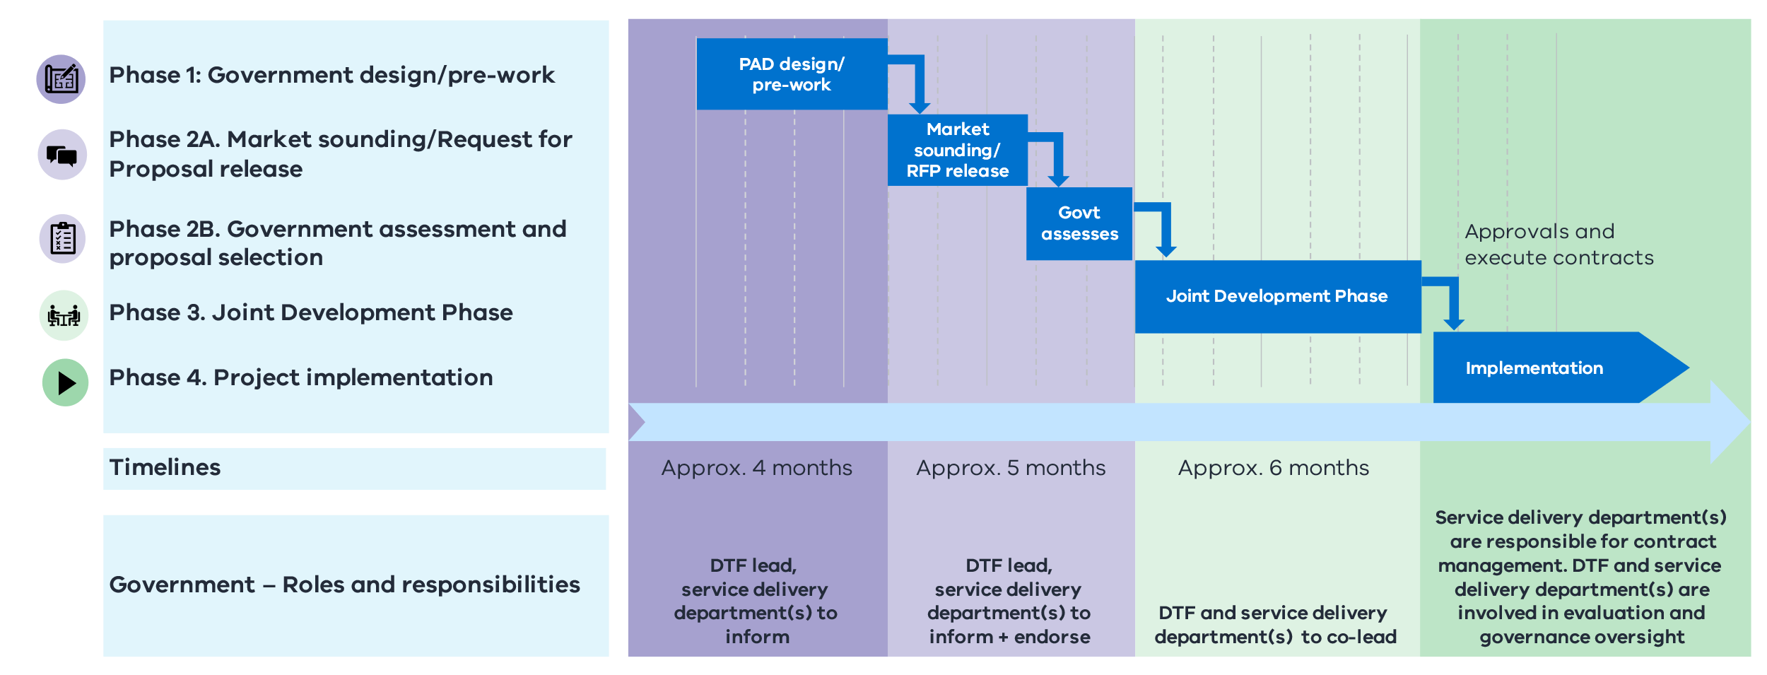

PADs: The next stage
Following the first five years of PADs and SIBs, the Government is identifying opportunities to scale up programs based on the growing evidence that these initiatives work.
Having applied various learnings over this period with the aim of making the process more streamlined and efficient, we expect new PADs to be put in place with greater speed and certainty.
The Government is not looking to change the intrinsic design of the PADs model, nor the key PADs principles as outlined in this paper.
However, we value the sector’s views and are hoping to draw on other ideas, experiences, and reflections that we have not yet heard to keep building on the initial PAD successes.

Consultation theme 1: The focus of future PADs
Government is seeking feedback on possible focus areas for new PADs in the future.
Focus areas that have been supported through current Victorian PADs include:

- people experiencing homelessness
- young people exiting out-of-home care
- primary school-aged children at risk of disengaging from education
- young people with mental health issues who have disengaged from education
- people exiting justice settings and at risk of homelessness (subject to current procurement process).

Future PADs focus
The Government has its own perspective on the potential future focus areas of PADs.
However, we are interested in your feedback on areas where a service gap may exist, or a priority cohort may need extra support.
Purely as an illustration, these cohorts could include Victorians who are:
- women
- Aboriginal Victorians
- under the age of 25
- experiencing disability
- from rural and/or regional communities.

Other Australian jurisdictions
Social impact programs in other jurisdictions have been developed in a variety of areas including:
Silver Chain (NSW) providing community-based palliative care services
Sticking Together (NSW) an initiative addressing youth unemployment.
On TRACC (NSW) supporting parolees to reintegrate into the community following release.
YouthChoices (QLD) aims to reduce reoffending rates among young people.
Newpin (QLD) aims to safely reunify children in out-of-home care with their families, focusing on Aboriginal and Torres Strait Islander children.
Resilient Families (SA) an intensive family support service to keep children safe at home in community and culture.
Aspire (SA) aims to improve the lives of homeless people in Adelaide.

Often people experiencing vulnerability will face more than one type of disadvantage, which can overlap and exacerbate each other. A PAD may choose to focus on a particular cohort and its interaction with a particular service area(s). For example, a target cohort could be Victorians with disability, and the service area could be mental health services.
We invite you to consider the overlapping nature of different types of social disadvantage and different service delivery areas, and how this could help frame what you consider as potential focus areas of upcoming PADs.
The overlapping nature of social disadvantage
Examples of how possible early intervention approaches could be considered in a holistic and system wide context:
Prison entrants are around 66 times more likely to be homeless than people in the general community.
Source Journeys Home Research Report No.6. Melbourne: Melbourne Institute of Economic and Social Research.
- The prevalence of mental illness is as high as 57.9 per cent for people with profound or severe ‘core activity’ limitations and 42.2 per cent for people with other disabilities.
Source: Royal Commission into Victoria’s Mental Health System, Final Report, Volume 3

Figure 2 shows a list of 12 priority service areas within the Victorian Government and their links to the existing Victorian PADs outlined above.
For illustrative purposes, we have noted the various focuses of the current PADs, such as homelessness, out-of-home care and hospital presentations, to show the cross-section of service areas that PADs already operate in.
The list of service areas shown in Figure 2 is not exhaustive. The table has been developed to frame your thinking around potential gaps and prompt you to consider other potential areas of focus.
In additon, a particular service deliery area having been a focus of a past PAD does not preclude it from being part of a future PAD. There may be a different lens to the issue or a different cohort within a service delivery area that is proposed for consideration.
In considering the potential focus for further PADs, it should also be recognised that the impact of PADs are much broader than just their primary or secondary areas of focus. The range of other areas that will be impacted by the PAD are important in terms of measuring success.

Figure 2: Focus of service delivery areas among existing PADs
Service delivery area | Targeted by current PADs
Hospital services | ✓✓✓
Mental health | ✓
Alcohol and other drug services
Child protection and family services | ✓
Housing assistance/homelessness | ✓✓✓
Family violence prevention
Community participation
Policing and community safety
Corrections, prisons and parole | ✓✓
Youth justice custodial services
School attendance/completion | ✓✓
Early childhood education services

Pre-existing non-government programs
The Journey to Social Inclusion Social Impact Investment (J2SI SII) PAD was developed from an existing program run by Sacred Heart Mission (SHM). SHM had already tested, developed and evaluated the program and shown positive outcomes for people experiencing chronic homelessness. The Government was then able to collaborate with SHM and investor and contingent grantors to expand the program into a PAD.
The Government recognises the vital first-hand knowledge that service providers have in working directly with Victorians experiencing vulnerability. The market-led approach to PADs gives the social services sector an opportunity to use this knowledge and expertise to propose a pre-existing non-government program to become a PAD.
The program proposed must be outcomes focused and innovative, in line with key PADs principles.

Key questions
- Is there a particular target cohort or social policy area that you think should be investigated for a PAD?
- Does your organisation have a program idea not currently receiving government funding that you think could be scaled up for delivery as a PAD?

Consultation theme 2: How government engages on the development of new PADs
There are different ways in which the Government can engage with the sector as part of the development of new PADs.

Making the PAD process more accessible
We are interested in your perspectives on how we can make the PADs process more accessible.
The application process and Joint Development Phase for PADs can be challenging especially for smaller organisations with fewer resources. DTF is seeking suggestions on ways to ensure a broader range of not-for profits and community organisation feel capable of participating and delivering a PAD.
We are interested in ways in which we can support your involvement, and what type of support you feel your organisation would need.
In considering your response, you might wish to consider elements such as:
- the skills required to engage in outcome-based funding arrangements
- the quantitative and/or qualitative analysis and data collection required for the measurement of outcomes
- the level of commercial acumen required to engage with investors
- your interest or ability to engage in a consortium with other organisations to deliver an outcome-based funding program
- whether your governance structure, constitution as not-for-profit and/or business model would support an outcome-based funding program.
As part of this, we also welcome suggestions for ways in which we can support Aboriginal organisations (including Aboriginal Community Controlled Organisations) to feel supported in participating and delivering a PAD.
Private investors are also a critical partner within the PADs model. Investors provide an upfront investment into the PAD, with returns linked to the outcomes achieved through the PAD. We are interested in hearing from private investors, including social investors and philanthropists, looking to invest in PADs. We are keen to identify any improvements that can be made to facilitate a greater level of social investment or make it easier for investors to take part in PADs.

Approach to future PADs
We are interested in your perspectives on whether there are significant benefits from having a known pipeline of future PADs.
The Government has historically announced the focus of PADs around the time of each budget, and subsequently undertaken a procurement process to seek sector interest in the development of the specific area.
An alternative approach would be for the Government to identify a known pipeline of potential future PADs. Under such a scenario, the Government could provide a list of likely PADs over the subsequent one to three years to provide the sector with line of sight and enable the Government to do the necessary early groundwork. Such a rolling pipeline could be drawn from sector feedback on the potential focus for new PADs (discussed in the previous section).
While such an approach may reduce timeframes and provide greater certainty around early preparation, the risks of such an approach include the loss of flexibility or the need to change approach based on changing government priorities or focus, including large reforms that may undermine the ability to roll out and measure a PAD.
Other suggestions for improvement
PADs are an innovative model with significant opportunity to evolve over time. We are looking to continuously improve our approach to PADs and are therefore open to other suggestions on improvements that can be made.

Key questions
- Are there other ways that government can engage with the sector, including ways to make it easier for smaller non-government organisations and Aboriginal organisations to participate, or ways to support greater levels of social investment?
- Would your organisation be ready to provide a submission to a Request for Proposal for a PAD? If not, what type of support would your organisation need to feel ready?
- How much would the Government publishing a forward pipeline of PADs support you in getting involved, compared with a year-to-year announcement, and what challenges could this pose?
- Do you have any feedback on our approach to PADs or other areas for refinement?

Consultation theme 3: Leveraging the Early Intervention Investment Framework
The PADs model provides the opportunity to test new and innovative ways to create solutions to difficult social issues.
A successful PAD intervention should not merely be an end in itself. It is important that there are opportunities to embed and expand the approaches that have been successfully trialled through a PAD.
One way of doing this is through leveraging the Government’s Early Intervention Investment Framework (EIIF). The EIIF enables government departments to consider funding opportunities that embed early intervention as a key principle. It represents an exciting innovation in the way the Government considers budget funding.
The EIIF prioritises investments in areas where timely assistance for Victorians will reduce acute service usage and improve outcomes. Like PADs, the EIIF links the Government’s funding to measurable impacts, both for people using the services and the service system.
It is important to recognise that the EIIF is internal to government and its funding is considered through the Victorian Government budget process. Government departments will determine their own funding priorities and programs that form part of the EIIF and, unlike PADs, it is not available for direct, external funding application.
However, government departments have an opportunity to expand successful PAD approaches that demonstrate improvements in outcomes and reductions in avoided costs as part of their suite of EIIF-related budget proposals.
Figure 3: EIIF proposals – like PADs – focus on outcome measures and avoided costs
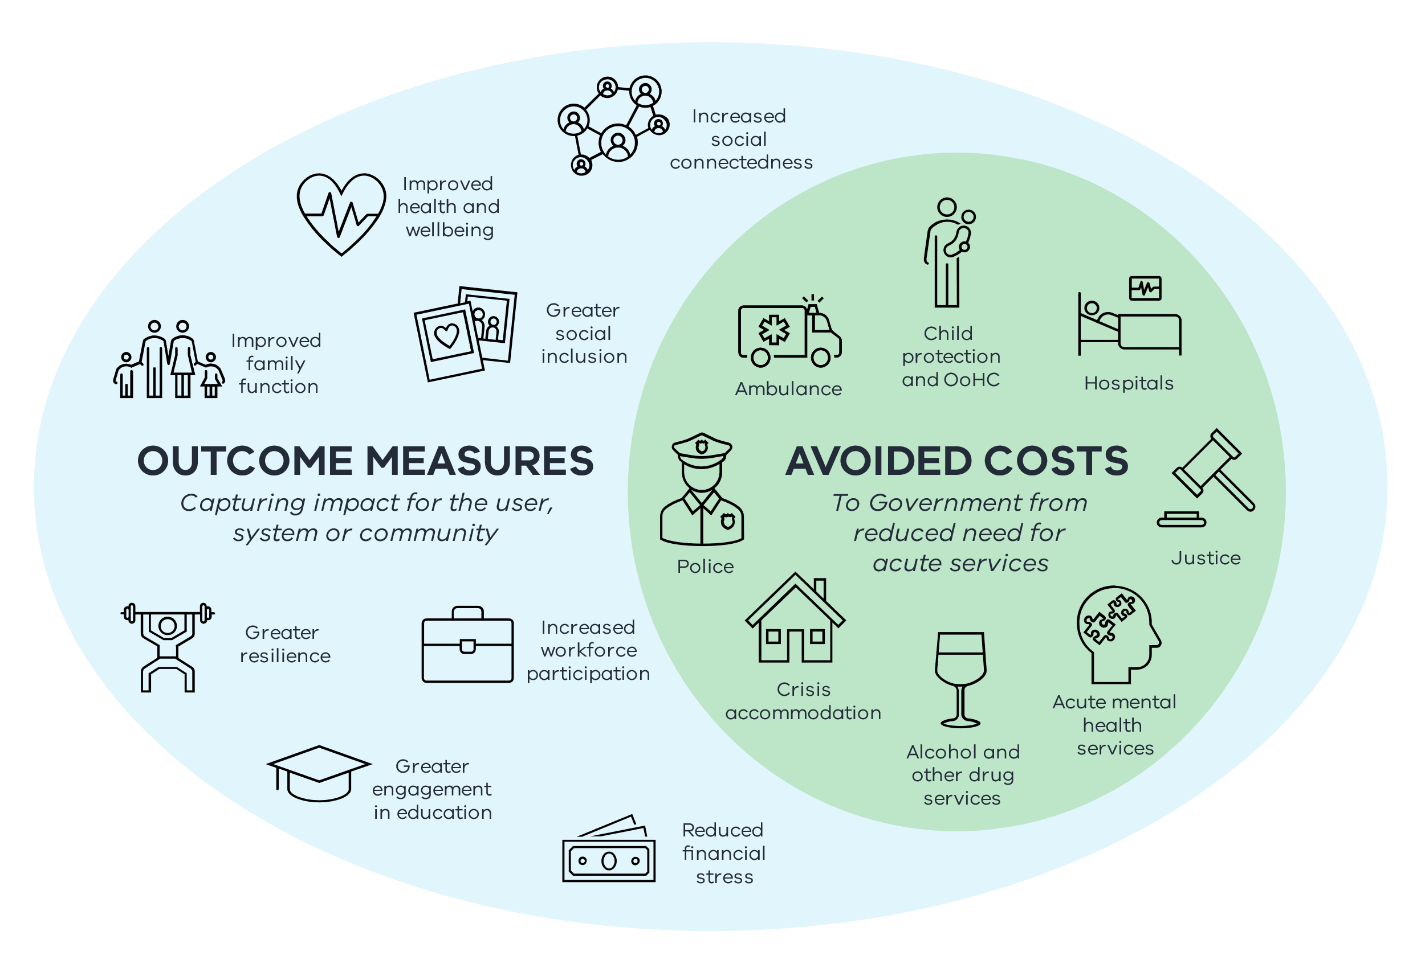
This has already occurred in a limited way as part of the 2021/22 Budget, which provided $324 million in funding across ten EIIF initiatives to deliver targeted, effective assistance to vulnerable people, reducing the likelihood of their needs escalating. This package included an extension of the J2SI SII PAD through a payment by results model, building on the evidence base and outcomes demonstrated through that PAD.
The remaining elements of the EIIF package support Victorians across a range of different cohorts, including families whose children are at risk of being placed in care, disengaged young people, and Victorians with chronic health conditions. This highlights the broad range of cohorts that can be supported through the EIIF, and similarities to areas that are a focus of PADs.
The EIIF and PADs are built on government’s growing expertise in quantifying the long-term costs and benefits of social policy.
The relationship between EIIF and PADs will strengthen through time, and we expect as the evidence base builds, it may inform a larger portion of the Government’s ‘early intervention’ funding, improving outcomes for vulnerable Victorians.
Figure 4: When PADS and the EIIF can be applied in the policy life cycle
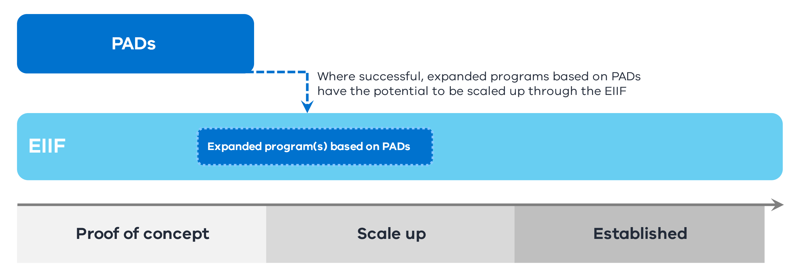

Key question
- In what ways do you think the EIIF enables the Government to approach outcomes-based funding differently?
- Does having a potential pathway to embed PADs, via the scale-up of funding for successful programs through the EIIF, change your approach to how you might develop a PAD?

Closing
We want to thank you for taking the time to engage with this consultation on the future directions of the PAD initiative. All feedback will be closely considered, and we value the input of all stakeholders in assisting us to make PADs better than ever.

Glossary
Avoided cost | Avoided cost refers to government savings because of a successful early intervention program, enabling the target cohort to reduce usage of other and more typically acute government services such as hospital emergency departments.
Department of Treasury and Finance (DTF) | The Department of Treasury and Finance (DTF) provides economic, financial and resource management advice to help the Victorian Government deliver its policies. DTF has a central role in the development and design process of PADs.
Early Intervention Investment Framework (EIIF) | The Early Intervention Investment Framework (EIIF) guides investments to where timely assistance for Victorians will reduce acute service usage and improve outcomes for vulnerable service users. Government departments prepare bids for the EIIF through the annual budget process.
Intervention | Intervention refers to the programs delivered by service providers. These programs aim to promote positive change and outcomes for the target cohort. For example, the Journey 2 Social Inclusion (J2SI SII) PADs intervention takes a trauma‑informed, relationship and strength‑based approach to case management and is supplemented by access to rapid housing.
Joint Development Phase (JDP) | The Joint Development Phase or JDP refers to the stage of the PADs process in which successful parties negotiate a detailed partnership proposal to be considered by the Government. Negotiations focus on outcome measures, funding arrangements and implications of performance and non-performance among other aspects.
Market sounding | Market sounding refers to the stage of the PADs process in which the Government seeks feedback from the sector and interested parties, such as social services organisations and potential investors, on the scope and focus of an upcoming PAD, ahead of releasing the RFP or formal tender for the PAD. Market sounding is usually facilitated through the release of a Statement of Intent (SoI) document.
Partnership Addressing Disadvantage (PAD) | Partnerships Addressing Disadvantage (PADs), previously known as Social Impacts Bonds (SIBs) and social impact investments, establish partnerships between the Government, service providers and investors to improve social outcomes for Victorians experiencing vulnerability.  PADs aim to improve outcomes for disadvantaged groups in society and avoid government costs through reduced usage of acute government services.
Private investors | Private investors, including philanthropic or social investors, refer to the private partners external to the Government and service providers who invest in a PAD to help fund the service providers alongside government contributions. Investors are paid a return that is linked to the outcomes achieved through the PAD model.
Request for Proposal (RFP) | The Request for Proposal (RFP) refers to the tender document the Government releases to seek proposals from the social services sector for a new PAD.
Service delivery department | Service delivery departments refer to government departments that lead the implementation of PADs in collaboration with successful proponents. For example, the Department of Family, Fairness and Housing (DFFH) is the service delivery department responsible for overseeing the implementation of the COMPASS PAD.
Statement of Intent (SoI) | A Statement of Intent (SoI) is the document through which the Government seeks market feedback and interest on a proposed PAD during the market sounding phase, ahead of releasing the formal tender or Request for Proposal for a new PAD.
Target cohort | The target cohort refers to the group of individuals a particular PAD aims to support. An example of a target cohort could be adults leaving correctional facilities at risk of homelessness.

Appendix A: Further information

Key principles of PADs
PADs aim to demonstrably improve outcomes for vulnerable Victorians and tackle difficult and deep-seated social issues.
Not all programs or investments may be suitable. PADs are likely to be appropriate where it is possible to:
- clearly define the client group
- deliver measurably positive outcomes to individuals
- achieve value for money for the Government
- deliver an intervention that is innovative, but with evidence of efficacy
- fairly share the risk and return
- test a proof of concept that can be scaled up
- provide learnings and a future evidence base for government investment.
Partnership is a key aspect of PADs. It is through the close engagement of various government and non-government bodies that the benefits of PADs are achieved.
Figure 5: A typical PAD service delivery and investment structure
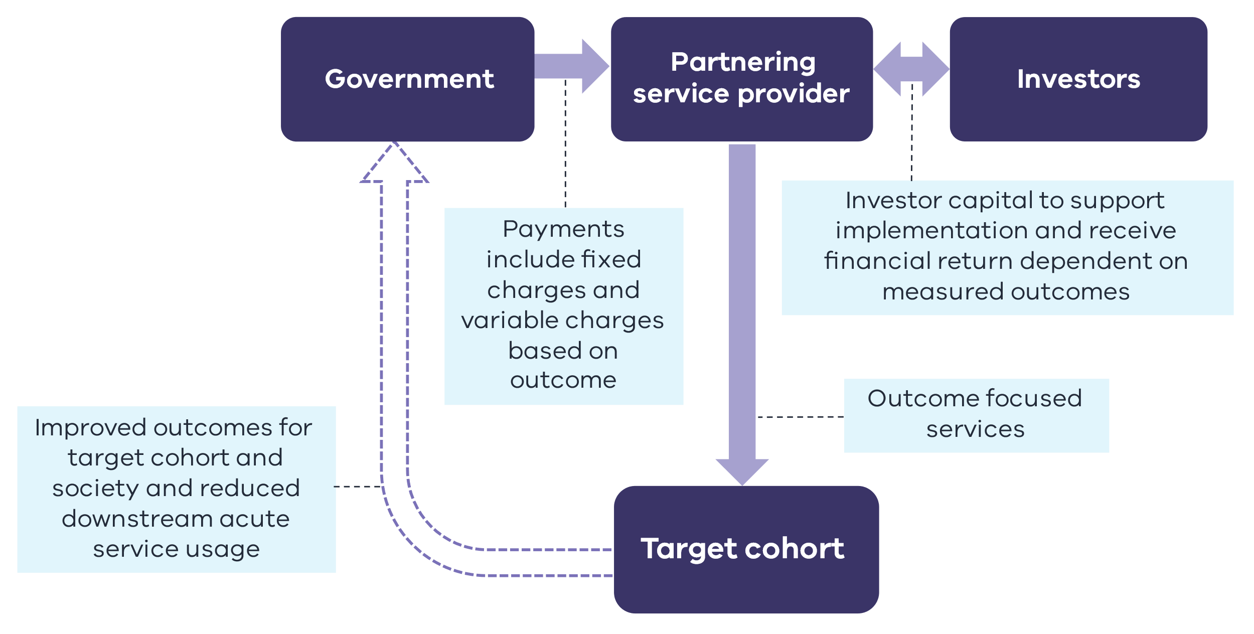
Key Partners include:
- Departments, who work with service providers to agree on the performance payments, other outcome measures and government funding associated with delivery, as well as any operational support required to implement the program.
- Investors and philanthropic investors, who provide private funding to finance a portion of the PAD, with financial returns based on the achievement of outcomes.
- Not-for-profits who deliver the services provided through PADs.

The stages in PAD development
The conventional development of a PAD is undertaken through a series of stages, as outlined in Figure 6. Part of this consultation process seeks input on ways in which we can streamline these processes for the benefit of PAD proponents and the Government.
Figure 6: PAD development stages
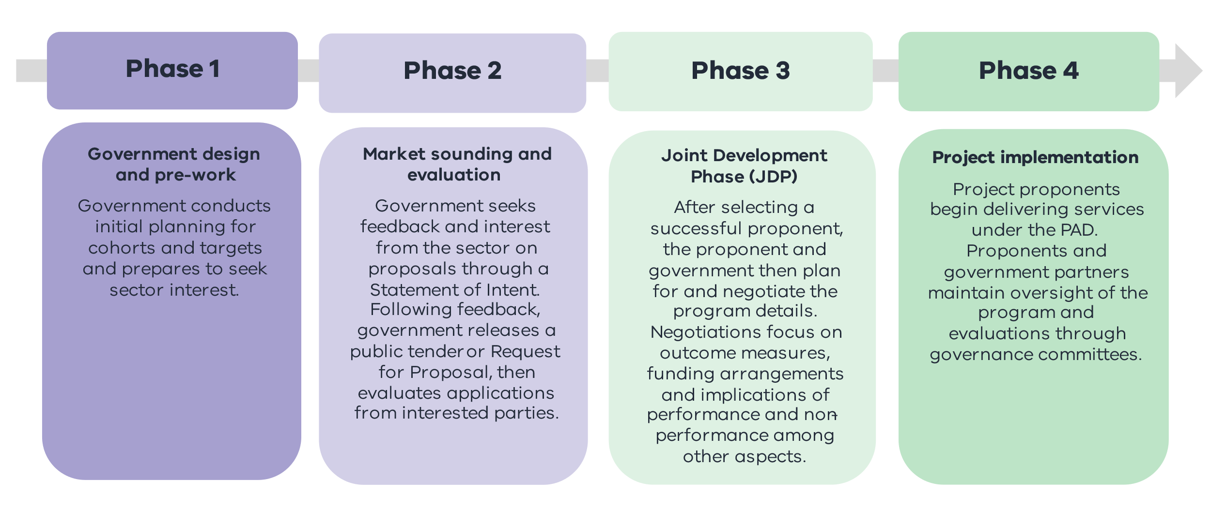
Other elements may also need to be considered. For instance, the potential for profit in the performance payments can impact on a non-government organisation’s governance and organisations constitutions. This may require the creation of a special purpose vehicle through Phase 3.

Improving outcomes
The primary focus of PADs is to improve social outcomes for the intended target cohort of the intervention. In doing so, PADs tackle long-standing complex social issues by partnering with non-government agencies and leveraging their expertise.
Outcome measures are central to PADs. The focus on outcomes, and their measurement, is a key part of the procurement and Joint Development Phase.
Service providers and investors receive performance payments should participants experience positive outcomes. These performance payments occur where there is demonstrated improvement for individuals in the PAD, compared with a baseline level of expected performance, or against a control group.
However, the outcomes sought under a PAD are broader than just those that relate to payable outcomes. A range of other non-payable related outcomes are also sought as part of the PAD. These outcomes including qualitative outcomes, which are also monitored.
Both payable and other outcomes can have a real and tangible benefit to individual participants in PADs, including, for example, improved access to secure and sustainable housing, reduced likelihood of hospital admission, reduced interaction with the criminal justice system, or greater engagement with the education system.

Other considerations
Effective PADs can offer numerous benefits to the individual, government and society.
For example, new and innovative approaches to housing and accompanying holistic supports to those at risk of homelessness can:
- improve health, social and economic outcomes for the cohort
- save or avoid government costs related to supplying acute services, such as emergency department presentations and interaction with the criminal justice system, through earlier intervention
- provide broader community benefits and social cohesion and inclusion
- provide learnings for government policy makers and the broader social services sector.
It is important for PADs to achieve value-for-money for government. New partnerships can demonstrate this where estimates of avoided costs are greater than performance payments.
Avoided costs are costs government does not incur due to the benefits associated with an early intervention program. The cost saving for government lies in targeting individual’s avoided use of acute and expensive services.
Figure 7: The benefits of early intervention on costs to the Government
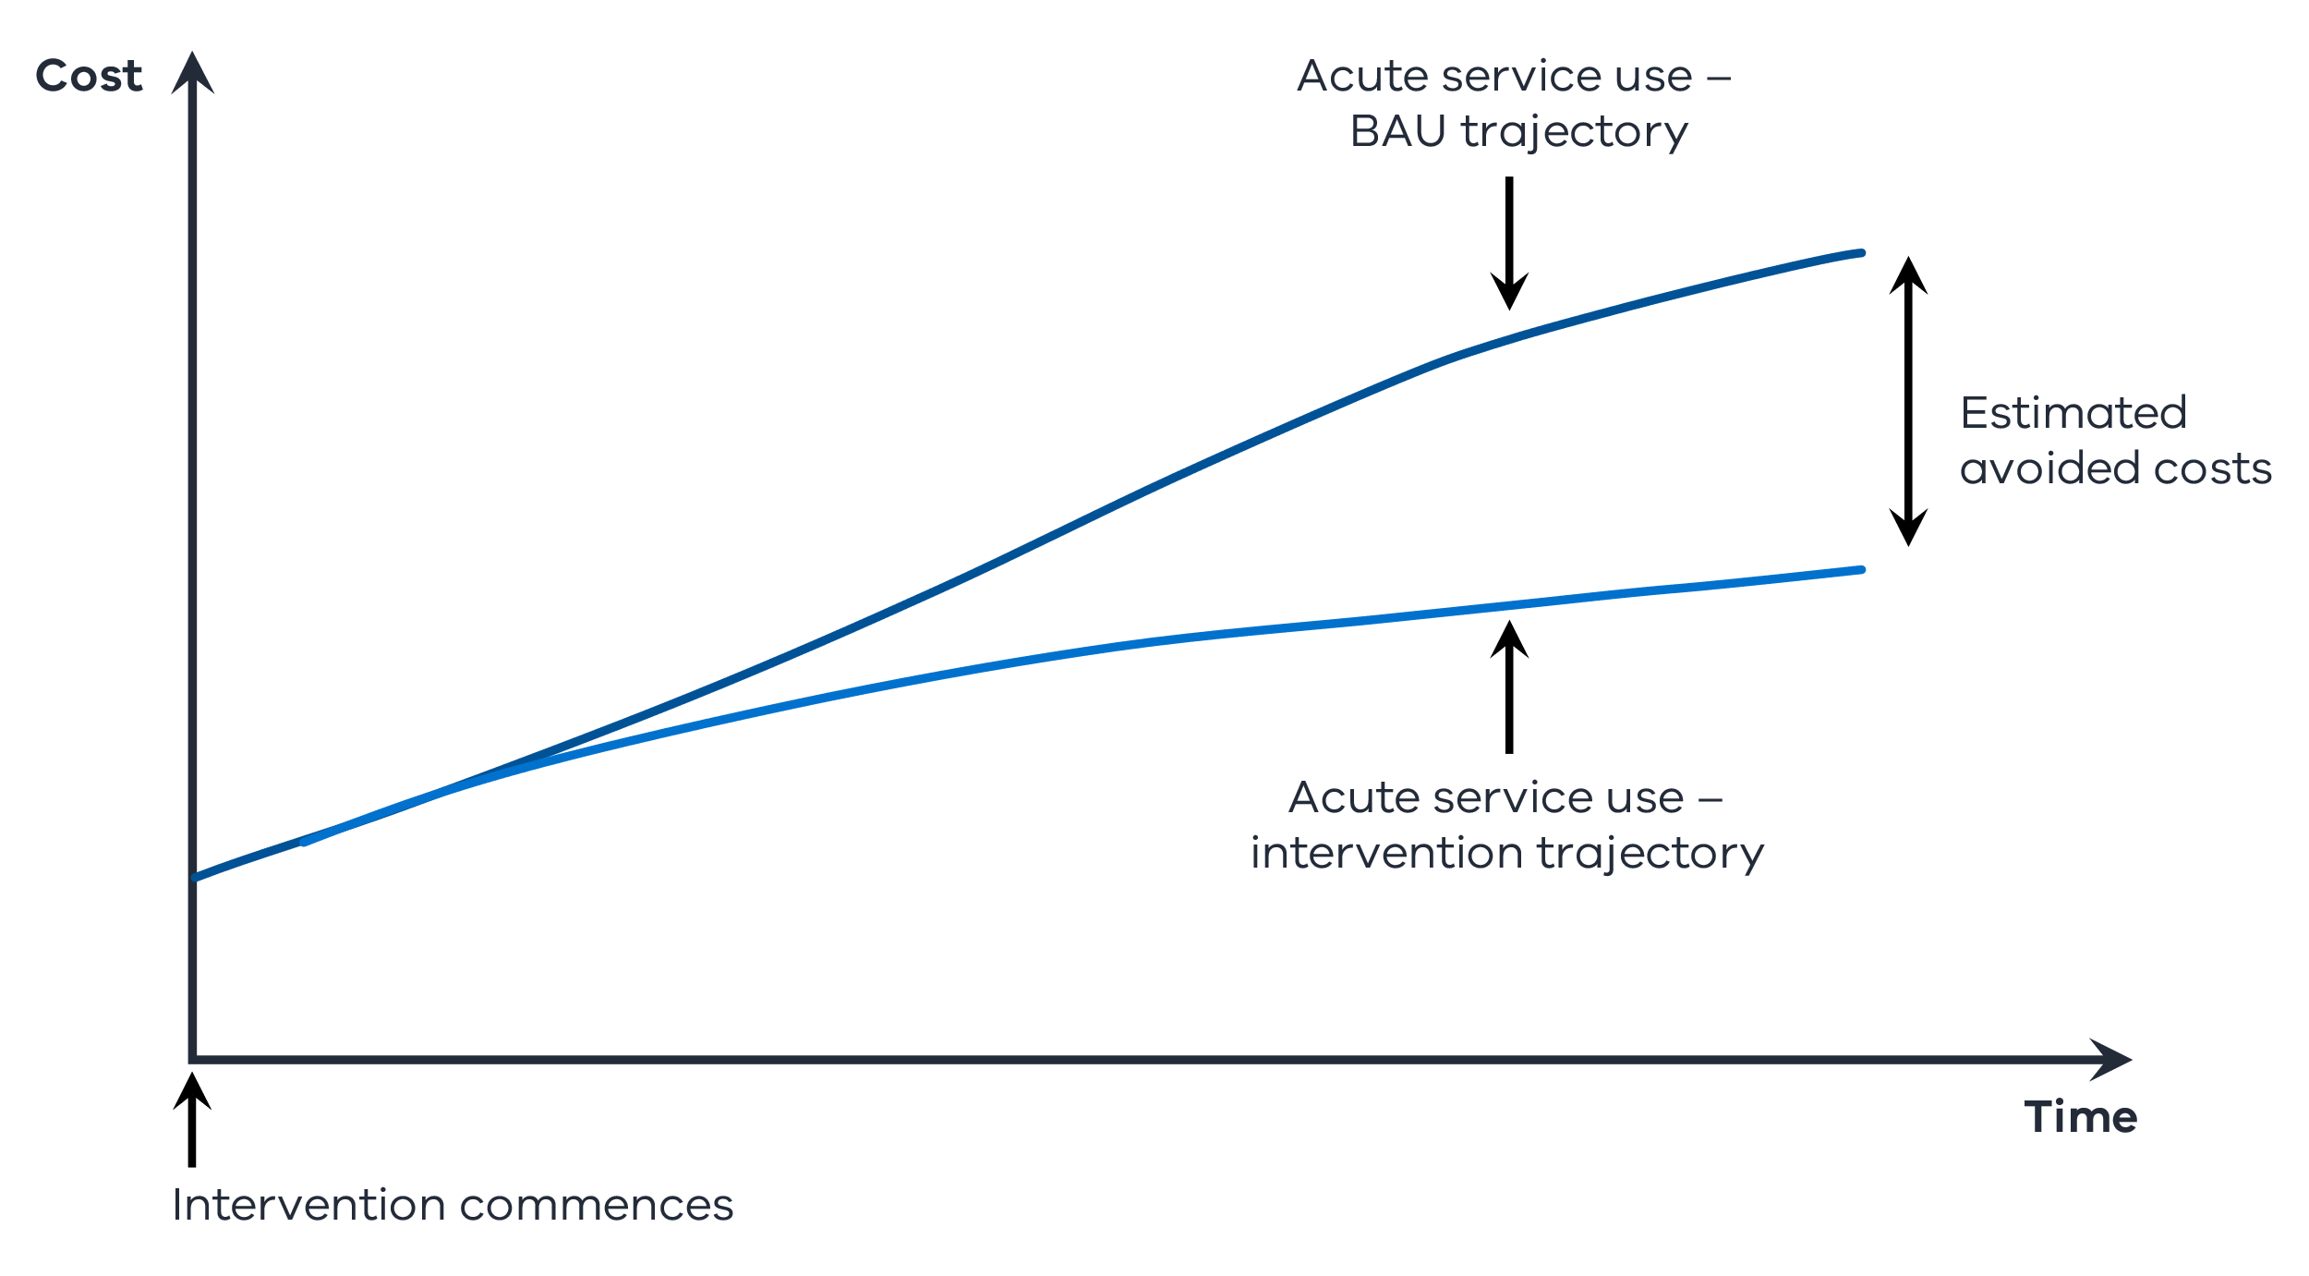

Independent evaluation
Independent evaluations are an integral component of the PADs model.
The evaluations assess the:
- the efficacy of the PAD model to the chosen policy area
- the efficacy of the new service delivery design
- the quality of outcomes experienced by the target cohort, government and society more generally.
Evaluations are used at different stages across the lifespan of a PAD. The evaluations are an important feedback loop to all parties and enable continual refinement of the PADs process and implementation.
The evaluation process also supports learnings for future government policy.

The PADs story so far
To date, the Victorian Government has worked with service providers to develop and implement four programs using the PADs model. All the following service providers have partnerships with investors who play an integral role in bringing PADs to fruition.

- Journey to Social Inclusion Social Impact Investment (J2SI SII): Sacred Heart Mission is delivering a scaled-up version of J2SI following a successful pilot. J2SI SII seeks to address chronic homelessness by taking a trauma-informed, relationship and strength-based approach to case management, supplemented by access to rapid housing. J2SI SII commenced delivering services in August 2018.

At August 2021, as independently certified at three measurement dates, the J2SI SII clients have reduced their hospital bed use by
56%
J2SI SII clients in stable housing:
90%

- COMPASS Leaving Care: COMPASS is a partnership between Anglicare Victoria, VincentCare Victoria, the Victorian Government and 50 investors. COMPASS supports young people leaving out-of-home care. COMPASS provides comprehensive support to each participant to help them make a positive start to independent living. The COMPASS team works with participants as they build skills and provides access to specialist services such as metal health, alcohol and drug services. The program provides different housing arrangements according to need. The COMPASS program began service delivery in October 2018. COMPASS is having a positive impact on participants, with an increase of those engaged in education (87%) and employment (63%).

The COMPASS cohort have increased engagement with education from
50% to 87%
and employment from
27% to 63%

- Living Learning: This program, delivered by Melbourne City Mission, provides education and wraparound mental health support to young people living with a mental health condition who are disengaged from traditional schooling. Living Learning commenced delivering services in January 2021. The implementation of the PAD is too early to indicate specific outcomes.
- Side by Side: Delivered by Berry Street and the Victorian Aboriginal Child Care Agency, Side by Side provides student and family support for primary school students, including Aboriginal and Torres Strait Islander students who are at risk of disengaging from school, with a focus on improving attendance, academic outcomes, and wellbeing. The program also provides combined trauma and cultural awareness and inclusion training in schools. Side by Side commenced delivering services in January 2021. The implementation of the PAD is too early to indicate specific outcomes.
Further information on the perspectives of the proponents involved in these four PADs can be viewed on the following video link: Department of Treasury and Finance | Partnerships Addressing Disadvantage
The Government is also undertaking a fifth PAD that is currently going through a procurement process. This PAD is focused on people exiting justice settings who are homeless or at risk of homelessness.

